UNITED STATES SECURITIES AND EXCHANGE COMMISSION

WASHINGTON, D.C. 20549

FORM 10-Q

- QUARTERLY REPORT PURSUANT TO SECTION 13 OR 15(d) OF THE SECURITIES EXCHANGE ACT OF 1934

For the quarterly period ended September 30, 2026

OR

- TRANSITION REPORT PURSUANT TO SECTION 13 OR 15(d) OF THE SECURITIES EXCHANGE ACT OF 1934

For the transition period from ____ to ____

Commission file number 001-37386


 |  | FTAI AVIATION LTD.
 |  | (Exact name of registrant as specified in its charter)
 | Cayman Islands |  |  |  |  |  |  |  | 98-1420784
 | (State or other jurisdiction of incorporation or organization) |  |  |  |  |  |  |  | (I.R.S. Employer Identification No.)
 | 405 West 13th Street, 3rd Floor | New York |  |  |  | NY |  |  | 10014
 | (Address of principal executive offices) |  |  |  |  |  |  |  |  |  | (Zip Code)
 |  | (Registrant’s telephone number, including area code) (332) 239-7600
 | (Former name, former address and former fiscal year, if changed since last report) N/A
 |  | Securities registered pursuant to Section 12(b) of the Act:
 | Title of each class: |  |  | Trading Symbol: |  |  |  |  |  |  | Name of exchange on which registered:
 | Ordinary shares, $0.01 par value per share |  |  |  |  | FTAI |  |  |  |  | The Nasdaq Global Select Market
 | 9.50% Fixed-Rate Reset Series D Cumulative Perpetual Redeemable Preferred Shares |  |  |  |  | FTAIM |  |  |  |  | The Nasdaq Global Select Market

Indicate by check mark whether the registrant (1) has filed all reports required to be filed by Section 13 or 15(d) of the Securities Exchange Act of 1934 during the preceding 12 months (or for such shorter period that the registrant was required to file such reports), and (2) has been subject to such filing requirements for the past 90 days. Yes ☑ No ☐

Indicate by check mark whether the registrant has submitted electronically every Interactive Data File required to be submitted pursuant to Rule 405 of Regulation S-T (§232.405 of this chapter) during the preceding 12 months (or for such shorter period that the registrant was required to submit such files). Yes ☑ No ☐

Indicate by check mark whether the registrant is a large accelerated filer, an accelerated filer, a non-accelerated filer, a smaller reporting company, or an emerging growth company. See the definitions of “large accelerated filer,” “accelerated filer,” “smaller reporting company,” and “emerging growth company” in Rule 12b-2 of the Exchange Act.

Large accelerated filer | ☑ | Accelerated filer | ☐
Non-accelerated filer | ☐ | Smaller reporting company | ☐
 |  | Emerging growth company | ☐

If an emerging growth company, indicate by check mark if the registrant has elected not to use the extended transition period for complying with any new or revised financial accounting standards provided pursuant to Section 13(a) of the Exchange Act. ☐

Indicate by check mark whether the registrant is a shell company (as defined in Rule 12b-2 of the Exchange Act). Yes ☐ No ☑ There were 102,261,586 ordinary shares outstanding at October 30, 2026.

FORWARD-LOOKING STATEMENTS AND RISK FACTORS SUMMARY

This report contains “forward-looking statements” within the meaning of the Private Securities Litigation Reform Act of 1995. Forward-looking statements are not statements of historical fact but instead are based on our present beliefs and assumptions and on information currently available to us. You can identify these forward-looking statements by the use of forward-looking words such as “outlook,” “believes,” “expects,” “potential,” “continues,” “may,” “will,” “should,” “could,” “seeks,” “approximately,” “predicts,” “intends,” “plans,” “estimates,” “anticipates,” “target,” “projects,” “contemplates” or the negative version of those words or other comparable words. Any forward-looking statements contained in this report are based upon our historical performance and on our current plans, estimates and expectations in light of information currently available to us. The inclusion of this forward-looking information should not be regarded as a representation by us, that the future plans, estimates or expectations contemplated by us will be achieved.

Such forward-looking statements are subject to various risks and uncertainties and assumptions relating to our operations, financial results, financial condition, business, prospects, growth strategy and liquidity. Accordingly, there are or will be important factors that could cause our actual results to differ materially from those indicated in these statements. The following is a summary of the principal risk factors that make investing in our securities risky and may materially adversely affect our business, financial condition, results of operations and cash flows. This summary should be read in conjunction with the more complete discussion of the risk factors we face, which are set forth in Part II, Item 1A. “Risk Factors” of this report. We believe that these factors include, but are not limited to:

- changes in economic conditions generally and specifically in our industry sectors, and other risks relating to the global economy, including, but not limited to, the Russia-Ukraine conflict, war in the Middle East, and any related responses or actions by businesses and governments;
- reductions in cash flows received from our assets, as well as contractual limitations on the use of our aviation assets to secure debt for borrowed money;

- our ability to take advantage of acquisition opportunities at favorable prices;

- our ability to realize the anticipated benefits of our strategic initiatives;

- a lack of liquidity surrounding our assets, which could impede our ability to vary our portfolio in an appropriate manner;

- the relative spreads between the yield on the assets we acquire and the cost of financing;

- adverse changes in the financing markets we access affecting our ability to finance our acquisitions;

- customer or lessee defaults on their obligations;

- our ability to renew existing contracts and enter into new contracts with existing or potential lessees;

- the availability and cost of capital for future acquisitions;

- risks involving our Strategic Capital Initiative;

- concentration of a particular type of asset or in a particular sector;

- competition within the aviation industry;

- the competitive market for acquisition opportunities;

- risks related to operating through joint ventures, partnerships, consortium arrangements or other collaborations with third parties;

- our ability to successfully integrate acquired businesses;

- obsolescence of our assets or our ability to sell, re-lease or re-charter our assets;

- exposure to uninsurable losses and force majeure events;

- the impact of trade disputes, including the imposition of new or increased tariffs, sanctions or other restrictions, and the legislative/regulatory environment and exposure to increased economic regulation;

- exposure to the oil and gas industry’s volatile oil and gas prices;

- difficulties in obtaining effective legal redress in jurisdictions in which we operate with less developed legal systems;

- our ability to maintain our exemption from registration under the Investment Company Act of 1940, as amended (the “Investment Company Act”) and the Investment Advisers Act of 1940, as amended (the “Investment Advisers Act”) and the fact that maintaining such exemption imposes limits on our operations;
- our ability to successfully utilize leverage in connection with our investments;

- foreign currency risk and risk management activities;

- effectiveness of our internal control over financial reporting;

- exposure to environmental risks, including natural disasters, increasing environmental legislation and the broader impacts of climate change;

- changes in interest rates and/or credit spreads, as well as the success of any hedging strategy we may undertake in relation to such changes;

- actions taken by national, state, or provincial governments, including nationalization, or the imposition of new taxes, could materially impact the financial performance or value of our assets;

2

- our ability to attract and retain highly skilled management and other personnel;

- volatility in the market price of our shares;

- the inability to pay dividends to our shareholders in the future;

- impacts from our past and future acquisitions, and our ability to successfully integrate acquired assets and assumed liabilities; and

- other risks described in the “Risk Factors” section of this report.

These factors should not be construed as exhaustive and should be read in conjunction with the other cautionary statements that are included in this report. The forward-looking statements made in this report relate only to events as of the date on which the statements are made. We do not undertake any obligation to publicly update or review any forward-looking statement except as required by law, whether as a result of new information, future developments or otherwise.

If one or more of these or other risks or uncertainties materialize, or if our underlying assumptions prove to be incorrect, our actual results may vary materially from what we may have expressed or implied by these forward-looking statements. We caution that you should not place undue reliance on any of our forward-looking statements. Furthermore, new risks and uncertainties arise from time to time, and it is impossible for us to predict those events or how they may affect us.

3

FTAI AVIATION LTD.

INDEX TO FORM 10-Q

 | PART I - FINANCIAL INFORMATION
Item 1. | Unaudited Consolidated Financial Statements of FTAI Aviation Ltd. | 5
 | Consolidated Balance Sheets as of September 30, 2026 and December 31, 2025 | 5
 | Consolidated Statements of Operations for the three and nine months ended September 30, 2026 and 2025 | 6
 | Consolidated Statements of Changes in Equity for the three and nine months ended September 30, 2026 and 2025 | 7
 | Consolidated Statements of Cash Flows for the nine months ended September 30, 2026 and 2025 | 9
 | Notes to Consolidated Financial Statements | 11

 | Note 1: Organization | 11
 | Note 2: Summary of Significant Accounting Policies | 11
 | Note 3: Leasing Equipment, net | 16
 | Note 4: Investments | 16
 | Note 5: Intangible Assets and Liabilities, net | 17
 | Note 6: Debt, net | 19
 | Note 7: Fair Value Measurements | 19
 | Note 8: Equity-Based Compensation | 20
 | Note 9: Income Taxes | 22
 | Note 10: Affiliate Transactions and Former Management Agreement | 22
 | Note 11: Segment Information | 25
 | Note 12: Earnings per Share and Equity | 34
 | Note 13: Commitments and Contingencies | 35
 | Note 14: Subsequent Events | 35
Item 2. | Management’s Discussion and Analysis of Financial Condition and Results of Operations | 36
Item 3. | Quantitative and Qualitative Disclosures About Market Risk | 54
Item 4. | Controls and Procedures | 54
 | PART II - OTHER INFORMATION
Item 1. | Legal Proceedings | 55
Item 1A. | Risk Factors | 55
Item 2. | Unregistered Sales of Equity Securities and Use of Proceeds | 70
Item 3. | Defaults Upon Senior Securities | 71
Item 4. | Mine Safety Disclosures | 71
Item 5. | Other Information | 71
Item 6. | Exhibits | 72

4

PART I—FINANCIAL INFORMATION

Item 1. Financial Statements

FTAI AVIATION LTD.

CONSOLIDATED BALANCE SHEETS

(Dollars in thousands, except share and per share data)

 |  |  |  | (Unaudited)
 | Notes |  |  | September 30, 2026 |  |  | December 31, 2025
Assets
Current Assets
Cash and cash equivalents | 2 |  | $ | 385,624 |  | $ | 300,476
Accounts receivable, net ⁽¹⁾ | 2 |  |  | 155,638 |  |  | 209,907
Inventory, net | 2 |  |  | 1,932,298 |  |  | 1,193,773
Other current assets ⁽²⁾ | 2 |  |  | 470,130 |  |  | 408,364
Total current assets |  |  |  | 2,943,690 |  |  | 2,112,520
Leasing equipment, net | 3 |  |  | 1,035,039 |  |  | 1,545,804
Property, plant, and equipment, net | 2 |  |  | 180,771 |  |  | 120,068
Investments | 4 |  |  | 400,883 |  |  | 314,156
Intangible assets, net | 5 |  |  | 12,478 |  |  | 19,929
Goodwill |  |  |  | 94,221 |  |  | 94,221
Other non-current assets |  |  |  | 139,249 |  |  | 167,060
Total assets |  |  | $ | 4,806,331 |  | $ | 4,373,758
Liabilities
Current Liabilities
Accounts payable |  |  | $ | 179,867 |  | $ | 208,224
Accrued liabilities |  |  |  | 225,379 |  |  | 90,009
Current maintenance deposits | 2 |  |  | 18,254 |  |  | 25,439
Current security deposits |  |  |  | 10,094 |  |  | 14,001
Contract liabilities - affiliate | 2 |  |  | 234,000 |  |  | —
Other current liabilities | 2 |  |  | 103,431 |  |  | 62,202
Total current liabilities |  |  |  | 771,025 |  |  | 399,875
Long-term debt, net | 6 |  |  | 3,455,515 |  |  | 3,448,891
Non-current maintenance deposits | 2 |  |  | 16,777 |  |  | 46,237
Non-current security deposits | 2 |  |  | 6,989 |  |  | 15,211
Other non-current liabilities |  |  |  | 122,669 |  |  | 129,370
Total liabilities |  |  | $ | 4,372,975 |  | $ | 4,039,584
Commitments and contingencies | 13
Equity
Ordinary shares: $0.01 par value per share; 2,000,000,000 shares authorized; 102,448,764 shares issued and outstanding as of |  |  | $ | 1,024 |  | $ | 1,026
September 30, 2026 (December 31, 2025 - 102,573,283) |  |  | $ | 1,024 |  | $ | 1,026
Preferred shares: $0.01 par value per share; 200,000,000 shares authorized; 2,600,000 shares issued and outstanding as of |  |  |  | 26 |  |  | 68
September 30, 2026 (December 31, 2025 - 6,800,000) |  |  |  | 26 |  |  | 68
Additional paid in capital |  |  |  | — |  |  | 50,567
Retained earnings |  |  |  | 432,306 |  |  | 282,513
Shareholders' equity |  |  |  | 433,356 |  |  | 334,174
Total liabilities and equity |  |  | $ | 4,806,331 |  | $ | 4,373,758

- Includes accounts receivable from the SCI Partnerships of $10,951 as of September 30, 2026 (December 31, 2025 - $47,294).

- Includes receivables from the SCI Partnerships of $3,086 as of September 30, 2026 (December 31, 2025 - $20,681).

See accompanying notes to consolidated financial statements.

5

FTAI AVIATION LTD.

CONSOLIDATED STATEMENTS OF OPERATIONS (unaudited)

(Dollars in thousands, except share and per share data)

 |  |  |  | Three Months Ended September 30, |  |  |  |  |  | Nine Months Ended September 30,
 | Notes |  |  | 2026 |  |  | 2025 |  |  | 2026 |  |  | 2025
Revenues
Aerospace products revenue | 2 |  | $ | 780,598 |  | $ | 459,206 |  | $ | 1,995,412 |  | $ | 1,144,317
MRE Contract revenue - affiliate | 2, 10 |  |  | 129,408 |  |  | 58,663 |  |  | 533,437 |  |  | 228,886
Lease income | 2 |  |  | 25,281 |  |  | 55,072 |  |  | 92,938 |  |  | 185,951
Maintenance revenue | 2 |  |  | 27,292 |  |  | 52,370 |  |  | 83,684 |  |  | 175,081
Asset sales revenue | 2 |  |  | 5,886 |  |  | 38,461 |  |  | 32,995 |  |  | 105,315
Other revenue ⁽¹⁾ |  |  |  | 9,192 |  |  | 3,292 |  |  | 22,973 |  |  | 5,831
Total revenues | 11 |  |  | 977,657 |  |  | 667,064 |  |  | 2,761,439 |  |  | 1,845,381
Expenses
Cost of sales |  |  |  | 623,821 |  |  | 362,922 |  |  | 1,783,871 |  |  | 980,894
Operating expenses | 2 |  |  | 62,327 |  |  | 39,092 |  |  | 175,434 |  |  | 105,858
Research and development | 2 |  |  | 22,014 |  |  | — |  |  | 41,461 |  |  | —
General and administrative |  |  |  | 2,305 |  |  | 1,829 |  |  | 6,963 |  |  | 7,387
Acquisition and transaction expenses |  |  |  | 5,030 |  |  | 7,066 |  |  | 27,090 |  |  | 18,847
Depreciation and amortization | 3, 5 |  |  | 43,295 |  |  | 55,278 |  |  | 142,570 |  |  | 170,076
Total expenses |  |  |  | 758,792 |  |  | 466,187 |  |  | 2,177,389 |  |  | 1,283,062
Other (expense) income
Interest expense |  |  |  | (65,119) |  |  | (60,784) |  |  | (190,628) |  |  | (186,789)
Equity in earnings (losses) of unconsolidated entities ⁽²⁾ | 4 |  |  | 16,933 |  |  | (4,224) |  |  | 24,540 |  |  | (16,841)
Gain on sale to the 2025 Partnership - affiliate | 2 |  |  | — |  |  | 4,609 |  |  | 17,633 |  |  | 50,083
Other income |  |  |  | 2,168 |  |  | 3,570 |  |  | 57,324 |  |  | 63,797
Total other expense |  |  |  | (46,018) |  |  | (56,829) |  |  | (91,131) |  |  | (89,750)
Income before income taxes |  |  |  | 172,847 |  |  | 144,048 |  |  | 492,919 |  |  | 472,569
Provision for income taxes | 9 |  |  | 22,239 |  |  | 26,330 |  |  | 79,318 |  |  | 87,067
Net income |  |  |  | 150,608 |  |  | 117,718 |  |  | 413,601 |  |  | 385,502
Less: Dividends on preferred shares |  |  |  | 1,544 |  |  | 3,709 |  |  | 8,962 |  |  | 13,533
Less: Loss on redemption of preferred shares |  |  |  | — |  |  | — |  |  | 3,800 |  |  | 6,327
Net income attributable to shareholders |  |  | $ | 149,064 |  | $ | 114,009 |  | $ | 400,839 |  | $ | 365,642
Earnings per share: | 12
Basic |  |  | $ | 1.45 |  | $ | 1.11 |  | $ | 3.91 |  | $ | 3.57
Diluted |  |  | $ | 1.43 |  | $ | 1.10 |  | $ | 3.85 |  | $ | 3.52
Weighted average shares outstanding:
Basic |  |  |  | 102,667,105 |  |  | 102,569,415 |  |  | 102,613,229 |  |  | 102,560,285
Diluted |  |  |  | 104,106,460 |  |  | 103,966,650 |  |  | 104,059,963 |  |  | 103,951,713

- Includes servicing fees of $4,704 and $17,553 for the three and nine months ended September 30, 2026, respectively (2025 - $3,035 and $5,635, respectively), from the SCI Partnerships.

- Includes the profit elimination of $(5,055) and $(21,652) for the three and nine months ended September 30, 2026, respectively (2025 - $(3,908) and $(15,793), respectively), for sales to the SCI Partnerships.

See accompanying notes to consolidated financial statements.

6

FTAI AVIATION LTD.

CONSOLIDATED STATEMENTS OF CHANGES IN EQUITY (unaudited)

(Dollars in thousands)

 |  |  |  |  | Three and Nine Months Ended September 30, 2026
 |  | Ordinary Shares |  |  | Preferred Shares |  | Additional Paid In |  |  |  | Retained Earnings |  |  | Total Equity
 |  |  |  |  |  |  |  | Capital |  |  |  |  |  | Total Equity
Equity - December 31, 2025 | $ | 1,026 |  | $ | 68 |  | $ | 50,567 |  | $ | 282,513 |  | $ | 334,174
Net income |  |  |  |  |  |  |  |  |  |  | 262,993 |  |  | 262,993
Total comprehensive income |  |  |  |  |  |  |  |  |  |  | 262,993 |  |  | 262,993
Redemption of preferred shares |  |  |  |  | (42) |  |  | (57,492) |  |  | (44,159) |  |  | (101,693)
Loss on redemption of preferred shares |  |  |  |  |  |  |  |  |  |  | (3,800) |  |  | (3,800)
Issuance of ordinary shares |  |  |  |  |  |  |  | 710 |  |  |  |  |  | 710
Dividends declared - ordinary shares |  |  |  |  |  |  |  |  |  |  | (87,194) |  |  | (87,194)
Dividends declared - preferred shares |  |  |  |  |  |  |  |  |  |  | (7,418) |  |  | (7,418)
Equity-based compensation |  |  |  |  |  |  |  | 13,679 |  |  |  |  |  | 13,679
Net settlement on vesting of equity awards |  |  |  |  |  |  |  | (7,464) |  |  |  |  |  | (7,464)
Equity - June 30, 2026 | $ | 1,026 |  | $ | 26 |  | $ | — |  | $ | 402,935 |  | $ | 403,987
Net income |  |  |  |  |  |  |  |  |  |  | 150,608 |  |  | 150,608
Total comprehensive income |  |  |  |  |  |  |  |  |  |  | 150,608 |  |  | 150,608
Share repurchases |  | (2) |  |  |  |  |  |  |  |  | (49,953) |  |  | (49,955)
Dividends declared - ordinary shares |  |  |  |  |  |  |  |  |  |  | (51,360) |  |  | (51,360)
Dividends declared - preferred shares |  |  |  |  |  |  |  |  |  |  | (1,544) |  |  | (1,544)
Equity-based compensation |  |  |  |  |  |  |  | 7,767 |  |  |  |  |  | 7,767
Net settlement on vesting of equity awards |  |  |  |  |  |  |  | (7,767) |  |  | (18,380) |  |  | (26,147)
Equity - September 30, 2026 | $ | 1,024 |  | $ | 26 |  | $ | — |  | $ | 432,306 |  | $ | 433,356

See accompanying notes to consolidated financial statements.

7

FTAI AVIATION LTD.

CONSOLIDATED STATEMENTS OF CHANGES IN EQUITY (unaudited)

(Dollars in thousands)

 |  |  |  |  | Three and Nine Months Ended September 30, 2025
 |  | Ordinary Shares |  |  | Preferred Shares |  | Additional Paid In |  |  |  | (Accumulated Deficit) |  |  | Total Equity
 |  |  |  |  |  |  |  | Capital |  |  | Retained Earnings |  |  | Total Equity
Equity - December 31, 2024 | $ | 1,026 |  | $ | 117 |  | $ | 153,328 |  | $ | (73,103) |  | $ | 81,368
Net income |  |  |  |  |  |  |  |  |  |  | 267,784 |  |  | 267,784
Total comprehensive income |  |  |  |  |  |  |  |  |  |  | 267,784 |  |  | 267,784
Redemption of preferred shares |  |  |  |  | (49) |  |  | (117,791) |  |  |  |  |  | (117,840)
Loss on redemption of preferred shares |  |  |  |  |  |  |  | (6,327) |  |  |  |  |  | (6,327)
Issuance of ordinary shares |  |  |  |  |  |  |  | 913 |  |  |  |  |  | 913
Dividends declared - ordinary shares |  |  |  |  |  |  |  | (61,534) |  |  |  |  |  | (61,534)
Dividends declared - preferred shares |  |  |  |  |  |  |  | (9,824) |  |  |  |  |  | (9,824)
Equity-based compensation |  |  |  |  |  |  |  | 10,404 |  |  |  |  |  | 10,404
Equity - June 30, 2025 | $ | 1,026 |  | $ | 68 |  | $ | (30,831) |  | $ | 194,681 |  | $ | 164,944
Net income |  |  |  |  |  |  |  |  |  |  | 117,718 |  |  | 117,718
Total comprehensive income |  |  |  |  |  |  |  |  |  |  | 117,718 |  |  | 117,718
Issuance of ordinary shares |  |  |  |  |  |  |  | 124 |  |  |  |  |  | 124
Dividends declared - ordinary shares |  |  |  |  |  |  |  |  |  |  | (30,771) |  |  | (30,771)
Dividends declared - preferred shares |  |  |  |  |  |  |  |  |  |  | (3,709) |  |  | (3,709)
Equity-based compensation |  |  |  |  |  |  |  | 5,655 |  |  |  |  |  | 5,655
Net settlement on vesting of equity awards |  |  |  |  |  |  |  | (1,497) |  |  |  |  |  | (1,497)
Equity - September 30, 2025 | $ | 1,026 |  | $ | 68 |  | $ | (26,549) |  | $ | 277,919 |  | $ | 252,464

See accompanying notes to consolidated financial statements.

8

FTAI AVIATION LTD.

CONSOLIDATED STATEMENTS OF CASH FLOWS (unaudited)

(Dollars in thousands)

 | Nine Months Ended September 30,
 | 2026 |  |  | 2025
Cash flows from operating activities:
Net income | $ | 413,601 |  | $ | 385,502
Adjustments to reconcile net income to net cash used in operating activities:
Equity in (earnings) losses of unconsolidated entities ⁽¹⁾ |  | (24,540) |  |  | 16,841
Gain on sale of assets |  | (285,068) |  |  | (294,761)
Gain on sale of assets to the 2025 Partnership - affiliate |  | (17,633) |  |  | (50,083)
Gain on insurance recoveries |  | (49,545) |  |  | (54,325)
Security deposits and maintenance claims included in earnings |  | (6,763) |  |  | (24,919)
Equity-based compensation |  | 21,446 |  |  | 16,059
Depreciation and amortization |  | 142,570 |  |  | 170,076
Deferred income taxes |  | 13,148 |  |  | 77,559
Change in fair value of guarantees |  | 1,255 |  |  | 2,460
Amortization of lease intangibles and incentives |  | 18,243 |  |  | 31,843
Amortization of deferred financing costs |  | 9,026 |  |  | 8,772
Provision for credit losses |  | — |  |  | 276
Other |  | 4,807 |  |  | 710
Change in:
Accounts receivable |  | 52,927 |  |  | (38,968)
Contract liabilities - affiliate |  | 234,000 |  |  | —
Inventory |  | (885,934) |  |  | (391,908)
Other assets |  | (112,055) |  |  | (64,011)
Accounts payable and accrued liabilities |  | 105,209 |  |  | 100,739
Management fees payable to affiliate |  | — |  |  | (960)
Other liabilities |  | 32,289 |  |  | (22,568)
Net cash used in operating activities |  | (333,017) |  |  | (131,666)
Cash flows from investing activities:
Investment in unconsolidated entities |  | (129,540) |  |  | (188,698)
Return of capital from unconsolidated entities |  | 67,352 |  |  | 27,113
Principal collections on finance leases |  | — |  |  | 1,580
Principal collections on notes receivable |  | 2,823 |  |  | 4,328
Acquisition of business, net of cash acquired |  | — |  |  | (37,133)
Acquisition of leasing equipment |  | (298,126) |  |  | (489,781)
Investments in financing receivables |  | — |  |  | (2,764)
Investment in promissory notes |  | (4,754) |  |  | —
Acquisition of property, plant and equipment |  | (66,373) |  |  | (17,511)
Acquisition of lease intangibles |  | (1,034) |  |  | 2,757
Deposits for acquisition of leasing equipment ⁽²⁾ |  | (34,446) |  |  | (58,646)
Proceeds from sale of assets |  | 988,218 |  |  | 890,434
Proceeds from sale of assets to the 2025 Partnership - affiliate |  | 175,657 |  |  | 485,108
Proceeds from settlement of insurance claims |  | 49,533 |  |  | 54,325
Proceeds from deposits on sale of leasing equipment |  | — |  |  | 6,405
Return of deposits for acquisition of leasing equipment ⁽²⁾ |  | 8,362 |  |  | 45,151
Net cash provided by investing activities | $ | 757,672 |  | $ | 722,668

See accompanying notes to consolidated financial statements.

9

FTAI AVIATION LTD.

CONSOLIDATED STATEMENTS OF CASH FLOWS (unaudited)

(Dollars in thousands)

 | Nine Months Ended September 30,
 | 2026 |  |  | 2025
Cash flows from financing activities:
Proceeds from debt | $ | 1,225,000 |  | $ | 430,000
Repayment of debt |  | (1,225,000) |  |  | (430,000)
Payment of deferred financing costs |  | (12,123) |  |  | (524)
Receipt of security deposits under operating lease agreements |  | 1,005 |  |  | 4,490
Return of security deposits under operating lease agreements |  | (1,514) |  |  | (3,469)
Receipt of maintenance deposits under operating lease agreements |  | 15,420 |  |  | 40,284
Release of maintenance deposits under operating lease agreements |  | (5,720) |  |  | (5,452)
Share repurchases |  | (49,955) |  |  | —
Settlement of equity-based compensation |  | (33,611) |  |  | (1,497)
Redemption of preferred shares |  | (105,493) |  |  | (124,167)
Cash dividends - ordinary shares |  | (138,554) |  |  | (92,305)
Cash dividends - preferred shares |  | (8,962) |  |  | (13,533)
Net cash used in financing activities | $ | (339,507) |  | $ | (196,173)
Net increase in cash and cash equivalents and restricted cash |  | 85,148 |  |  | 394,829
Cash and cash equivalents and restricted cash, beginning of period |  | 300,626 |  |  | 115,266
Cash and cash equivalents and restricted cash, end of period | $ | 385,774 |  | $ | 510,095
Supplemental disclosure of non-cash investing and financing activities
(see Note 2 for additional non-cash information):
Receipt of notes receivable in connection with the sale of leasing equipment | $ | 47,181 |  | $ | 32,996
Acquisition of leasing equipment in accrued liabilities |  | (2,303) |  |  | (22,634)
Purchase deposits reclassified to leasing equipment from other assets upon acquisition |  | — |  |  | (52,817)
Accounts receivable settled with maintenance deposits |  | (10,427) |  |  | (23,883)

- Includes the profit elimination of $(21,652) for the nine months ended September 30, 2026 (2025 - $(15,793)) for sales to the SCI Partnerships within the Aerospace Products segment.

- Includes deposits for acquisition of leasing equipment paid on behalf of the SCI Partnerships of $2,932 for the nine months ended September 30, 2026 (2025 - $23,473), and return of deposits for the acquisition of leasing equipment reimbursed from the SCI Partnerships of $2,932 for the nine months ended September 30, 2026 (2025 - $42,813).

See accompanying notes to consolidated financial statements.

10

FTAI AVIATION LTD.

NOTES TO CONSOLIDATED FINANCIAL STATEMENTS (unaudited)

(Dollars in tables in thousands, unless otherwise noted)

1. ORGANIZATION

This report on Form 10-Q should be read in conjunction with the FTAI Aviation Ltd. (“FTAI”, “FTAI Aviation” or “the Company”) Annual Report on Form 10-K for the fiscal year ended December 31, 2025 (“Form 10-K”).

FTAI Aviation is a Cayman Islands exempted company which, through its subsidiaries, is a leading independent engine maintenance platform focused on the CFM56-5B, CFM56-7B and V2500 aircraft engines which power the 737NG and A320ceo aircraft. The Company repairs and rebuilds engines and aftermarket components of engines as well as develops and manufactures Parts Manufacturer Approval (“PMA”) parts through a joint venture. Additionally, the Company owns and manages leased aircraft and engines to airlines and asset owners globally. On December 30, 2025, the Company announced the launch of FTAI Power, a platform focused on converting CFM56 aircraft engines to aeroderivative power turbines. The Company has two reportable segments, (i) Aerospace Products and (ii) Aviation Leasing (see Note 11).

The Company conducts engine maintenance at its 100% owned facilities in Montréal, Miami, Lisbon, and Orange, as well as through its 50% equity ownership in QuickTurn Europe, located in Rome, and 50% equity ownership in Prime Engine Accessories, located in Bristol. Collectively, these facilities span over one million square feet and are equipped with advanced tooling, engine test cells, and engineering capabilities to support a wide range of component repairs and service requirements. In addition, the Company also supports global operations through exclusive arrangements and strategic partnerships at key locations worldwide. The Company’s principal corporate location is in New York City, and has a global presence through offices in Cardiff, Dubai, Dublin and Singapore, in addition to Montréal, Miami, Orange, Lisbon, Rome, Bristol and Indianapolis.

The majority of FTAI’s target customers are small and medium sized airlines which have narrowbody fleets powered by CFM56-5B, CFM56-7B and V2500 engines. There are hundreds of these operators worldwide, which creates a large addressable market in which FTAI focuses and can provide significant value versus competitors.

2. SUMMARY OF SIGNIFICANT ACCOUNTING POLICIES

Basis of Accounting—The accompanying consolidated financial statements are prepared in accordance with U.S. generally accepted accounting principles (“U.S. GAAP”) and include the accounts of the Company and its subsidiaries.

Principles of Consolidation—The Company consolidates all entities in which it has a controlling financial interest based on either the variable interest entity (“VIE”) model or voting interest entity (“VOE”) model. All intercompany balances and transactions have been eliminated in consolidation. All adjustments (consisting of normal recurring accruals) considered necessary for a fair presentation have been included.

When assessing an entity for consolidation, the Company first evaluates whether it has a variable interest in the entity. The Company does not consolidate any entity for which it does not have a variable interest.

The Company next determines whether the entity is a VIE. Under ASC 810-10-15-14, an entity is a VIE if, by design, (i) the total equity investment at risk is not sufficient to permit the entity to finance its activities without additional subordinated financial support; (ii) the holders of the equity investment at risk as a group lack the power to direct the activities that most significantly affect the entity’s economic performance, the obligation to absorb its expected losses, or the right to receive its expected residual returns; or (iii) the voting rights of some investors are not proportionate to their obligations to absorb the entity’s expected losses or rights to receive its expected residual returns, and substantially all of the entity’s activities either involve or are conducted on behalf of an investor with disproportionately few voting rights. For limited partnerships and similar entities, the holders of the equity investment at risk lack the power described in (ii) unless a simple majority or lower threshold of the limited partners (excluding the general partner, entities under common control with the general partner, and other parties acting on behalf of the general partner) hold substantive kick-out rights or participating rights. For this purpose, kick-out rights include the ability to dissolve (liquidate) the partnership without cause.

The Company consolidates a VIE when it concludes it is the primary beneficiary. The primary beneficiary is defined as the variable interest holder with (a) the power to direct the activities of a VIE that most significantly impact the entity’s economic performance and (b) the obligation to absorb losses of the entity or the right to receive benefits from the entity that could potentially be significant to the VIE. The Company does not consolidate an entity if it is not deemed to be its primary beneficiary.

Entities that do not qualify as VIEs are assessed for consolidation as VOEs. The Company consolidates a VOE when the Company owns the majority of an entity’s voting interests or otherwise has the ability to control the entity. For limited partnerships in which the Company is the general partner, the Company is presumed to control the partnership unless the limited partners hold substantive kick-out or participating rights.

The Company applies the equity method of accounting for investments in entities that it does not control but over which it exercises significant influence. Under the equity method, the Company records its proportionate share of the underlying net income (loss) of these entities.

Use of Estimates—The preparation of financial statements in conformity with U.S. GAAP requires management to make estimates and assumptions that affect the reported amounts of assets and liabilities, the disclosure of contingent assets and

11

FTAI AVIATION LTD.

NOTES TO CONSOLIDATED FINANCIAL STATEMENTS (unaudited)

(Dollars in tables in thousands, unless otherwise noted)

liabilities at the date of the consolidated financial statements and the reported amounts of revenues and expenses during the reporting period. Actual results could differ from those estimates.

Reclassifications—Certain amounts from prior periods in the Company’s consolidated financial statements have been reclassified to align with the presentation in the current period.

Risks and Uncertainties—In the normal course of business, the Company encounters several significant types of economic risk including credit, market, and capital market risks. Credit risk is the risk of the inability or unwillingness of a lessee or customer to make contractually required payments or to fulfill its other contractual obligations. Market risk reflects the risk of a downturn or volatility in the underlying industry segments in which the Company operates, which could adversely impact the pricing of the services offered by the Company or a lessee’s or customer’s ability to make payments, increase the risk of unscheduled lease terminations and depress lease rates and the value of the Company’s leasing equipment or operating assets. Capital market risk is the risk that the Company is unable to obtain capital at reasonable rates to fund the growth of its business or to refinance existing debt facilities. The Company, through its subsidiaries, also conducts operations outside of the United States; such international operations are subject to the same risks as those associated with the Company’s United States operations as well as additional risks, including unexpected changes in regulatory requirements, heightened risk of political and economic instability, potentially adverse tax consequences and the burden of complying with foreign laws. The Company does not have significant exposure to foreign currency risk as all of its leasing and sale arrangements are denominated in U.S. dollars.

Cash and Cash Equivalents—The Company considers all highly liquid short-term investments with a maturity of 90 days or less when purchased to be cash equivalents.

Inventory, net—The Company holds aircraft engines, engine modules, spare parts and used material inventory for sale. At times, inventory is transferred to leasing equipment in connection with a rebuilt engine or engine repair. Inventory is carried at the lower of cost or net realizable value on the Company’s Consolidated Balance Sheets.

Revenues—Revenues are within the scope of ASC 606, Revenue from contracts with customers and ASC 842, Leases, unless otherwise noted. The Company has elected to exclude sales tax and other similar taxes from revenues.

Aerospace Products Revenue—Aerospace products revenue primarily consists of the transaction price related to the sale of CFM56-5B, CFM56-7B and V2500 engines, engine modules, spare parts and used material inventory, and are accounted for within the scope of ASC 606. Revenue is recognized at the point in time when a performance obligation is satisfied by transferring control over the related asset to a customer along with corresponding costs of sales. In certain transactions, the Company may receive noncash consideration from a customer in the form of engines or modules. Such noncash consideration is measured at fair value at the time of the sale and is included in the transaction price used to recognize revenue. Aerospace products revenue also consists of engine management service contracts, where the Company has a stand-ready obligation to provide replacement CFM56-5B and CFM56-7B engines to customers as they become unserviceable during the contract term. The Company recognizes revenue related to these engine management service contracts over time using a straight-line attribution method and the costs related to fulfilling the performance obligation are expensed as incurred.

Maintenance, Repair and Exchange (“MRE”) Contract revenue - affiliate—MRE Contract revenue - affiliate consists of the transaction price related to the sale of CFM56-5B, CFM56-7B and V2500 commercial aircraft engines and related modules to, and subsequent exchange of unserviceable engines and modules from, the special purpose entities (the “SPVs”) of the first and second partnership of the Strategic Capital Initiative (the “2025 Partnership” and “2026 Partnership”, respectively; collectively the “SCI Partnerships”). The net cash purchase price received by the Company is contractual and customary market-based compensation for fulfilling such performance obligations. MRE Contract revenue - affiliate is recognized under ASC 606 at the point in time when a performance obligation is satisfied by transferring control of the serviceable engine or module to the SCI Partnerships, along with corresponding costs of sales. Refer to Note 10 “Affiliate Transactions and Former Management Agreement” for additional information on the SCI Partnerships and the Strategic Capital Initiative.

Operating Leases—The Company leases equipment pursuant to operating leases. Operating leases with fixed rentals and step rentals are recognized on a straight-line basis over the term of the lease, assuming no renewals. Revenue is not recognized when collection is not reasonably assured. When collectability is not reasonably assured, the lessee is placed on non-accrual status and revenue is recognized when cash payments are received.

Generally, under the Company’s aircraft lease and engine agreements, the lessee is required to make periodic maintenance payments calculated based on the lessee’s utilization of the leased asset or at the end of the lease. Typically, under the Company’s aircraft lease agreements, the lessee is responsible for maintenance, repairs and other operating expenses throughout the term of the lease. These periodic maintenance payments accumulate over the term of the lease to fund major maintenance events, and the Company is contractually obligated to return maintenance payments to the lessee up to the cost of maintenance events paid by the lessee. In the event the total cost of maintenance events over the term of a lease is less than the cumulative maintenance payments, the Company is not required to return any unused maintenance payments to the lessee.

Maintenance payments received for which the Company expects to repay to the lessee are presented as current and non-current Maintenance deposits in its Consolidated Balance Sheets. Excess maintenance payments received that the Company does not expect to repay to the lessee are recorded as Maintenance revenue on its Consolidated Statements of Operations. Estimates in recognizing revenue include mean time between removal for engines on leased aircraft, projected costs for engine maintenance,

12

FTAI AVIATION LTD.

NOTES TO CONSOLIDATED FINANCIAL STATEMENTS (unaudited)

(Dollars in tables in thousands, unless otherwise noted)

and forecasted utilization, which are affected by historical usage patterns and overall industry, market and economic conditions. Significant changes to these estimates could have a material effect on the amount of revenue recognized in the period.

For purchase and lease back transactions, we account for the transaction as a single arrangement. We allocate the consideration paid based on the relative fair value of the aircraft and lease. The fair value of the lease may include a lease premium or discount, which is recorded as a favorable or unfavorable lease intangible.

Finance Leases—From time to time the Company enters into finance lease arrangements that include a lessee obligation to purchase the leased equipment at the end of the lease term, a bargain purchase option, or provides for minimum lease payments with a present value that equals or exceeds substantially all of the fair value of the leased equipment at the date of lease inception. Net investment in finance leases represents the minimum lease payments due from lessee, net of unearned income. The lease payments are segregated into principal and interest components similar to a loan. Unearned income is recognized on an effective interest method over the lease term and is recorded as lease income. The principal component of the lease payment is reflected as a reduction to the net investment in finance leases. Revenue is not recognized when collection is not reasonably assured. When collectability is not reasonably assured, the lessee is placed on non-accrual status and revenue is recognized when cash payments are received.

Asset Sales Revenue—Asset sales revenue primarily consists of the transaction price related to the sale of aircraft and aircraft engines from the Company’s Aviation Leasing segment. From time to time, the Company may also assign the related lease agreements to the customer as part of the sale of these assets. The Company routinely sells leasing equipment to customers and such transactions are considered recurring and ordinary in nature to its business. As such, these sales are accounted for within the scope of ASC 606. Revenue is recognized when a performance obligation is satisfied by transferring control of an asset to the customer along with corresponding costs of sales.

Servicing Fees—The Company provides services to the SCI Partnerships related to acquiring, leasing, remarketing and selling aircraft, administering leases and collections, overseeing lessee maintenance and insurance, and obtaining valuations. The Company receives customary, market-based servicing fees in exchange for the services rendered. Servicing fees are recognized over time as the services are performed and are included in Other revenue on the Company’s Consolidated Statements of Operations.

Expenses

Research and Development— Research and development (“R&D”) consists of costs incurred for design and testing related to the development of aeroderivative turbines for FTAI Power. R&D costs that have no alternative use are expensed as incurred in accordance with ASC 730.

R&D expense was $22.0 million and $41.5 million for the three and nine months ended September 30, 2026, respectively (2025 - $0.0 million and $0.0 million, respectively).

Other (Expense) Income

Gain on Sale to the 2025 Partnership - affiliate—The 2025 Partnership acquired on-lease narrowbody aircraft from the Company (the “Seed Assets”) and receives replacement aircraft engines and modules through the Company’s MRE business. During the three and nine months ended September 30, 2026, 0 and 15 aircraft were sold to the 2025 Partnership for a gain of $0.0 million and $17.6 million, respectively (2025 - 8 and 45 aircraft sold for a gain of $4.6 million and $50.1 million, respectively). The aircraft sales were accounted for under ASC 610-20, Other Income — Gains and Losses from the Derecognition of Nonfinancial Assets, as they were non-recurring in nature and not considered part of the Company’s ordinary activities. Refer to Note 10 “Affiliate Transactions and Former Management Agreement” for additional information on the 2025 Partnership and the Strategic Capital Initiative.

Other Income—During the three and nine months ended September 30, 2026, the Company recognized $0.0 million and $49.5 million, respectively (2025 - $0.0 million and $54.3 million, respectively), in insurance recoveries in connection with the settlement of claims related to the aircraft and engines located in Russia and recorded the gain within other income.

Concentration of Credit Risk—The Company is subject to concentrations of credit risk with respect to amounts due from customers and lessees. The Company attempts to limit its credit risk by performing ongoing credit evaluations. The Company earned 37%, 14% and 14% of its revenue from three customers in the Aerospace Products segment during the three months ended September 30, 2026, and 27% and 20% of its revenue from two customers in the Aerospace Products segment during the nine months ended September 30, 2026. The Company earned 16% and 11% of its revenue from two customers in the Aerospace Products segment during the three months ended September 30, 2025, and 12% of its revenue from one customer in the Aerospace Products segment during the nine months ended September 30, 2025.

As of September 30, 2026, there was one customer in the Aerospace Products segment that represented 21% of total accounts receivable, net. As of December 31, 2025, there was one customer in the Aerospace Products segment that represented 23% of total accounts receivable, net.

13

FTAI AVIATION LTD.

NOTES TO CONSOLIDATED FINANCIAL STATEMENTS (unaudited)

(Dollars in tables in thousands, unless otherwise noted)

The Company maintains cash and restricted cash balances, which generally exceed federally insured limits, and subject the Company to credit risk, in high credit quality financial institutions. The Company monitors the financial condition of these institutions and has not experienced any losses associated with these accounts.

Allowance for Doubtful Accounts—The Company determines the allowance for doubtful accounts based on its assessment of the collectability of its leasing receivables, notes receivables and inventory sales. In assessing the allowance, the Company considers past collection history and specific risks identified among uncollected accounts. The assessment of collectability of its leasing receivables, notes receivables and inventory sales is done quarterly, on a customer-by-customer basis. The allowance for doubtful accounts was $28.4 million as of September 30, 2026 (December 31, 2025 - $28.4 million). There was no provision for credit losses for the three and nine months ended September 30, 2026, respectively (2025 - $0.1 million and $0.3 million, respectively). The provision for credit losses is included in the Company's operating expenses. Receivables are written off after all reasonable means to collect the full amount have been exhausted. For the three and nine months ended September 30, 2026, the Company recorded no write-offs and recoveries, net of its allowance for doubtful accounts (2025 - $0.1 million and $46.8 million, respectively).

Other Current Assets—Other current assets are summarized as follows:

 |  | September 30, 2026 (unaudited) |  |  | December 31, 2025
Notes receivable | $ | 214,981 |  | $ | 216,298
Prepaid expenses including prepayments for maintenance that has not yet been incurred |  | 175,799 |  |  | 79,806
Other |  | 79,350 |  |  | 112,260
Other current assets | $ | 470,130 |  | $ | 408,364

Other Current Liabilities—Other current liabilities are summarized as follows:

 |  | September 30, 2026 (unaudited) |  |  | December 31, 2025
Customer deposits and advanced payments |  | 28,466 |  |  | 33,755
Tax liabilities |  | 59,002 |  |  | 15,264
Other |  | 15,963 |  |  | 13,183
Other current liabilities | $ | 103,431 |  | $ | 62,202

Contract Liabilities - affiliate—Contract liabilities - affiliate represent cash received from J&F Power Systems LLC ("J&F") in advance of delivery of equipment orders. There was no contract liability balance as of December 31, 2025 and as a result, no revenue was recognized during the nine months ended September 30, 2026 related to the contract liability balance as of December 31, 2025.

Contract liabilities - affiliate increased by $234.0 million during the nine months ended September 30, 2026, due to an increase in cash consideration received from J&F, which preceded the Company's satisfaction of the associated performance obligations (i.e. delivery of equipment orders) relating to equipment sales expected to be fulfilled in the next 12 months. Refer to Note 10 “Affiliate Transactions and Former Management Agreement” for additional information on J&F.

Dividends—Dividends are recorded if and when declared by the Board of Directors. For the three and nine months ended September 30, 2026, the Board of Directors declared cash dividends of $0.50 and $1.45 per ordinary share, respectively (2025 - $0.35 and $0.95, respectively).

Additionally, for the three months ended September 30, 2026, the Board of Directors declared cash dividends on the Series D Preferred Shares of $0.59 per share (2025 - Series C Preferred Shares of $0.52 and Series D Preferred Shares of $0.59).

Cash Flow Presentation—Included in net cash (used in) provided by operating activities are inflows from the sale of engine modules and parts that were on engines originally purchased and reported as leasing equipment, net. The purchase of the original engine was reported as an outflow in net cash used in investing activities at the time of purchase through the acquisition of leasing equipment line item. As part of the aerospace products business, the Company breaks down generally unserviceable engines with the intent to manufacture modules and parts for creation and sale of new assets. To manufacture the modules and parts and bring them into a salable condition, the Company spends significant costs, often over multiple reporting periods, for new inventory and capitalizable labor (e.g., engineering) that are included in net cash (used in) provided by operating activities as components of the changes in the related working capital accounts.

Therefore, when the costs to manufacture the assets are greater than (predominant to) the estimated value transferred from leasing equipment into inventory, the related cash receipt has been reported as an inflow in net cash (used in) provided by operating activities.

14

FTAI AVIATION LTD.

NOTES TO CONSOLIDATED FINANCIAL STATEMENTS (unaudited)

(Dollars in tables in thousands, unless otherwise noted)

Additionally, the Company buys inventory from third parties with the intent to use the parts in the manufacturing of the items discussed above, which is reported as an outflow in net cash (used in) provided by operating activities. When rebuilding whole engines for resale, for which the cash inflow upon sale is reported as a cash inflow from investing activities, the Company will transfer modules and parts needed (those purchased from third parties as well as parts from engines previously transferred to inventory from leasing equipment and rebuilt as discussed above) in the rebuild from inventory to leasing equipment.

With respect to purchases of aircraft and engines, when the expected predominant source of cash inflows from the acquired leasing equipment at the time of acquisition is from leasing activities, the related cash outflow is reported as an outflow in net cash used in investing activities. When the expected predominant source of cash inflows is from sales transactions, the related cash outflow is reported as an outflow in net cash (used in) provided by operating activities.

The cash and noncash related activities described above during the nine months ended September 30, 2026 and 2025 are detailed below (unaudited):

 |  | Nine Months Ended September 30,
(in thousands) |  | 2026 |  |  | 2025
Cost of modules and parts sold sourced from engines originally within leasing equipment | $ | 11,262 |  | $ | 22,429
Transfers of engines from leasing equipment to inventory for manufacturing and sale |  | 107,658 |  |  | 219,732
Transfers of inventory to leasing equipment for rebuilding and sale of engines |  | (235,244) |  |  | (228,691)
Total outflows related to manufacturing modules and parts - included in net cash used in operating activities |  | (964,904) |  |  | (478,642)
Cash received for assets sold sourced from leasing equipment - inflow included in net cash used in operating activities |  | 23,619 |  |  | 54,853
Cash received for sales of leasing equipment that include components sourced from inventory - inflow included in net cash provided by investing activities |  | 795,322 |  |  | 635,865
Cash paid for engine and aircraft inventory - outflow included in net cash used in operating activities |  | (728,205) |  |  | (127,260)

Recent Accounting Pronouncements

Recently Adopted Accounting Pronouncements— In July 2025, the FASB issued ASU 2025-05, Financial Instruments - Credit Losses (Topic 326): Measurement of Credit Losses for Accounts

Receivable and Contract Assets, which provides a practical expedient in developing reasonable and supportable forecasts as a part of estimating expected credit losses, allowing entities to assume that current conditions as of the balance sheet date do not change for the remaining life of the asset. The amendments in ASU 2025-05 are effective for annual reporting periods beginning after December 15, 2025, and interim reporting periods within those annual reporting periods. The Company adopted this guidance in the first quarter of 2026. However, the Company did not elect the practical expedient or make the accounting policy election provided by the ASU and, accordingly, the amendments did not have an impact on its consolidated financial statements.

Accounting Pronouncements Not Yet Adopted—There have been no other changes to the discussion of recently issued accounting standards included in our Annual Report on Form 10‑K for the year ended December 31, 2025. Specifically, the Company continues to monitor the future adoption of ASU 2024‑03, Income Statement—Reporting Comprehensive Income (Topic 220): Improvements to Reportable Segment Expense Disclosures, which has a future effective date. The Company is currently evaluating the impact this standard may have on its consolidated financial statements and related disclosures.

15

FTAI AVIATION LTD.

NOTES TO CONSOLIDATED FINANCIAL STATEMENTS (unaudited)

(Dollars in tables in thousands, unless otherwise noted)

3. LEASING EQUIPMENT, NET

Leasing equipment, net is summarized as follows:

 | September 30, 2026 (unaudited) |  |  |  | December 31, 2025
Leasing equipment | $ | 1,389,689 |  | $ | 2,057,624
Less: Accumulated depreciation |  | (354,650) |  |  | (511,820)
Leasing equipment, net | $ | 1,035,039 |  | $ | 1,545,804

The Company identified certain assets in its leasing equipment portfolio with indicators of impairment. During the three and nine months ended September 30, 2026 and 2025, these indicators of impairment did not result in the Company recording any transactional impairment charges.

Depreciation expense for leasing equipment is summarized as follows (unaudited):

 | Three Months Ended September 30, |  |  |  |  |  |  | Nine Months Ended September 30,
 | 2026 |  |  | 2025 |  |  |  | 2026 |  |  | 2025
Depreciation expense for leasing equipment | $ | 38,067 |  | $ | 51,050 |  | $ | 127,187 |  | $ | 158,185

4. INVESTMENTS

The following table presents the ownership interests and carrying values of the Company’s investments:

 |  |  |  |  |  | Carrying Value
 | Investment |  | Ownership Percentage |  |  | September 30, 2026 (unaudited) |  |  | December 31, 2025
Advanced Engine Repair JV | Equity method |  | 25% |  | $ | 24,710 |  | $ | 22,429
2025 Partnership | Equity method |  | 19% |  |  | 341,248 |  |  | 281,740
2026 Partnership | Equity method |  | 21% |  |  | 12,932 |  |  | —
QuickTurn Europe | Equity method |  | 50% |  |  | 10,052 |  |  | 9,987
Other | Various |  | Various |  |  | 11,941 |  |  | —
 |  |  |  |  | $ | 400,883 |  | $ | 314,156

The Company did not recognize any other-than-temporary impairments for the three and nine months ended September 30, 2026 and 2025.

The following table presents the Company’s proportionate share of equity in earnings (losses) (unaudited):

 | Three Months Ended September 30, |  |  |  |  |  |  | Nine Months Ended September 30,
 | 2026 |  |  | 2025 |  |  |  | 2026 |  |  | 2025
Advanced Engine Repair JV | $ | 2,498 |  | $ | 668 |  | $ | 2,281 |  | $ | 1,576
2025 Partnership ⁽¹⁾ |  | 23,334 |  |  | (4,992) |  |  | 31,164 |  |  | (18,436)
2026 Partnership ⁽¹⁾ |  | (7,068) |  |  | — |  |  | (7,068) |  |  | —
QuickTurn Europe |  | 71 |  |  | 100 |  |  | 65 |  |  | 19
Other |  | (1,902) |  |  | — |  |  | (1,902) |  |  | —
Total | $ | 16,933 |  | $ | (4,224) |  | $ | 24,540 |  | $ | (16,841)

(1) Includes the profit elimination of $(5,055) and $(21,652) for the three and nine months ended September 30, 2026, respectively (2025 - $(3,908) and $(15,793), respectively), for sales to the SCI Partnerships.

Equity Method Investments

Advanced Engine Repair JV

In December 2016, the Company invested $15.0 million for a 25% interest in an advanced engine repair joint venture. This joint venture is focused on developing new cost savings programs for engine repairs.

In August 2019, the Company expanded the scope of our joint venture and invested an additional $13.5 million and maintained a 25% interest. The Company exercises significant influence over this investment and accounts for this investment as an equity method investment.

16

FTAI AVIATION LTD.

NOTES TO CONSOLIDATED FINANCIAL STATEMENTS (unaudited)

(Dollars in tables in thousands, unless otherwise noted)

2025 Partnership

As of December 31, 2025, the Company invested $291.5 million in the 2025 Partnership. During the nine months ended September 30, 2026, the Company invested $95.1 million in the 2025 Partnership, and received $66.8 million in distributions from the 2025 Partnership. The 2025 Partnership is an investment focused on acquiring 737NG and A320ceo on-lease narrowbody aircraft, for which the Company is the Servicer and holds a 19% limited partner ownership. The unaffiliated limited partners hold substantive kick-out rights over the Company as general partner. The Company exercises significant influence over this investment and accounts for it using the equity method. As the Servicer, the Company is responsible for lessee invoicing and collections, airline relationship management, contracts management including lease extension and aircraft deliveries and redeliveries. The Company's proportionate share of equity in earnings related to this investment is based on the contractual profit-sharing arrangement and the elimination of profit on sales of engine and modules to the 2025 Partnership under ASC 606. The profit from the MRE Contract revenue - affiliate is eliminated through equity method earnings and will be recognized over time as the 2025 Partnership generates income from leasing and sales activities.

2026 Partnership

During the three months ended September 30, 2026, the Company invested $20.0 million in the 2026 Partnership. The 2026 Partnership is an investment focused on acquiring 737NG and A320ceo on-lease narrowbody aircraft, for which the Company is the Servicer and holds a 21% limited partner ownership. The unaffiliated limited partners hold substantive kick-out rights over the Company as general partner. The Company exercises significant influence over this investment and accounts for this as an equity method investment. As the Servicer, the Company is responsible for lessee invoicing and collections, airline relationship management, contracts management including lease extension and aircraft deliveries and redeliveries. The Company's proportionate share of equity in earnings related to this investment is based on the contractual profit-sharing arrangement and the elimination of profit on sales of engine and modules to the 2026 Partnership under ASC 606. The profit from the MRE Contract revenue - affiliate is eliminated through equity method earnings and will be recognized over time as the 2026 Partnership generates income from leasing and sales activities.

QuickTurn Europe

On June 5, 2025, the Company invested $10.5 million for a 50% interest in Quick Turn Engine Center Europe S.r.l. (previously IAG Engine Center Europe S.r.l.) or “QuickTurn Europe”, a 200,000 square-foot CFM56 engine maintenance repair and overhaul facility located at the Rome Fiumicino Airport. The joint venture was established to expand the Company’s global engine maintenance capabilities and meet increasing demand for MRE services. The Company accounts for its investment in QuickTurn Europe as an equity method investment as it has significant influence through its interest.

5. INTANGIBLE ASSETS AND LIABILITIES, NET

Intangible assets and liabilities, net are summarized as follows:

 | September 30, 2026 (unaudited) |  |  |  | December 31, 2025
Intangible assets
Acquired favorable lease intangibles | $ | 3,489 |  | $ | 17,245
Less: Accumulated amortization |  | (1,496) |  |  | (8,935)
Acquired favorable lease intangibles, net |  | 1,993 |  |  | 8,310
Acquired customer relationships |  | 12,607 |  |  | 12,607
Less: Accumulated amortization |  | (2,122) |  |  | (988)
Acquired customer relationships, net |  | 10,485 |  |  | 11,619
Total intangible assets, net | $ | 12,478 |  | $ | 19,929
Intangible liabilities
Acquired unfavorable lease intangibles | $ | 5,970 |  | $ | 7,688
Less: Accumulated amortization |  | (2,926) |  |  | (2,132)
Acquired unfavorable lease intangibles, net | $ | 3,044 |  | $ | 5,556

17

FTAI AVIATION LTD.

NOTES TO CONSOLIDATED FINANCIAL STATEMENTS (unaudited)

(Dollars in tables in thousands, unless otherwise noted)

The weighted average amortization period of acquired intangible assets during the nine months ended September 30, 2026 is as follows:

 | Weighted Average Amortization Period
Lease intangibles | 1.2 years
Customer relationships | 10.1 years
Total intangible assets | 7.3 years

Intangible liabilities relate to unfavorable lease intangibles and are included as a component of other non-current liabilities.

Amortization of intangible assets and liabilities is recorded as follows (unaudited):

 |  |  | Three Months Ended September 30, |  |  |  |  |  |  | Nine Months Ended September 30,
 | Classification in Consolidated Statements of Operations |  | 2026 |  |  | 2025 |  |  |  | 2026 |  |  | 2025
Lease intangibles | Lease income |  | $ | (242) |  | $ | 534 |  | $ | 6 |  | $ | 5,893
Customer relationships | Depreciation and amortization |  |  | 373 |  |  | 95 |  |  | 1,130 |  |  | 314
Total |  |  | $ | 131 |  |  | 629 |  | $ | 1,136 |  |  | 6,207

As of September 30, 2026, estimated net annual amortization of intangibles is as follows (unaudited):

Remainder of 2026 | $ | 150
2027 |  | 657
2028 |  | 1,290
2029 |  | 1,273
2030 |  | 1,193
Thereafter |  | 4,871
Total | $ | 9,434

18

FTAI AVIATION LTD.

NOTES TO CONSOLIDATED FINANCIAL STATEMENTS (unaudited)

(Dollars in tables in thousands, unless otherwise noted)

6. DEBT, NET

The Company’s debt, net is summarized as follows:

 |  |  |  | September 30, 2026 (unaudited) |  |  |  |  | December 31, 2025
 |  | Outstanding Borrowings |  | Stated Interest Rate |  | Maturity Date |  |  | Outstanding Borrowings
Loans payable
 |  |  |  | (i) Base Rate + 0.25% - 1.00%; or
Revolving Credit Facility (1) | $ | — |  | (ii) Adjusted Term SOFR Rate + 1.25% - 2.00% |  | 4/24/31 |  | $ | —
Total loans payable |  | — |  |  |  |  |  |  | —
Bonds payable
Senior Notes due 2028 (2) |  | 1,000,690 | 5.50% |  |  | 5/1/28 |  |  | 1,000,995
Senior Notes due 2030 (3) |  | 497,792 | 7.88% |  |  | 12/1/30 |  |  | 497,470
Senior Notes due 2031 |  | 700,000 | 7.00% |  |  | 5/1/31 |  |  | 700,000
Senior Notes due 2032 |  | 800,000 | 7.00% |  |  | 6/15/32 |  |  | 800,000
Senior Notes due 2033 (4) |  | 497,968 | 5.88% |  |  | 4/15/33 |  |  | 497,784
Total bonds payable |  | 3,496,450 |  |  |  |  |  |  | 3,496,249
Debt |  | 3,496,450 |  |  |  |  |  |  | 3,496,249
Less: Debt issuance costs |  | (40,935) |  |  |  |  |  |  | (47,358)
Total debt, net | $ | 3,455,515 |  |  |  |  |  | $ | 3,448,891
Total debt due within one year | $ | — |  |  |  |  |  | $ | —

- Requires a quarterly commitment fee at a rate of 0.15% - 0.30% on the average daily unused portion, as well as customary letter of credit fees and agency fees. Both the quarterly commitment fee and the margin for the Base Rate and Adjusted Term SOFR Rate are based upon the debt to EBITDA ratio as of the end of the most recent fiscal quarter.

- Includes an unamortized premium of $690 at September 30, 2026 (December 31, 2025 - $995).

- Includes an unamortized discount of $2,208 at September 30, 2026 (December 31, 2025 - $2,530).

- Includes an unamortized discount of $2,032 at September 30, 2026 (December 31, 2025 - $2,216).

The Company was in compliance with all debt covenants as of September 30, 2026.

Revolving Credit Facility

On April 24, 2026, the Company amended and restated its Revolving Credit Facility by executing a Fourth Amended and Restated Credit Agreement (the “Revolver Amendment”). The Revolver Amendment provides for revolving loans to be made available to the Company in an aggregate principal amount of up to $2.025 billion, of which up to $50.0 million may be utilized for the issuance of letters of credit.

7. FAIR VALUE MEASUREMENTS

Fair value measurements and disclosures require the use of valuation techniques to measure fair value that maximize the use of observable inputs and minimize use of unobservable inputs. These inputs are prioritized as follows:

- Level 1: Observable inputs such as quoted prices in active markets for identical assets or liabilities.

- Level 2: Inputs other than quoted prices included within Level 1 that are observable, either directly or indirectly, such as quoted prices for similar assets or liabilities or market corroborated inputs.

- Level 3: Unobservable inputs for which there is little or no market data and which require the Company to develop its own assumptions about how market participants price the asset or liability. The valuation techniques that may be used to measure fair value are as follows:
- Market approach—Uses prices and other relevant information generated by market transactions involving identical or comparable assets or liabilities.

- Income approach—Uses valuation techniques to convert future amounts to a single present amount based on current market expectations about those future amounts.

19

FTAI AVIATION LTD.

NOTES TO CONSOLIDATED FINANCIAL STATEMENTS (unaudited)

(Dollars in tables in thousands, unless otherwise noted)

- Cost approach—Based on the amount that currently would be required to replace the service capacity of an asset (replacement cost).

The Company’s cash and cash equivalents and restricted cash consist largely of demand deposit accounts with maturities of 90 days or less when purchased that are considered to be highly liquid.

These instruments are valued using inputs observable in active markets for identical instruments and are therefore classified as Level 1 within the fair value hierarchy.

Except as discussed below, the Company’s financial instruments other than cash and cash equivalents and restricted cash consist principally of accounts receivable, notes receivable, accounts payable and accrued liabilities, security deposits, maintenance deposits and management fees payable, whose fair values approximate their carrying values based on an evaluation of pricing data, vendor quotes, and historical trading activity or due to their short maturity profiles.

The fair values of the Company’s bonds payable are presented in the table below and classified as Level 2 within the fair value hierarchy:

 |  | September 30, 2026 (unaudited) |  |  | December 31, 2025
Senior Notes due 2028 | $ | 988,980 |  | $ | 1,001,880
Senior Notes due 2030 |  | 509,100 |  |  | 531,735
Senior Notes due 2031 |  | 698,159 |  |  | 737,618
Senior Notes due 2032 |  | 792,136 |  |  | 842,240
Senior Notes due 2033 |  | 471,990 |  |  | 508,525

The Company has contingent obligations under ASC 460, Guarantees, in connection with certain sales of aircraft on lease, which are measured at fair value. The guarantees are valued at $13.3 million as of September 30, 2026 (December 31, 2025 - $12.0 million), and are reflected as a component of other non-current liabilities. The fair values of the guarantees are determined based on the estimated condition of the engines at the end of each lease term and the estimated cost of replacement and applicable discount rates and are classified as Level 3. During the three and nine months ended September 30, 2026, the Company recorded a $0.4 million and $1.3 million increase, respectively (2025 - $0.4 million and $2.5 million increase, respectively) related to the change in fair value, which is recorded in Asset sales revenue.

Given variability in the condition of the engines at the end of the lease terms, which range from 2 to 6 years, the maximum potential amount of undiscounted future payments that could be required under the guarantees at September 30, 2026 was $43.0 million, which is not reasonably expected.

During the three and nine months ended September 30, 2026 and 2025, there were no significant transfers into or out of Level 3.

The Company measures the fair value of certain assets on a non-recurring basis when U.S. GAAP requires the application of fair value, including events or changes in circumstances that indicate that the carrying amounts of assets may not be recoverable. Assets subject to these measurements include intangible assets, property, plant and equipment and leasing equipment. The Company records such assets at fair value when it is determined the carrying value may not be recoverable. Fair value measurements for assets subject to impairment tests, as well as for noncash consideration on sales, are based on an income approach which uses Level 3 inputs, which include the Company’s assumptions as to future cash flows from operation of the leasing and sale of assets.

8. EQUITY-BASED COMPENSATION

The Company has a FTAI Aviation Ltd. 2025 Omnibus Incentive Plan (the “Incentive Plan”) which provides for the ability to award equity compensation awards in the form of stock options to eligible employees, consultants, directors, and other individuals who provide services to the Company, each as determined by the Compensation Committee of the Board of Directors.

As of September 30, 2026, the Incentive Plan provides for the issuance of up to 5.6 million shares. Equity-based compensation expense is reported within cost of sales and operating expenses.

Unvested equity-based awards are subject to forfeiture. The Company’s accounting policy is to record the impact of forfeitures when they occur.

20

FTAI AVIATION LTD.

NOTES TO CONSOLIDATED FINANCIAL STATEMENTS (unaudited)

(Dollars in tables in thousands, unless otherwise noted)

Equity-based compensation for each type of award was as follows (unaudited):

 | Three Months Ended September 30, |  |  |  |  |  | Nine Months Ended September 30, |  |  |  |  |  |  | Remaining Expense To Be |  | Weighted Average Remaining
 |  |  |  |  |  |  |  |  |  |  |  |  |  | Recognized, If All Vesting |  | Contractual Term
 | 2026 |  |  | 2025 |  |  | 2026 |  |  | 2025 |  |  |  | Recognized, If All Vesting |  | Contractual Term
 | 2026 |  |  | 2025 |  |  | 2026 |  |  | 2025 |  |  |  | Conditions Are Met |  | (in years)
Stock Options | $ | 127 |  | $ | 127 |  | $ | 381 |  | $ | 381 |  | $ | 889 | 6.9
Performance shares |  | 4,520 |  |  | 3,502 |  |  | 12,882 |  |  | 10,265 |  |  | 36,043 | 2.1
Restricted Shares |  | 3,120 |  |  | 2,026 |  |  | 8,183 |  |  | 5,413 |  |  | 21,922 | 1.1
Total | $ | 7,767 |  | $ | 5,655 |  | $ | 21,446 |  | $ | 16,059 |  | $ | 58,854

Options

During the nine months ended September 30, 2026 and 2025, the Company did not issue any options to employees.

Performance Shares

During the nine months ended September 30, 2026, the Company issued performance shares to select officers and employees of the Company with a grant date fair value of $12.2 million, vesting over a 3 year performance period based on the achievement of relative total shareholder return (50%) and cumulative diluted EPS (50%).

During the nine months ended September 30, 2025, the Company issued performance shares to select officers and employees of the Company with a grant date fair value of $4.4 million, vesting over a 3 year performance period based on the achievement of relative total shareholder return (50%) and cumulative diluted EPS (50%).

Restricted Shares

During the nine months ended September 30, 2026, the Company issued restricted shares to select officers and employees of the Company with a grant date fair value of $15.2 million, vesting over 3 years.

Additionally, the Company issued restricted shares to the directors of the Company with a grant date fair value of $0.9 million. These awards vest on the earlier of (i) the one-year anniversary of the grant date (May 28, 2027) or (ii) the date of the Company’s next annual general meeting of shareholders occurring after the grant date.

During the nine months ended September 30, 2025, the Company issued restricted shares to select officers and employees of the Company with a grant date fair value of $5.5 million, vesting over 3 years.

Additionally, the Company issued restricted shares to the directors of the Company with a grant date fair value of $0.8 million. These awards vest on the earlier of (i) the one-year anniversary of the grant date (May 29, 2026) or (ii) the date of the Company’s next annual general meeting of shareholders occurring after the grant date.

All awards are subject to continued employment, with compensation expense recognized ratably over the vesting periods. The fair values of the cumulative diluted EPS performance shares and restricted shares were based on the closing price of the Company’s ordinary shares on the respective grant dates, and the fair value of the total shareholder return performance shares was determined using the Monte Carlo simulation.

21

FTAI AVIATION LTD.

NOTES TO CONSOLIDATED FINANCIAL STATEMENTS (unaudited)

(Dollars in tables in thousands, unless otherwise noted)

9. INCOME TAXES

The current and deferred components of the provision for income taxes are as follows (unaudited):

 | Three Months Ended September 30, |  |  |  |  |  |  | Nine Months Ended September 30,
 | 2026 |  |  | 2025 |  |  |  | 2026 |  |  | 2025
Current:
Ireland | $ | 16,393 |  | $ | 2,867 |  | $ | 42,589 |  | $ | 6,300
Cayman Islands |  | — |  |  | — |  |  | — |  |  | —
Bermuda |  | 5,232 |  |  | — |  |  | 12,497 |  |  | —
United States:
Federal |  | (529) |  |  | (7,859) |  |  | 1,879 |  |  | —
State and local |  | (159) |  |  | 1,518 |  |  | 565 |  |  | 3,063
Other Non-Ireland including Pillar Two top-up tax |  | 3,353 |  |  | 44 |  |  | 8,640 |  |  | 145
Total current provision |  | 24,290 |  |  | (3,430) |  |  | 66,170 |  |  | 9,508
Deferred:
Ireland |  | (2,047) |  |  | 17,045 |  |  | 12,111 |  |  | 47,957
Cayman Islands |  | — |  |  | — |  |  | — |  |  | —
Bermuda |  | 839 |  |  | 8,052 |  |  | 2,518 |  |  | 18,689
United States:
Federal |  | (2,013) |  |  | 7,092 |  |  | 91 |  |  | 12,524
State and local |  | (159) |  |  | (1,496) |  |  | 565 |  |  | 950
Other Non-Ireland |  | 1,329 |  |  | (933) |  |  | (2,137) |  |  | (2,561)
Total deferred provision |  | (2,051) |  |  | 29,760 |  |  | 13,148 |  |  | 77,559
Total provision for income taxes | $ | 22,239 |  | $ | 26,330 |  | $ | 79,318 |  | $ | 87,067

The Company is incorporated in the Cayman Islands where income taxes are not imposed. Taxable income or loss generated by the Company’s corporate subsidiaries is subject to Irish, U.S. federal, state and foreign corporate income tax in locations where they conduct business.

The Company’s effective tax rate differs from the Irish statutory rate of 12.5% primarily due to the impact of Pillar II and the portion of its income that is subject to taxation in jurisdictions other than Ireland.

As of and for the nine months ended September 30, 2026, the Company had not established a liability for uncertain tax positions as no such positions existed. In general, the Company’s tax returns and the tax returns of its corporate subsidiaries are subject to U.S. federal, state, local and foreign income tax examinations by tax authorities. Generally, the Company is not subject to examination by taxing authorities for tax years prior to 2022. The Company does not believe that it is reasonably possible that the total amount of unrecognized tax benefits will significantly change within 12 months of the reporting date.

10. AFFILIATE TRANSACTIONS AND FORMER MANAGEMENT AGREEMENT

Strategic Capital Initiative

As of September 30, 2026, two partnerships have been formed under the Strategic Capital Initiative: the 2025 Partnership and the 2026 Partnership (collectively, the “SCI Partnerships”).

During the three and nine months ended September 30, 2026, the Company recorded $129.4 million and $533.4 million of MRE Contract revenue - affiliate, respectively (2025 - $58.7 million and $228.9 million, respectively), for the sale and purchase of engines and related modules to and from the SCI Partnerships. Refer to Note 2 “Summary of Significant Accounting Policies” for additional information on MRE Contract revenue - affiliate.

During the nine months ended September 30, 2026, on behalf of the SCI Partnerships, the Company paid refundable deposits of $2.9 million (2025 - $23.5 million) to unrelated, third-parties on future purchases of aircraft.

During the nine months ended September 30, 2026, the SCI Partnerships reimbursed the Company $2.9 million (2025 - $42.8 million) in refundable deposits.

The Company provides aircraft management services to the SCI Partnerships, and receives customary, market-based compensation for providing such services, which is included in Other revenue on the Company’s Consolidated Statement of Operations. The Company received servicing fees of $4,704 and $17,553 for the three and nine months ended September 30, 2026, respectively (2025 - $3,035 and $5,635, respectively), from the SCI Partnerships.

22

FTAI AVIATION LTD.

NOTES TO CONSOLIDATED FINANCIAL STATEMENTS (unaudited)

(Dollars in tables in thousands, unless otherwise noted)

2025 Partnership

On June 29, 2026, the Company amended and restated the Aircraft Sale and Purchase agreement, originally entered into as of December 30, 2024, pursuant to which the SPVs of the 2025 Partnership would acquire 15 on-lease 737NG and A320ceo aircraft in addition to the originally committed 45 on-lease 737NG and A320ceo aircraft.

As of September 30, 2026, the Company sold all committed aircraft to the 2025 Partnership. In aggregate, the net purchase price for the committed on-lease 737NG and A320ceo aircraft was approximately $700.0 million. The purchase price of the seed assets were contractual and the Company received customary, market-based compensation for the sale of the seed assets to the 2025 Partnership.

2026 Partnership

During 2026, the Company launched the 2026 Partnership, the second partnership under the Strategic Capital Initiative. Through SPVs, the 2026 partnership will focus on acquiring 737NG and A320ceo aircraft. The SPVs have entered into agreements with third-party institutional investors for the private placement of limited partner interest in the SPVs. The Company also made a minority limited partner investment and will make future investments in the 2026 Partnership in the same proportion relative to third party limited partner investments.

J&F Power Systems LLC

During the three months ended September 30, 2026, the Company invested $2.5 million for a 49% interest in J&F Power Systems LLC ("J&F"), the Company's joint venture with Jereh Group. J&F was established to package, test and distribute modular power generation solutions. The Company exercises significant influence, but not control, over the operating and financial policies of J&F and accounts for it as an equity method investment.

During the three months ended September 30, 2026, the Company received an advanced disbursement of $234.0 million from J&F. The cash received is accounted for as a contract liability on the Company’s Consolidated Balance Sheets. Refer to Note 2 “Summary of Significant Accounting Policies” for additional information on contract liabilities.

Former Management Agreement

On May 28, 2024, the Company entered into definitive agreements with FIG LLC (the “Former manager”) and Master GP to internalize the Company’s management function (the “Internalization”). As part of the termination of the Management Agreement, the Company (i) paid the Former Manager (for itself and on behalf of the Master GP, as applicable) the Cash Consideration, the compensation accrued and payable, but not yet paid, under the Management Agreement and the expenses that were reimbursable, but not yet reimbursed, under the Management Agreement; (ii) issued to the Former Manager (for itself and on behalf of the Master GP, as applicable) the Share Consideration; and (iii) purchased from Master GP all of its partnership interests in FTAI Aviation Holdco Ltd., a subsidiary of the Company, in exchange for $30 thousand. Following the Internalization, the Company no longer pays management fees or incentive distributions to the Former Manager and Master GP.

In connection with the termination of the Management Agreement, the Company also entered into a Transition Services Agreement with the Former Manager. Under the Transition Services Agreement, the Former Manager was required to continue to provide the Company and its affiliates with all of the Services for a transition period through October 31, 2024, during which the Company procured replacements for the Services. In addition, the Former Manager was required to continue to provide the services that were reasonably required by the Company to prepare its quarterly and annual financial statements through May 31, 2025. The Services were provided to the Company for a fee equal to the Former Manager’s cost of providing the Services, plus a mark-up of ten percent (10%).

Prior to the Internalization, the Former Manager was paid annual fees in exchange for advising the Company on various aspects of its business, formulating its investment strategies, arranging for the acquisition and disposition of assets, arranging for financing, monitoring performance, and managing its day-to-day operations, inclusive of all costs incidental thereto. In addition, the Former Manager was reimbursed for various expenses incurred by the Former Manager on the Company’s behalf, including the costs of legal, accounting and other administrative activities. Additionally, the Company entered into certain incentive allocation arrangements with Master GP, which owned approximately 0.01% of FTAI Aviation Holdco Ltd. (a wholly owned subsidiary of the Company).

The Former Manager was entitled to a management fee and reimbursement of certain expenses. The management fee was determined by taking the average value of total equity (excluding non-controlling interests) determined on a consolidated basis in accordance with U.S. GAAP at the end of the two most recently completed months multiplied by an annual rate of 1.50%, which was payable monthly in arrears in cash.

Prior to the Internalization and the termination of the Management Agreement on May 28, 2024, Master GP was entitled to incentive allocations (comprised of income incentive allocation and capital gains incentive allocation, defined below). The income incentive allocation was calculated and distributable quarterly in arrears based on the pre-incentive allocation net income for the immediately preceding calendar quarter (the “Income Incentive Allocation”). For this purpose, pre-incentive allocation net income means, with respect to a calendar quarter, net income attributable to shareholders during such quarter calculated in accordance with U.S. GAAP excluding the Company’s pro rata share of (1) realized or unrealized gains and losses, and (2) certain non-cash

23

FTAI AVIATION LTD.

NOTES TO CONSOLIDATED FINANCIAL STATEMENTS (unaudited)

(Dollars in tables in thousands, unless otherwise noted)

or one-time items, and (3) any other adjustments as may be approved by the Company’s independent directors. Pre-incentive allocation net income did not include any Income Incentive Allocation or Capital Gains Incentive Allocation (described below) paid to Master GP during the relevant quarter.

Prior to the Internalization, one of our subsidiaries allocated and distributed to Master GP an Income Incentive Allocation with respect to its pre-incentive allocation net income in each calendar quarter as follows: (1) no Income Incentive Allocation in any calendar quarter in which pre-incentive allocation net income, expressed as a rate of return on the average value of our net equity capital (excluding non-controlling interests) at the end of the two most recently completed calendar quarters, does not exceed 2% for such quarter (8% annualized); (2) 100% of pre-incentive allocation net income with respect to that portion of such pre-incentive allocation net income, if any, that is equal to or exceeds 2% but does not exceed 2.2223% for such quarter; and (3) 10% of the amount of pre-incentive allocation net income, if any, that exceeds 2.2223% for such quarter. These calculations were prorated for any period of less than three months.

Prior to the Internalization, Capital Gains Incentive Allocation was calculated and distributable in arrears as of the end of each calendar year and was equal to 10% of the Company’s pro rata share of cumulative realized gains from the date of the IPO through the end of the applicable calendar year, net of the Company’s pro rata share of cumulative realized or unrealized losses, the cumulative non-cash portion of equity-based compensation expenses and all realized gains upon which prior performance-based Capital Gains Incentive Allocation payments were made to Master GP.

The Company paid all of its operating expenses, except those specifically required to be borne by the Former Manager under the Management Agreement. The expenses required to be paid by the Company included, but were not limited to, issuance and transaction costs incident to the acquisition, disposition and financing of its assets, legal and auditing fees and expenses, the compensation and expenses of its independent directors, the costs associated with the establishment and maintenance of any credit facilities and other indebtedness of the Company (including commitment fees, legal fees, closing costs, etc.), expenses associated with other securities offerings of the Company, costs and expenses incurred in contracting with third parties (including affiliates of the Former Manager), the costs of printing and mailing proxies and reports to its shareholders, costs incurred by the Former Manager or its affiliates for travel on the Company’s behalf, costs associated with any computer software or hardware that was used by the Company, costs to obtain liability insurance to indemnify the Company’s directors and officers and the compensation and expenses of the Company’s transfer agent.

The Company paid or reimbursed the Former Manager and its affiliates for performing certain legal, accounting, due diligence tasks and other services that outside professionals or outside consultants otherwise would perform, provided that such costs and reimbursements were no greater than those which would be paid to outside professionals or consultants. The Former Manager was responsible for all of its other costs incident to the performance of its duties under the Management Agreement, including compensation of the Former Manager’s employees, rent for facilities and other “overhead” expenses; the Company did not reimburse the Former Manager for these expenses.

The following table summarizes the Company’s reimbursements to the Former Manager (unaudited):

 | Three Months Ended September 30, |  |  |  |  |  |  | Nine Months Ended September 30,
 | 2026 |  |  | 2025 |  |  |  | 2026 |  |  | 2025
Classification in the Consolidated Statements of Operations:
General and administrative | $ | — |  | $ | (82) |  | $ | — |  | $ | 247
Acquisition and transaction expenses |  | — |  |  | (53) |  |  | — |  |  | 122
Total | $ | — |  | $ | (135) |  | $ | — |  | $ | 369

24

FTAI AVIATION LTD.

NOTES TO CONSOLIDATED FINANCIAL STATEMENTS (unaudited)

(Dollars in tables in thousands, unless otherwise noted)

11. SEGMENT INFORMATION

The key factors used to identify the reportable segments are the organization and alignment of the Company’s internal operations and the nature of its products and services. The Company’s two reportable segments are (i) Aerospace Products and (ii) Aviation Leasing. The Aerospace Products segment, through the Company’s maintenance facilities and joint ventures, among other investments, develops and manufactures, repairs/refurbishes and sells aircraft engines and aftermarket components for the CFM56-5B, CFM56-7B and V2500 commercial aircraft engines. The Aviation Leasing segment owns and manages aviation assets, including aircraft and aircraft engines, which it leases to lessees directly and through the Company’s equity method investment formed as part of the Company’s Strategic Capital Initiative.

Corporate and Other primarily consists of debt, unallocated corporate general and administrative expenses, internalization fee and management fees and incentive compensation pursuant to the Management Agreement prior to the Internalization effective May 28, 2024. Additionally, Corporate and Other also includes results from an offshore energy business, which consists of equipment that support offshore oil and gas activities and production, and expenses relating to FTAI Power.

The accounting policies of the segments are the same as those described in the summary of significant accounting policies; however, financial information presented by segment includes the impact of intercompany eliminations. The Company’s Chief Executive Officer is its Chief Operating Decision Maker (“CODM”). Segment information is presented in the same manner that the CODM reviews the operating results in assessing performance and allocating resources. The CODM evaluates performance for each reportable segment based on net income (loss) attributable to shareholders and is used to monitor budget vs. actual results.

The CODM determined that segment asset information is not a key factor in measuring performance or allocating resources. Therefore, segment asset information is not included in the tables below as it is not provided to or reviewed by the CODM.

The following tables set forth certain information, which include all significant expenses reviewed by the CODM, for each reportable segment (unaudited):

25

FTAI AVIATION LTD.

NOTES TO CONSOLIDATED FINANCIAL STATEMENTS (unaudited)

(Dollars in tables in thousands, unless otherwise noted)

I. For the Three Months Ended September 30, 2026

 |  |  |  |  | Three Months Ended September 30, 2026
 |  | Aerospace Products |  |  | Aviation Leasing |  |  | Corporate and Other |  |  | Eliminations |  |  | Total
Revenues
Aerospace products revenue | $ | 780,598 |  | $ | — |  | $ | — |  | $ | — |  | $ | 780,598
MRE Contract revenue - affiliate |  | 129,408 |  |  | — |  |  | — |  |  | — |  |  | 129,408
Lease income |  | — |  |  | 25,281 |  |  | — |  |  | — |  |  | 25,281
Maintenance revenue |  | — |  |  | 27,292 |  |  | — |  |  | — |  |  | 27,292
Asset sales revenue |  | — |  |  | 5,886 |  |  | — |  |  | — |  |  | 5,886
Other revenue (1) |  | — |  |  | 9,192 |  |  | — |  |  | — |  |  | 9,192
Total revenues |  | 910,006 |  |  | 67,651 |  |  | — |  |  | — |  |  | 977,657
Expenses
Cost of sales |  | 618,007 |  |  | 5,814 |  |  | — |  |  | — |  |  | 623,821
Operating expenses |  | 11,913 |  |  | 12,479 |  |  | 37,935 |  |  | — |  |  | 62,327
Research and development |  | — |  |  | — |  |  | 22,014 |  |  | — |  |  | 22,014
General and administrative |  | — |  |  | — |  |  | 2,305 |  |  | — |  |  | 2,305
Acquisition and transaction expenses |  | 124 |  |  | 1,374 |  |  | 3,532 |  |  | — |  |  | 5,030
Depreciation and amortization |  | 4,942 |  |  | 37,242 |  |  | 1,111 |  |  | — |  |  | 43,295
Total expenses |  | 634,986 |  |  | 56,909 |  |  | 66,897 |  |  | — |  |  | 758,792
Other income (expense)
Interest expense |  | — |  |  | — |  |  | (65,119) |  |  | — |  |  | (65,119)
Equity in earnings (losses) of unconsolidated entities (2) |  | 1,431 |  |  | 20,557 |  |  | — |  |  | (5,055) |  |  | 16,933
Gain on sale to the 2025 Partnership - affiliate |  | — |  |  | — |  |  | — |  |  | — |  |  | —
Other (expense) income |  | (54) |  |  | 2,222 |  |  | — |  |  | — |  |  | 2,168
Total other income (expense) |  | 1,377 |  |  | 22,779 |  |  | (65,119) |  |  | (5,055) |  |  | (46,018)
Income (loss) before income taxes |  | 276,397 |  |  | 33,521 |  |  | (132,016) |  |  | (5,055) |  |  | 172,847
Provision for (benefit from) income taxes |  | 50,883 |  |  | 8,373 |  |  | (37,017) |  |  | — |  |  | 22,239
Net income (loss) |  | 225,514 |  |  | 25,148 |  |  | (94,999) |  |  | (5,055) |  |  | 150,608
Less: Dividends on preferred shares |  | — |  |  | — |  |  | 1,544 |  |  | — |  |  | 1,544
Net income (loss) attributable to shareholders | $ | 225,514 |  | $ | 25,148 |  | $ | (96,543) |  | $ | (5,055) |  | $ | 149,064

- Includes servicing fees of 4,704 for the three months ended September 30, 2026 from the SCI Partnerships.

- Includes the profit elimination of $(5,055) for the three months ended September 30, 2026 for sales to the SCI Partnerships within the Aerospace Products segment.

26

FTAI AVIATION LTD.

NOTES TO CONSOLIDATED FINANCIAL STATEMENTS (unaudited)

(Dollars in tables in thousands, unless otherwise noted)

Summary information with respect to the Company’s geographic sources of revenue, based on location of customer and lessee, is as follows:

 |  |  |  |  | Three Months Ended September 30, 2026
 |  | Aerospace Products |  |  | Aviation Leasing |  |  | Corporate and Other |  |  | Total
Revenues
Africa | $ | 10,500 |  | $ | 247 |  | $ | — |  | $ | 10,747
Asia |  | 15,105 |  |  | 26,191 |  |  | — |  |  | 41,296
Europe |  | 78,486 |  |  | 22,644 |  |  | — |  |  | 101,130
North America |  | 787,055 |  |  | 14,673 |  |  | — |  |  | 801,728
South America |  | 18,860 |  |  | 3,896 |  |  | — |  |  | 22,756
Total revenues (1) | $ | 910,006 |  | $ | 67,651 |  | $ | — |  | $ | 977,657

- The United States, included in North America, represents 72% of total revenues based on the location of the Company’s customers and lessees. No other country represents more than 10% of total revenues.

27

FTAI AVIATION LTD.

NOTES TO CONSOLIDATED FINANCIAL STATEMENTS (unaudited)

(Dollars in tables in thousands, unless otherwise noted)

II. For the Nine Months Ended September 30, 2026

 |  |  |  |  | Nine Months Ended September 30, 2026
 |  | Aerospace Products |  |  | Aviation Leasing |  |  | Corporate and Other |  |  | Eliminations |  |  | Total
Revenues
Aerospace products revenue | $ | 1,995,412 |  | $ | — |  | $ | — |  | $ | — |  | $ | 1,995,412
MRE Contract revenue - affiliate |  | 533,437 |  |  | — |  |  | — |  |  | — |  |  | 533,437
Lease income |  | — |  |  | 92,938 |  |  | — |  |  | — |  |  | 92,938
Maintenance revenue |  | — |  |  | 83,684 |  |  | — |  |  | — |  |  | 83,684
Asset sales revenue |  | — |  |  | 32,995 |  |  | — |  |  | — |  |  | 32,995
Other revenue (1) |  | — |  |  | 22,973 |  |  | — |  |  | — |  |  | 22,973
Total revenues |  | 2,528,849 |  |  | 232,590 |  |  | — |  |  | — |  |  | 2,761,439
Expenses
Cost of sales |  | 1,743,548 |  |  | 40,323 |  |  | — |  |  | — |  |  | 1,783,871
Operating expenses |  | 33,749 |  |  | 34,539 |  |  | 107,146 |  |  | — |  |  | 175,434
Research and development |  | — |  |  | — |  |  | 41,461 |  |  | — |  |  | 41,461
General and administrative |  | — |  |  | — |  |  | 6,963 |  |  | — |  |  | 6,963
Acquisition and transaction expenses |  | 253 |  |  | 7,408 |  |  | 19,429 |  |  | — |  |  | 27,090
Depreciation and amortization |  | 14,523 |  |  | 124,712 |  |  | 3,335 |  |  | — |  |  | 142,570
Total expenses |  | 1,792,073 |  |  | 206,982 |  |  | 178,334 |  |  | — |  |  | 2,177,389
Other income (expense)
Interest expense |  | — |  |  | — |  |  | (190,628) |  |  | — |  |  | (190,628)
Equity in earnings (losses) of unconsolidated entities (2) |  | 1,209 |  |  | 44,983 |  |  | — |  |  | (21,652) |  |  | 24,540
Gain on sale to the 2025 Partnership - affiliate |  | — |  |  | 17,633 |  |  | — |  |  | — |  |  | 17,633
Other income |  | 58 |  |  | 56,698 |  |  | 568 |  |  | — |  |  | 57,324
Total other income (expense) |  | 1,267 |  |  | 119,314 |  |  | (190,060) |  |  | (21,652) |  |  | (91,131)
Income (loss) before income taxes |  | 738,043 |  |  | 144,922 |  |  | (368,394) |  |  | (21,652) |  |  | 492,919
Provision for (benefit from) income taxes |  | 134,550 |  |  | 34,470 |  |  | (89,702) |  |  | — |  |  | 79,318
Net income (loss) |  | 603,493 |  |  | 110,452 |  |  | (278,692) |  |  | (21,652) |  |  | 413,601
Less: Dividends on preferred shares |  | — |  |  | — |  |  | 8,962 |  |  | — |  |  | 8,962
Less: Loss on redemption of preferred shares |  | — |  |  | — |  |  | 3,800 |  |  | — |  |  | 3,800
Net income (loss) attributable to shareholders | $ | 603,493 |  | $ | 110,452 |  | $ | (291,454) |  | $ | (21,652) |  | $ | 400,839

- Includes servicing fees of $17,553 for the nine months ended September 30, 2026 from the SCI Partnerships.

- Includes the profit elimination of $(21,652) for the nine months ended September 30, 2026 for sales to the SCI Partnerships within the Aerospace Products segment.

28

FTAI AVIATION LTD.

NOTES TO CONSOLIDATED FINANCIAL STATEMENTS (unaudited)

(Dollars in tables in thousands, unless otherwise noted)

Summary information with respect to the Company’s geographic sources of revenue, based on location of customer and lessee, is as follows:

 |  |  |  |  | Nine Months Ended September 30, 2026
 |  | Aerospace Products |  |  | Aviation Leasing |  |  | Corporate and Other |  |  | Total
Revenues
Africa | $ | 20,000 |  | $ | 5,466 |  | $ | — |  | $ | 25,466
Asia |  | 134,517 |  |  | 62,250 |  |  | — |  |  | 196,767
Europe |  | 552,353 |  |  | 81,335 |  |  | — |  |  | 633,688
North America |  | 1,773,031 |  |  | 64,000 |  |  | — |  |  | 1,837,031
South America |  | 48,948 |  |  | 19,539 |  |  | — |  |  | 68,487
Total revenues (1) | $ | 2,528,849 |  | $ | 232,590 |  | $ | — |  | $ | 2,761,439

- The United States, included in North America, Bermuda, included in North America, and Ireland, included in Europe, represent 51%, 12% and 17% of total revenues, respectively, based on the location of our customers and lessees. No other country represents more than 10% of total revenues.

Presented below are the contracted minimum future annual revenues to be received under existing operating leases as of September 30, 2026:

 |  | September 30, 2026
Remainder of 2026 | $ | 18,004
2027 |  | 53,134
2028 |  | 35,927
2029 |  | 17,972
2030 |  | 8,512
Thereafter |  | 5,545
Total | $ | 139,094

29

FTAI AVIATION LTD.

NOTES TO CONSOLIDATED FINANCIAL STATEMENTS (unaudited)

(Dollars in tables in thousands, unless otherwise noted)

III. For the Three Months Ended September 30, 2025

 |  |  |  |  | Three Months Ended September 30, 2025
 |  | Aerospace Products |  |  | Aviation Leasing |  |  | Corporate and Other |  |  | Eliminations |  |  | Total
Revenues
Aerospace products revenue | $ | 459,206 |  | $ | — |  | $ | — |  | $ | — |  | $ | 459,206
MRE contract revenue - affiliate |  | 58,663 |  |  | — |  |  | — |  |  | — |  |  | 58,663
Lease income |  | — |  |  | 55,072 |  |  | — |  |  | — |  |  | 55,072
Maintenance revenue |  | — |  |  | 52,370 |  |  | — |  |  | — |  |  | 52,370
Asset sales revenue |  | — |  |  | 38,461 |  |  | — |  |  | — |  |  | 38,461
Other revenue (1) |  | — |  |  | 3,292 |  |  | — |  |  | — |  |  | 3,292
Total revenues |  | 517,869 |  |  | 149,195 |  |  | — |  |  | — |  |  | 667,064
Expenses
Cost of sales |  | 328,153 |  |  | 34,769 |  |  | — |  |  | — |  |  | 362,922
Operating expenses |  | 10,545 |  |  | 10,146 |  |  | 18,401 |  |  | — |  |  | 39,092
General and administrative |  | — |  |  | — |  |  | 1,829 |  |  | — |  |  | 1,829
Acquisition and transaction expenses |  | 599 |  |  | 3,571 |  |  | 2,896 |  |  | — |  |  | 7,066
Depreciation and amortization |  | 3,930 |  |  | 50,226 |  |  | 1,122 |  |  | — |  |  | 55,278
Total expenses |  | 343,227 |  |  | 98,712 |  |  | 24,248 |  |  | — |  |  | 466,187
Other income (expense)
Interest expense |  | — |  |  | — |  |  | (60,784) |  |  | — |  |  | (60,784)
Equity in earnings (losses) of unconsolidated entities (2) |  | 767 |  |  | (1,083) |  |  | — |  |  | (3,908) |  |  | (4,224)
Gain on sale to the 2025 Partnership - affiliate |  | — |  |  | 4,609 |  |  | — |  |  | — |  |  | 4,609
Other income |  | — |  |  | 2,103 |  |  | 1,467 |  |  | — |  |  | 3,570
Total other income (expense) |  | 767 |  |  | 5,629 |  |  | (59,317) |  |  | (3,908) |  |  | (56,829)
Income (loss) before income taxes |  | 175,409 |  |  | 56,112 |  |  | (83,565) |  |  | (3,908) |  |  | 144,048
Provision for (benefit from) income taxes |  | 26,815 |  |  | 14,500 |  |  | (14,985) |  |  | — |  |  | 26,330
Net income (loss) |  | 148,594 |  |  | 41,612 |  |  | (68,580) |  |  | (3,908) |  |  | 117,718
Less: Dividends on preferred shares |  | — |  |  | — |  |  | 3,709 |  |  | — |  |  | 3,709
Net income (loss) attributable to shareholders | $ | 148,594 |  | $ | 41,612 |  | $ | (72,289) |  | $ | (3,908) |  | $ | 114,009

- Includes servicing fees of $3,035 for the three months ended September 30, 2025 from the 2025 Partnership.

- Includes the profit elimination of $(3,908) for the three months ended September 30, 2025 for sales to the 2025 Partnership within the Aerospace Products segment.

30

FTAI AVIATION LTD.

NOTES TO CONSOLIDATED FINANCIAL STATEMENTS (unaudited)

(Dollars in tables in thousands, unless otherwise noted)

Summary information with respect to the Company’s geographic sources of revenue, based on location of customer and lessee, is as follows:

 |  |  |  |  | Three Months Ended September 30, 2025
 |  | Aerospace Products |  |  | Aviation Leasing |  |  | Corporate and Other |  |  | Total
Revenues
Africa | $ | 25,720 |  | $ | 7,919 |  | $ | — |  | $ | 33,639
Asia |  | 98,644 |  |  | 43,658 |  |  | — |  |  | 142,302
Europe |  | 97,302 |  |  | 48,295 |  |  | — |  |  | 145,597
North America |  | 286,006 |  |  | 41,803 |  |  | — |  |  | 327,809
South America |  | 10,197 |  |  | 7,520 |  |  | — |  |  | 17,717
Total revenues (1) | $ | 517,869 |  | $ | 149,195 |  | $ | — |  | $ | 667,064

- The United States, included in North America, and Ireland, included in Europe, represent 38% and 14% of total revenues, respectively, based on the location of the Company’s customers and lessees. No other country represents more than 10% of total revenues.

31

FTAI AVIATION LTD.

NOTES TO CONSOLIDATED FINANCIAL STATEMENTS (unaudited)

(Dollars in tables in thousands, unless otherwise noted)

IV. For the Nine Months Ended September 30, 2025

 |  |  |  |  | Nine Months Ended September 30, 2025
 |  | Aerospace Products |  |  | Aviation Leasing |  |  | Corporate and Other |  |  | Eliminations |  |  | Total
Revenues
Aerospace products revenue | $ | 1,144,317 |  | $ | — |  | $ | — |  | $ | — |  | $ | 1,144,317
MRE Contract revenue - affiliate |  | 228,886 |  |  | — |  |  | — |  |  | — |  |  | 228,886
Lease income |  | — |  |  | 185,951 |  |  | — |  |  | — |  |  | 185,951
Maintenance revenue |  | — |  |  | 175,081 |  |  | — |  |  | — |  |  | 175,081
Asset sales revenue |  | — |  |  | 105,315 |  |  | — |  |  | — |  |  | 105,315
Other revenue (1) |  | — |  |  | 5,827 |  |  | 4 |  |  | — |  |  | 5,831
Total revenues |  | 1,373,203 |  |  | 472,174 |  |  | 4 |  |  | — |  |  | 1,845,381
Expenses
Cost of sales |  | 874,377 |  |  | 106,517 |  |  | — |  |  | — |  |  | 980,894
Operating expenses |  | 25,221 |  |  | 28,661 |  |  | 51,976 |  |  | — |  |  | 105,858
General and administrative |  | — |  |  | — |  |  | 7,387 |  |  | — |  |  | 7,387
Acquisition and transaction expenses |  | 3,145 |  |  | 7,053 |  |  | 8,649 |  |  | — |  |  | 18,847
Depreciation and amortization |  | 11,218 |  |  | 155,710 |  |  | 3,148 |  |  | — |  |  | 170,076
Total expenses |  | 913,961 |  |  | 297,941 |  |  | 71,160 |  |  | — |  |  | 1,283,062
Other income (expense)
Interest expense |  | — |  |  | — |  |  | (186,789) |  |  | — |  |  | (186,789)
Equity in earnings (losses) of unconsolidated entities (2) |  | 1,594 |  |  | (2,642) |  |  | — |  |  | (15,793) |  |  | (16,841)
Gain on sale to the 2025 Partnership - affiliate |  | — |  |  | 50,083 |  |  | — |  |  | — |  |  | 50,083
Other income |  | — |  |  | 61,696 |  |  | 2,101 |  |  | — |  |  | 63,797
Total other income (expense) |  | 1,594 |  |  | 109,137 |  |  | (184,688) |  |  | (15,793) |  |  | (89,750)
Income (loss) before income taxes |  | 460,836 |  |  | 283,370 |  |  | (255,844) |  |  | (15,793) |  |  | 472,569
Provision for (benefit from) income taxes |  | 72,017 |  |  | 58,301 |  |  | (43,251) |  |  | — |  |  | 87,067
Net income (loss) |  | 388,819 |  |  | 225,069 |  |  | (212,593) |  |  | (15,793) |  |  | 385,502
Less: Dividends on preferred shares |  | — |  |  | — |  |  | 13,533 |  |  | — |  |  | 13,533
Less: Loss on redemption of preferred shares |  | — |  |  | — |  |  | 6,327 |  |  | — |  |  | 6,327
Net income (loss) attributable to shareholders | $ | 388,819 |  | $ | 225,069 |  | $ | (232,453) |  | $ | (15,793) |  | $ | 365,642

- Includes servicing fees of $5,635 for the nine months ended September 30, 2025 from the 2025 Partnership.

- Includes the profit elimination of $(15,793) for the nine months ended September 30, 2025 for sales to the 2025 Partnership within the Aerospace Products segment.

32

FTAI AVIATION LTD.

NOTES TO CONSOLIDATED FINANCIAL STATEMENTS (unaudited)

(Dollars in tables in thousands, unless otherwise noted)

Summary information with respect to the Company’s geographic sources of revenue, based on location of customer and lessee, is as follows:

 |  |  |  |  | Nine Months Ended September 30, 2025
 |  | Aerospace Products |  |  | Aviation Leasing |  |  | Corporate and Other |  |  | Total
Revenues
Africa | $ | 52,202 |  | $ | 18,713 |  | $ | — |  | $ | 70,915
Asia |  | 180,930 |  |  | 130,010 |  |  | 4 |  |  | 310,944
Europe |  | 320,618 |  |  | 205,596 |  |  | — |  |  | 526,214
North America |  | 791,477 |  |  | 91,668 |  |  | — |  |  | 883,145
South America |  | 27,976 |  |  | 26,187 |  |  | — |  |  | 54,163
Total revenues (1) | $ | 1,373,203 |  | $ | 472,174 |  | $ | 4 |  | $ | 1,845,381

- The United States, included in North America, and Ireland, included in Europe, represent 33% and 16% of total revenues, respectively, based on the location of the Company’s customers and lessees. No other country represents more than 10% of total revenues.

V. Location of Long-Lived Assets

The following tables sets forth the geographic location of property, plant and equipment and leasing equipment, net:

 | September 30, 2026 (unaudited) |  |  |  | December 31, 2025
Property, plant and equipment and leasing equipment, net
Africa | $ | 23,731 |  | $ | 17,174
Asia |  | 265,007 |  |  | 323,542
Europe |  | 427,055 |  |  | 587,359
North America |  | 273,309 |  |  | 480,977
South America |  | 226,708 |  |  | 256,820
Total property, plant and equipment and leasing equipment, net (1) | $ | 1,215,810 |  | $ | 1,665,872

- The United States, included in North America, and Chile, included in South America, represents 13% and 14% of property, plant and equipment and leasing equipment, net, respectively, as of September 30, 2026. The United States, included in North America, represented 22% of property, plant and equipment and leasing equipment, net as of December 31, 2025. No other country represents more than 10% of property, plant and equipment and leasing equipment, net.

33

FTAI AVIATION LTD.

NOTES TO CONSOLIDATED FINANCIAL STATEMENTS (unaudited)

(Dollars in tables in thousands, unless otherwise noted)

12. EARNINGS PER SHARE AND EQUITY

Basic earnings per ordinary share (“EPS”) is calculated by dividing net income attributable to shareholders by the weighted average number of ordinary shares outstanding, plus any participating securities. Diluted EPS is calculated by dividing net income attributable to shareholders by the weighted average number of ordinary shares outstanding, plus any participating securities and potentially dilutive securities. Potentially dilutive securities are calculated using the treasury stock method.

The calculation of basic and diluted EPS is presented below (unaudited):

 |  | Three Months Ended September 30, |  |  |  |  |  | Nine Months Ended September 30,
(in thousands, except share and per share data) |  | 2026 |  |  | 2025 |  |  | 2026 |  |  | 2025
Net income | $ | 150,608 |  | $ | 117,718 |  | $ | 413,601 |  | $ | 385,502
Less: Dividends on preferred shares |  | 1,544 |  |  | 3,709 |  |  | 8,962 |  |  | 13,533
Less: Loss on redemption of preferred shares |  | — |  |  | — |  |  | 3,800 |  |  | 6,327
Net income attributable to shareholders | $ | 149,064 |  | $ | 114,009 |  | $ | 400,839 |  | $ | 365,642
Weighted Average Ordinary Shares Outstanding - Basic |  | 102,667,105 |  |  | 102,569,415 |  |  | 102,613,229 |  |  | 102,560,285
Weighted Average Ordinary Shares Outstanding - Diluted |  | 104,106,460 |  |  | 103,966,650 |  |  | 104,059,963 |  |  | 103,951,713
Earnings per share:
Basic | $ | 1.45 |  | $ | 1.11 |  | $ | 3.91 |  | $ | 3.57
Diluted | $ | 1.43 |  | $ | 1.10 |  | $ | 3.85 |  | $ | 3.52

For the three and nine months ended September 30, 2026, 52,791 shares were excluded from the calculation of Diluted EPS (2025 - none).

During the three and nine months ended September 30, 2026, the Company issued 578 and 1,493 ordinary shares, respectively, to certain directors as compensation (2025 - 835 and 1,511, respectively).

Preferred Shares

In February 2025, the Company redeemed in full the outstanding 4,940,000 8.00% Fixed-to-Floating Rate Series B Cumulative Perpetual Redeemable Preferred Shares at a redemption price equal to $25.00 per share in cash, plus $2.4 million of accumulated and unpaid distributions thereon to, but not including, the redemption date of February 16, 2025.

In June 2026, the Company redeemed in full the outstanding 4,200,000 8.25% Fixed-Rate Reset Series C Cumulative Perpetual Redeemable Preferred Shares at a redemption price equal to $25.00 per share in cash.

Share Repurchases

On September 15, 2026, the Company’s Board of Directors authorized and approved a share repurchase program (the “Share Repurchase Program”) under which the Company may repurchase up to $500 million of its outstanding ordinary shares. The Company’s repurchases under the Share Repurchase Program may be made from time to time at management’s discretion on the open market at prevailing market prices, in privately negotiated transactions, in block trades and/or through other legally permissible means, depending on market conditions and in accordance with applicable rules and regulations.

During the three months ended September 30, 2026, the Company repurchased and cancelled 260.2 thousand ordinary shares at an aggregate cost of $49.95 million and an average price of $192.00 per ordinary share. At September 30, 2026, $450.05 million remained available for repurchase under the share repurchase program.

Refer to Note 14 “Subsequent Events” for additional information related to the share repurchase program subsequent to September 30, 2026.

34

FTAI AVIATION LTD.

NOTES TO CONSOLIDATED FINANCIAL STATEMENTS (unaudited)

(Dollars in tables in thousands, unless otherwise noted)

13. COMMITMENTS AND CONTINGENCIES

In the normal course of business, the Company and its subsidiaries may be involved in various claims, legal proceedings, or may enter into contracts that contain a variety of representations and warranties and which provide general indemnifications. Within the Company’s offshore energy business, a lessee did not fulfill its obligation under its charter arrangement, therefore the Company is pursuing rights afforded to it under the charter and the range of potential losses against the obligation is $0.0 million to $3.3 million. The Company believes the risk of loss in connection with such arrangements is remote.

14. SUBSEQUENT EVENTS

Dividends

On October 27, 2026, the Company’s Board of Directors declared a cash dividend on its ordinary shares and eligible participating securities of $0.50 per share for the three months ended September 30, 2026, payable on November 23, 2026 to the holders of record on November 10, 2026.

Additionally, on October 27, 2026, the Company’s Board of Directors also declared cash dividends on the Series D Preferred Shares of $0.59 per share, payable on December 15, 2026 to the holders of record on December 1, 2026.

Share repurchases

Subsequent to September 30, 2026 and through the period ended October 30, 2026, the Company repurchased and retired 187.18 thousand ordinary shares at an aggregate cost of $30.00 million and an average price of $160.27 per ordinary share.

Accelerated Share Repurchase

On October 27, 2026, the Company’s Board of Directors approved a $500.0 million increase to the Company’s share repurchase program, bringing the total authorization to $1.0 billion.

In connection with the increased authorization, the Company has entered into an accelerated share repurchase agreement with Royal Bank of Canada to repurchase $500.0 million of its ordinary shares. The Company expects to complete the transaction during the fourth quarter of 2026. Following completion of the ASR, approximately $420.0 million will remain available under the share repurchase program which will expire in 2027.

35

Item 2. Management’s Discussion and Analysis of Financial Condition and Results of Operations

The following Management’s Discussion and Analysis of Financial Condition and Results of Operations (“MD&A”) is intended to help you understand FTAI Aviation Ltd. (the “Company,” “we,” “our” or “us”). Our MD&A should be read in conjunction with our unaudited consolidated financial statements and the accompanying notes, and with Part II, Item 1A, “Risk Factors” included elsewhere in this Quarterly Report on Form 10-Q.

Overview

We are a leading independent engine maintenance platform focused on the CFM56-5B, CFM56-7B and V2500 aircraft engines which power the 737NG and A320ceo aircraft. We repair and rebuild engines in our maintenance facilities and with our joint venture partners, and sell or lease the engines to airlines and asset owners around the world. Our primary business model is to sell engines via exchange through our proprietary Maintenance, Repair and Exchange (“MRE”) model which is reported under our Aerospace Products segment.

We also own and manage a portfolio of on- and off-lease aircraft and engines through our Aviation Leasing segment. While historically these investment activities have been primarily held on balance sheet, at the end of 2024, we launched our Strategic Capital Initiative, through which the Company manages third-party capital to invest in on-lease aircraft. We expect our primary investment activities to be through our Strategic Capital Initiative going forward.

As of September 30, 2026, we had total consolidated assets of $4.8 billion and total equity of $433.4 million.

Internalization of Management

On May 28, 2024, the Company entered into definitive agreements with the Former Manager and Master GP to internalize the Company’s management function. As part of the termination of the Management Agreement, the Company (i) paid the Former Manager (for itself and on behalf of the Master GP, as applicable) the Cash Consideration, the compensation accrued and payable, but not yet paid, under the Management Agreement and the expenses that were reimbursable, but not yet reimbursed, under the Management Agreement; (ii) issued to the Former Manager (for itself and on behalf of the Master GP, as applicable) the Share Consideration; (iii) purchased from Master GP all of its partnership interests in FTAI Aviation Holdco Ltd., a subsidiary of the Company, in exchange for $30 thousand. Following the Internalization, the Company no longer pays management fees or incentive distributions to the Former Manager and Master GP.

In connection with the termination of the Management Agreement, the Company also entered into a Transition Services Agreement with the Former Manager. Under the Transition Services Agreement, the Former Manager was required to continue to provide the Company and its affiliates with all of the Services for a transition period until October 31, 2024, during which the Company procured replacements for the Services. In addition, the Former Manager was required to continue to provide the services that were reasonably required by the Company to prepare its quarterly and annual financial statements until May 31, 2025. The Services were provided to the Company for a fee equal to the Former Manager’s cost of providing the Services, including the allocated cost of, among other things, overhead, employee wages and compensation, rent and related real estate expenses and actually incurred out-of-pocket expenses, plus a mark-up of ten percent (10%).

Strategic Capital Initiative

On December 30, 2024, we announced the launch of our Strategic Capital Initiative (the “SCI”) in collaboration with third-party institutional investors. The SCI and its related partnerships, as discussed further below, allow the Company to generate income while maintaining an asset-light business model.

The SCI Partnerships

We formed the 2025 Partnership and 2026 Partnership (collectively, the “SCI Partnerships”), the first and second partnership under the SCI, to provide institutional investors with the opportunity to invest in on-lease 737NG and A320ceo aircraft with the objective of generating returns for the SCI Partnership’s partners through leasing cash flows and eventual asset sales. The 2025 Partnership completed its fundraise in October 2025 with $2.0 billion of equity commitments, which are supplemented by asset-level debt financing. We made a minority capital commitment to the SCI Partnerships, and our capital contributions are called in the same proportion as those of third-party institutional investors. As of September 30, 2026, we held an approximately 19% and 21% capital interest in the 2025 Partnership and 2026 Partnership, respectively, with a carrying value of $341.2 million and $12.9 million, respectively.

The SCI Partnerships use their equity capital and asset-level debt to acquire on-lease aircraft at scale from airlines, lessors and other third parties and, with requisite investor consent, from the Company. As of September 30, 2026, the 2025 Partnership owned 205 on-lease aircraft, 60 of which were acquired from the Company and 145 from third parties. As of September 30, 2026, the 2026 partnership owned 10 on-lease aircraft, all of which were acquired from third parties. The SCI Partnerships, and follow-on partnerships, are or will be the primary buyers of all future on-lease 737NG and A320ceo aircraft that meet the partnership’s investment criteria.

Through our wholly owned consolidated subsidiaries, we are both the general partner of the SCI Partnerships and the servicers of their aircraft and engine portfolio. As servicers, our subsidiaries provide services to the SCI Partnerships related to acquiring, leasing, remarketing and selling aircraft, administering leases and collections, overseeing lessee maintenance and insurance, and obtaining valuations. We receive customary, market-based servicing fees in exchange for the services rendered. As the

36

general partner, we are entitled to profit participation distributions after the limited partners have received distributions equal to their contributed capital plus a preferred return.

When an aircraft owned by the SCI Partnerships requires a serviceable engine or module to fulfill its obligations under an aircraft lease, the SCI Partnerships purchase a serviceable engine or module from the Company and sell the unserviceable engine or module to the Company, for a contractual net purchase price. These exchanges take place under a Maintenance, Repair and Exchange (“MRE”) agreement that is in place for the life of the partnerships.

We have three contractual relationships with the SCI Partnerships that give rise to revenue for the Company, directly or indirectly through our wholly owned consolidated subsidiaries:

- MRE agreement. “MRE Contract revenue – affiliate” is recognized at the point in time when control of each serviceable engine or module transfers to the SCI Partnerships and is reported in our Aerospace Products segment. MRE Contract revenue – affiliate totaled $129.4 million and $533.4 million for the three and nine months ended September 30, 2026, respectively.

- Servicing agreements. Servicing fees are recognized over time as the services are performed and are included in other revenue in our Aviation Leasing segment. Servicing fees totaled $4.7 million and $17.6 million for the three and nine months ended September 30, 2026, respectively.

- Profit participation. Profit participation is variable consideration and is recognized only when it is probable that a significant reversal of cumulative revenue will not occur. We expect this to be when the underlying aircraft investments are realized and the distributions are no longer subject to reversal. No profit participation has been recognized to date.

We account for our capital interest in the SCI Partnerships under the equity method. Because we hold a 19% and 21% interest in the 2025 Partnership and 2026 Partnership, respectively, we eliminate our proportionate share of the profit on MRE sales to the SCI Partnerships until realized by the SCI Partnerships. The amount of profit eliminated totaled $5.1 million and $21.7 million for the three and nine months ended September 30, 2026, respectively.

The gain on sale of the 0 and 15 on-lease aircraft sold to the 2025 Partnership during the three and nine months ended September 30, 2026, respectively, totaled $0.0 million and $17.6 million, respectively, and was recognized as a “Gain on sale to the 2025 Partnership - affiliate” within Other income (expense) component of the Consolidated Statements of Operations for the nine months ended September 30, 2026.

J&F Power Systems LLC

During 2026, we invested in J&F Power Systems LLC (“J&F”), the Company’s joint venture with Jereh Group. J&F was established to package, test and distribute modular power generation solutions. The Company exercises significant influence, but not control, over the operating and financial policies of J&F and accounts for it as an equity method investment. During the three months ended September 30, 2026, the Company received an advanced disbursement of $234.0 million from J&F, which is accounted for as a contract liability on the Company’s Consolidated Balance Sheets. As of September 30, 2026, we held an approximate 49% capital interest in J&F, with a carrying value of $2.5 million.

Operating Segments

The key factors used to identify the reportable segments are the organization and alignment of our internal operations and the nature of our products and services. Our two reportable segments are (i) Aerospace Products and (ii) Aviation Leasing. The Aerospace Products segment, through our maintenance facilities and joint ventures, among other investments, develops and manufactures, repairs/refurbishes and sells aircraft engines and aftermarket components primarily for the CFM56-5B, CFM56-7B and V2500 commercial aircraft engines. The Aviation Leasing segment owns and manages aviation assets, including aircraft and aircraft engines, which it leases and sells to lessees, directly and also through its equity method investment.

Corporate and Other primarily consists of debt, unallocated corporate general and administrative expenses, internalization fee and management fees and incentive compensation pursuant to the Management Agreement prior to the Internalization effective May 28, 2024. Additionally, Corporate and Other also includes offshore energy related assets, which consist of equipment that support offshore oil and gas activities and production, and expenses relating to FTAI Power.

37

Adjusted EBITDA (Non-GAAP)

Besides net income (loss), the chief operating decision maker (“CODM”), who is the Company’s Chief Executive Officer, utilizes Adjusted EBITDA as a key performance measure. Adjusted EBITDA is not a financial measure in accordance with U.S. generally accepted accounting principles (“U.S. GAAP”). This performance measure provides the CODM with the information necessary to assess operational performance and make resource and allocation decisions. We believe Adjusted EBITDA is a useful metric for investors and analysts for similar purposes of assessing our operational performance.

Adjusted EBITDA is defined as net income (loss) attributable to shareholders, adjusted (a) to exclude the impact of provision for (benefit from) income taxes, equity-based compensation expense, acquisition and transaction expenses, losses on the modification or extinguishment of debt and preferred shares and capital lease obligations, asset impairment charges, incentive allocations, depreciation and amortization expense, interest expense and dividends on preferred shares, internalization fee to affiliate, FTAI Power pre-commercial research and development, (b) to include the impact of our pro-rata share of Adjusted EBITDA from unconsolidated entities and (c) to exclude the impact of equity in earnings (losses) of unconsolidated entities, if any.

38

Results of Operations

Comparison of the three and nine months ended September 30, 2026 and 2025

The following table presents our consolidated results of operations:

 |  | Three Months Ended September 30, |  |  |  |  |  |  |  |  | Nine Months Ended
 |  |  |  |  |  |  |  |  |  |  | September 30,
(in thousands) |  | 2026 |  |  | 2025 |  |  | Change |  |  | 2026 |  |  | 2025 |  |  | Change
Revenues
Aerospace products revenue | $ | 780,598 |  | $ | 459,206 |  | $ | 321,392 |  | $ | 1,995,412 |  | $ | 1,144,317 |  | $ | 851,095
MRE Contract revenue - affiliate |  | 129,408 |  |  | 58,663 |  |  | 70,745 |  |  | 533,437 |  |  | 228,886 |  |  | 304,551
Lease income |  | 25,281 |  |  | 55,072 |  |  | (29,791) |  |  | 92,938 |  |  | 185,951 |  |  | (93,013)
Maintenance revenue |  | 27,292 |  |  | 52,370 |  |  | (25,078) |  |  | 83,684 |  |  | 175,081 |  |  | (91,397)
Asset sales revenue |  | 5,886 |  |  | 38,461 |  |  | (32,575) |  |  | 32,995 |  |  | 105,315 |  |  | (72,320)
Other revenue ⁽¹⁾ |  | 9,192 |  |  | 3,292 |  |  | 5,900 |  |  | 22,973 |  |  | 5,831 |  |  | 17,142
Total revenues |  | 977,657 |  |  | 667,064 |  |  | 310,593 |  |  | 2,761,439 |  |  | 1,845,381 |  |  | 916,058
Expenses
Cost of sales |  | 623,821 |  |  | 362,922 |  |  | 260,899 |  |  | 1,783,871 |  |  | 980,894 |  |  | 802,977
Operating expenses |  | 62,327 |  |  | 39,092 |  |  | 23,235 |  |  | 175,434 |  |  | 105,858 |  |  | 69,576
Research and development |  | 22,014 |  |  | — |  |  | 22,014 |  |  | 41,461 |  |  | — |  |  | 41,461
General and administrative |  | 2,305 |  |  | 1,829 |  |  | 476 |  |  | 6,963 |  |  | 7,387 |  |  | (424)
Acquisition and transaction expenses |  | 5,030 |  |  | 7,066 |  |  | (2,036) |  |  | 27,090 |  |  | 18,847 |  |  | 8,243
Depreciation and amortization |  | 43,295 |  |  | 55,278 |  |  | (11,983) |  |  | 142,570 |  |  | 170,076 |  |  | (27,506)
Total expenses |  | 758,792 |  |  | 466,187 |  |  | 292,605 |  |  | 2,177,389 |  |  | 1,283,062 |  |  | 894,327
Other (expense) income
Interest expense |  | (65,119) |  |  | (60,784) |  |  | (4,335) |  |  | (190,628) |  |  | (186,789) |  |  | (3,839)
Equity in earnings (losses) of unconsolidated entities ⁽²⁾ |  | 16,933 |  |  | (4,224) |  |  | 21,157 |  |  | 24,540 |  |  | (16,841) |  |  | 41,381
Gain on sale to the 2025 Partnership - affiliate |  | — |  |  | 4,609 |  |  | (4,609) |  |  | 17,633 |  |  | 50,083 |  |  | (32,450)
Other income |  | 2,168 |  |  | 3,570 |  |  | (1,402) |  |  | 57,324 |  |  | 63,797 |  |  | (6,473)
Total other expense |  | (46,018) |  |  | (56,829) |  |  | 10,811 |  |  | (91,131) |  |  | (89,750) |  |  | (1,381)
Income before income taxes |  | 172,847 |  |  | 144,048 |  |  | 28,799 |  |  | 492,919 |  |  | 472,569 |  |  | 20,350
Provision for income taxes |  | 22,239 |  |  | 26,330 |  |  | (4,091) |  |  | 79,318 |  |  | 87,067 |  |  | (7,749)
Net income |  | 150,608 |  |  | 117,718 |  |  | 32,890 |  |  | 413,601 |  |  | 385,502 |  |  | 28,099
Less: Dividends on preferred shares |  | 1,544 |  |  | 3,709 |  |  | (2,165) |  |  | 8,962 |  |  | 13,533 |  |  | (4,571)
Less: Loss on redemption of preferred shares |  | — |  |  | — |  |  | — |  |  | 3,800 |  |  | 6,327 |  |  | (2,527)
Net income attributable to shareholders | $ | 149,064 |  | $ | 114,009 |  | $ | 35,055 |  | $ | 400,839 |  | $ | 365,642 |  | $ | 35,197

- Includes servicing fees of $4,704 and $17,553 for the three and nine months ended September 30, 2026, respectively (2025 - $3,035 and $5,635, respectively), from the SCI Partnerships.

- Includes the profit elimination of $(5,055) and $(21,652) for the three and nine months ended September 30, 2026, respectively (2025 - $(3,908) and $(15,793), respectively), for sales to the SCI Partnerships.

39

The following table sets forth a reconciliation of net income (loss) attributable to shareholders to Adjusted EBITDA:

 |  | Three Months Ended |  |  |  |  |  |  |  |  | Nine Months Ended
 |  | September 30, |  |  |  |  |  |  |  |  | September 30,
(in thousands) |  | 2026 |  |  | 2025 |  |  | Change |  |  | 2026 |  |  | 2025 |  |  | Change
Net income attributable to shareholders | $ | 149,064 |  | $ | 114,009 |  | $ | 35,055 |  | $ | 400,839 |  | $ | 365,642 |  | $ | 35,197
Add: Provision for income taxes |  | 22,239 |  |  | 26,330 |  |  | (4,091) |  |  | 79,318 |  |  | 87,067 |  |  | (7,749)
Add: Equity-based compensation expense |  | 7,767 |  |  | 5,655 |  |  | 2,112 |  |  | 21,446 |  |  | 16,059 |  |  | 5,387
Add: Acquisition and transaction expenses |  | 5,030 |  |  | 7,066 |  |  | (2,036) |  |  | 27,090 |  |  | 18,847 |  |  | 8,243
Add: Losses on the modification or extinguishment of debt and preferred shares |  | — |  |  | — |  |  | — |  |  | 3,800 |  |  | 6,327 |  |  | (2,527)
and capital lease obligations |  |  |  |  |  |  |  |  |  |  | 3,800 |  |  | 6,327 |  |  | (2,527)
Add: Asset impairment charges |  | — |  |  | — |  |  | — |  |  | — |  |  | — |  |  | —
Add: Incentive allocations |  | — |  |  | — |  |  | — |  |  | — |  |  | — |  |  | —
Add: Depreciation and amortization expense (1) |  | 49,183 |  |  | 67,855 |  |  | (18,672) |  |  | 160,814 |  |  | 201,919 |  |  | (41,105)
Add: Interest expense and dividends on preferred shares |  | 66,663 |  |  | 64,493 |  |  | 2,170 |  |  | 199,591 |  |  | 200,322 |  |  | (731)
Add: Internalization fee to affiliate |  | — |  |  | — |  |  | — |  |  | — |  |  | — |  |  | —
Add: FTAI Power pre-commercial research and development (2) |  | 22,014 |  |  | — |  |  | 22,014 |  |  | 41,461 |  |  | — |  |  | 41,461
Add: Pro-rata share of Adjusted EBITDA from unconsolidated entities (3) |  | 48,323 |  |  | 11,657 |  |  | 36,666 |  |  | 96,596 |  |  | 16,513 |  |  | 80,083
Less: Equity in (earnings) losses of unconsolidated entities (4) |  | (21,988) |  |  | 316 |  |  | (22,304) |  |  | (46,192) |  |  | 1,048 |  |  | (47,240)
Adjusted EBITDA (non-GAAP) | $ | 348,295 |  | $ | 297,381 |  | $ | 50,914 |  | $ | 984,763 |  | $ | 913,744 |  | $ | 71,019

- Includes the following items for the three months ended September 30, 2026: (i) depreciation and amortization expense of $43,295 (2025 - $55,278), (ii) lease intangible amortization of $(242) (2025 - $534) and (iii) amortization for lease incentives of $6,130 (2025 - $12,043).

Includes the following items for the nine months ended September 30, 2026: (i) depreciation and amortization expense of $142,570 (2025 - $170,076), (ii) lease intangible amortization of $6 (2025 - $5,893) and (iii) amortization for lease incentives of $18,238 (2025 - $25,950).

- Represents non-recurring research and development costs incurred for the design and testing related to the development of FTAI Power’s aeroderivative turbine that has not yet been commercially launched and has not generated revenue.

- Includes the following items for the three months ended September 30, 2026: (i) net income of $21,988 (2025 - net loss of $316), (ii) interest expense of $7,359 (2025 - $2,629), (iii) depreciation and amortization expense of $18,969 (2025 - $9,449), and (iv) tax expense of $7 (2025 -benefit of $105).

Includes the following items for the nine months ended September 30, 2026: (i) net income of $46,192 (2025 - net loss of $1,048), (ii) interest expense of $16,626 (2025 - $4,119), (iii) depreciation and amortization expense of $33,716 (2025 - $13,077), (iv) acquisition and transaction expenses of $0 (2025 - $470), and (v) tax expense of $62 (2025 - benefit of $105).

- Excludes the profit elimination of $5,055 and $21,652 for the three and nine months ended September 30, 2026, respectively (2025 - $3,908 and $15,793, respectively), for sales to the SCI Partnerships.

Revenues

Comparison of the three months ended September 30, 2026 and 2025

Total revenues increased by $310.6 million, driven by the following:

- Aerospace products revenue increased by $321.4 million, primarily due to a $313.8 million increase in CFM56-5B, CFM56-7B and V2500 engine and module sales.

- MRE Contract revenue - affiliate increased by $70.7 million, primarily due to an increase in engine and module sales made to the SCI Partnerships.

- Lease income decreased by $29.8 million, due to decreases in aircraft lease revenue of $12.3 million, driven by the sale of Seed Assets to the 2025 Partnership, and decreases in engine lease revenue of $17.5 million, driven by a decrease in revenue generating assets on lease.

- Asset sales revenue decreased by $32.6 million, primarily due to an overall decrease in the number of sales transactions of commercial aircraft and engines in the current period as compared to the prior period.

- Maintenance revenue decreased by $25.1 million, due to decreases in aircraft maintenance revenue of $7.9 million and engine maintenance revenue of $17.2 million, both driven by a decrease in revenue generating assets on lease.

40

Comparison of the nine months ended September 30, 2026 and 2025

Total revenues increased by $916.1 million, driven by the following:

- Aerospace Products revenue increased by $851.1 million, primarily due to a $823.3 million increase in CFM56-5B, CFM56-7B and V2500 engine and module sales.

- MRE Contract revenue - affiliate increased by $304.6 million, primarily due to an increase in engine and module sales made to the SCI Partnerships.

- Lease income decreased by $93.0 million, primarily due to a decrease in aircraft lease revenue of $56.5 million, and a decrease in engine lease revenue of $36.5 million, both driven by a decrease in revenue generating assets on lease.

- Maintenance revenue decreased by $91.4 million, primarily due to a decrease in aircraft maintenance revenue of $47.0 million and a decrease in engine maintenance revenue of $44.4 million, both driven by a decrease in revenue generating assets on lease.

- Asset sales revenue decreased by $72.3 million, primarily due to an overall decrease in the number of sales transactions of commercial aircraft and engines in the current period as compared to the prior period.

Expenses

Comparison of the three months ended September 30, 2026 and 2025

Total expenses increased by $292.6 million, driven by the following:

- Cost of sales increased by $260.9 million, primarily due to increases in CFM56-5B, CFM56-7B and V2500 engine and module sales, and parts inventory sales, which directly corresponds to components of increases in Aerospace products revenue over the same period.

- Operating expenses increased by $23.2 million, primarily due to increases in compensation and benefits expense and shipping and logistics expense across our operating segments, as well as increased general corporate expenses.

- Research and development expenses increased $22.0 million, resulting from costs incurred during the current period for design and testing related to the development of aeroderivative turbines for FTAI Power.

- Depreciation and amortization expense decreased by $12.0 million, primarily driven by the sale of Seed Assets to the 2025 Partnership.

Comparison of the nine months ended September 30, 2026 and 2025

Total expenses increased by $894.3 million, driven by the following:

- Cost of sales increased by $803.0 million, primarily due to increases in CFM56-5B, CFM56-7B and V2500 engine and module sales, and parts inventory sales, which directly corresponds to components of increases in Aerospace products revenue over the same period.

- Operating expenses increased by $69.6 million, primarily due to an increase in compensation and benefits expense due to an increase in employee headcount and increased overall compensation, as well as increased general corporate expenses.

- Research and development expenses increased $41.5 million, resulting from costs incurred during the current year for design and testing related to the development of aeroderivative turbines for FTAI Power.

- Depreciation and amortization expense decreased by $27.5 million, primarily driven by the sale of Seed Assets to the 2025 Partnership.

Other (expense) income

Comparison of the three months ended September 30, 2026 and 2025

Total other expense decreased by $10.8 million driven by the following:

- Equity in earnings of unconsolidated entities increased by $21.2 million, driven by net income earned by the 2025 Partnership in the current period, compared to losses in the prior period.

- Gain on sale to the 2025 Partnership - affiliate decreased by $4.6 million, driven by the lower number of Seed Assets sold to the 2025 Partnership in the current period as compared to the prior period.

- Interest expense increased $4.3 million, driven by the amended and restated Revolving Credit Facility which was executed on April 24, 2026.

Comparison of the nine months ended September 30, 2026 and 2025

Total other expense increased by $1.4 million driven by the following:

41

- Equity in earnings of unconsolidated entities increased by $41.4 million, driven by net income earned by the 2025 Partnership in the current period, compared to losses in the prior period.

- Gain on sale to the 2025 Partnership - affiliate decreased by $32.5 million, driven by the lower number of Seed Assets sold to the 2025 Partnership in the current period as compared to the prior period.

- Other income decreased by $6.5 million, primarily due to a decrease in insurance settlements in the current period as compared to the prior period.

Provision for income taxes

The provision for income taxes decreased $4.1 million and $7.7 million for the three and nine months ended September 30, 2026, as compared to the prior period, primarily driven by higher corporate overhead expenses deductible for tax purposes and lower income generated in the Aviation Leasing segment within taxable jurisdictions, offset by higher income generated in the Aerospace Products segment.

Net income

Net income increased by $32.9 million and $28.1 million for the three and nine months ended September 30, 2026, as compared to the prior period, primarily due to the changes noted above.

Adjusted EBITDA (Non-GAAP)

Adjusted EBITDA increased by $50.9 million and $71.0 million for the three and nine months ended September 30, 2026, as compared to the prior period, primarily due to the changes noted above.

Aerospace Products Segment

The Aerospace Products segment, through our maintenance facilities and joint ventures, among other investments, develops and manufactures, repairs/refurbishes, and sells aircraft engines and aftermarket components primarily for the CFM56-5B, CFM56-7B, and V2500 commercial aircraft engines. Our engine, module, and parts sales are facilitated through a dedicated commercial maintenance program designed to focus on modular and parts repair and refurbishment of CFM56-5B and CFM56-7B engines. In addition, other serviceable used modules and parts are sold through our exclusive partnership, which is responsible for the teardown, repair, marketing, and sales of parts from our CFM56 engine pool.

In 2023, we acquired the remaining interest in Quick Turn Engine Center LLC (“QuickTurn”), a dedicated hospital maintenance and testing facility specializing in the CFM56-5B and CFM56-7B engines.

In 2024, we acquired Lockheed Martin Commercial Engine Solutions (“LMCES”) to establish permanent engine and module manufacturing capabilities.

In 2025, we entered into an agreement within our MRE business to supply replacement aircraft engines and modules for the life of the 2025 Partnership. We also acquired Pacific Aerodynamic Inc.

(“Pac Aero”), a specialist in CFM56 compressor blade and vane repairs, expanding our repair capabilities, and the MRE business of AerotechOPS (“ATOPS”), expanding our MRE business in Miami.

In 2026, we entered into an agreement within our MRE business to supply replacement aircraft engines and modules for the life of the 2026 Partnership.

Additionally, we maintain a (i) 25% equity interest in the Advanced Engine Repair joint venture, which focuses on developing innovative cost-saving programs for engine repairs, (ii) 50% equity interest in QuickTurn Europe, which operates as a dedicated maintenance, repair, and overhaul facility for CFM56 engines, and (iii) 50% equity interest in Prime Engine Accessories LLC, which focuses on developing in-house CFM56 accessory maintenance repairs.

42

The following table presents our results of operations:

 |  | Three Months Ended September 30, |  |  |  |  |  |  |  |  | Nine Months Ended
 |  |  |  |  |  |  |  |  |  |  | September 30,
(in thousands) |  | 2026 |  |  | 2025 |  |  | Change |  |  | 2026 |  |  | 2025 |  |  | Change
Revenues
Aerospace products revenue | $ | 780,598 |  | $ | 459,206 |  | $ | 321,392 |  | $ | 1,995,412 |  | $ | 1,144,317 |  | $ | 851,095
MRE Contract revenue - affiliate |  | 129,408 |  |  | 58,663 |  |  | 70,745 |  |  | 533,437 |  |  | 228,886 |  |  | 304,551
Total revenues |  | 910,006 |  |  | 517,869 |  |  | 392,137 |  |  | 2,528,849 |  |  | 1,373,203 |  |  | 1,155,646
Expenses
Cost of sales |  | 618,007 |  |  | 328,153 |  |  | 289,854 |  |  | 1,743,548 |  |  | 874,377 |  |  | 869,171
Operating expenses |  | 11,913 |  |  | 10,545 |  |  | 1,368 |  |  | 33,749 |  |  | 25,221 |  |  | 8,528
Acquisition and transaction expenses |  | 124 |  |  | 599 |  |  | (475) |  |  | 253 |  |  | 3,145 |  |  | (2,892)
Depreciation and amortization |  | 4,942 |  |  | 3,930 |  |  | 1,012 |  |  | 14,523 |  |  | 11,218 |  |  | 3,305
Total expenses |  | 634,986 |  |  | 343,227 |  |  | 291,759 |  |  | 1,792,073 |  |  | 913,961 |  |  | 878,112
Other income
Equity in earnings of unconsolidated entities |  | 1,431 |  |  | 767 |  |  | 664 |  |  | 1,209 |  |  | 1,594 |  |  | (385)
Other (expense) income |  | (54) |  |  | — |  |  | (54) |  |  | 58 |  |  | — |  |  | 58
Total other income |  | 1,377 |  |  | 767 |  |  | 610 |  |  | 1,267 |  |  | 1,594 |  |  | (327)
Income before income taxes |  | 276,397 |  |  | 175,409 |  |  | 100,988 |  |  | 738,043 |  |  | 460,836 |  |  | 277,207
Provision for income taxes |  | 50,883 |  |  | 26,815 |  |  | 24,068 |  |  | 134,550 |  |  | 72,017 |  |  | 62,533
Net income attributable to shareholders | $ | 225,514 |  | $ | 148,594 |  | $ | 76,920 |  | $ | 603,493 |  | $ | 388,819 |  | $ | 214,674

The following table sets forth a reconciliation of net income attributable to shareholders to Adjusted EBITDA:

 |  | Three Months Ended September 30, |  |  |  |  |  |  |  |  | Nine Months Ended
 |  |  |  |  |  |  |  |  |  |  | September 30,
(in thousands) |  | 2026 |  |  | 2025 |  |  | Change |  |  | 2026 |  |  | 2025 |  |  | Change
Net income attributable to shareholders | $ | 225,514 |  | $ | 148,594 |  | $ | 76,920 |  | $ | 603,493 |  | $ | 388,819 |  | $ | 214,674
Add: Provision for income taxes |  | 50,883 |  |  | 26,815 |  |  | 24,068 |  |  | 134,550 |  |  | 72,017 |  |  | 62,533
Add: Equity-based compensation expense |  | 238 |  |  | 168 |  |  | 70 |  |  | 488 |  |  | 491 |  |  | (3)
Add: Acquisition and transaction expenses |  | 124 |  |  | 599 |  |  | (475) |  |  | 253 |  |  | 3,145 |  |  | (2,892)
Add: Losses on the modification or extinguishment of debt and preferred shares |  | — |  |  | — |  |  | — |  |  | — |  |  | — |  |  | —
and capital lease obligations |  |  |  |  |  |  |  |  |  |  |  |  |  |  |  |  | —
Add: Asset impairment charges |  | — |  |  | — |  |  | — |  |  | — |  |  | — |  |  | —
Add: Incentive allocations |  | — |  |  | — |  |  | — |  |  | — |  |  | — |  |  | —
Add: Depreciation and amortization expense |  | 4,942 |  |  | 3,930 |  |  | 1,012 |  |  | 14,523 |  |  | 11,218 |  |  | 3,305
Add: Interest expense and dividends on preferred shares |  | — |  |  | — |  |  | — |  |  | — |  |  | — |  |  | —
Add: Internalization fee to affiliate |  | — |  |  | — |  |  | — |  |  | — |  |  | — |  |  | —
Add: FTAI Power pre-commercial research and development |  | — |  |  | — |  |  | — |  |  | — |  |  | — |  |  | —
Add: Pro-rata share of Adjusted EBITDA from unconsolidated entities (1) |  | 2,109 |  |  | 1,082 |  |  | 1,027 |  |  | 2,573 |  |  | 2,134 |  |  | 439
Less: Equity in (earnings) of unconsolidated entities |  | (1,431) |  |  | (767) |  |  | (664) |  |  | (1,209) |  |  | (1,594) |  |  | 385
Adjusted EBITDA (non-GAAP) | $ | 282,379 |  | $ | 180,421 |  | $ | 101,958 |  | $ | 754,671 |  | $ | 476,230 |  | $ | 278,441

- Includes the following items for the three months ended September 30, 2026: (i) net income of $1,431 (2025 - $767), (ii) depreciation and amortization expense of $671 (2025 - $420), and (iii) tax expense of $7 (2025 - tax benefit of $105).

Includes the following items for the nine months ended September 30, 2026: (i) net income of $1,209 (2025 - $1,594), (ii) depreciation and amortization expense of $1,302 (2025 - $645), and (iii) tax expense of $62 (2025 - tax benefit of $105).

43

Revenues

Comparison of the three months ended September 30, 2026 and 2025

Total revenues increased by $392.1 million, due to the following:

- Aerospace products revenue increased by $321.4 million, primarily due to a $313.8 million increase in CFM56-5B, CFM56-7B and V2500 engine and module sales.

- MRE Contract revenue - affiliate increased by $70.7 million, primarily due to an increase in engine and module sales made to the SCI Partnerships.

Comparison of the nine months ended September 30, 2026 and 2025

Total revenues increased by $1.2 billion, due to the following:

- Aerospace products revenue increased by $851.1 million, primarily due to a $823.3 million increase in CFM56-5B, CFM56-7B and V2500 engine and module sales.

- MRE Contract revenue - affiliate increased by $304.6 million, primarily due to an increase in engine and module sales made to the SCI Partnerships.

Expenses

Comparison of the three months ended September 30, 2026 and 2025

Total expenses increased by $291.8 million, due to the following:

- Cost of sales increased by $289.9 million, primarily due to increases in CFM56-5B, CFM56-7B and V2500 engine and module sales and parts inventory sales, which directly corresponds to components of increases in Aerospace products revenue over the same period.

Comparison of the nine months ended September 30, 2026 and 2025

Total expenses increased by $878.1 million, due to the following:

- Cost of sales increased by $869.2 million, primarily due to increases in CFM56-5B, CFM56-7B and V2500 engine and module sales and parts inventory sales, which directly corresponds to components of increases in Aerospace products revenue over the same period.

Provision for income taxes

The provision for income taxes increased by $24.1 million and $62.5 million for the three and nine months ended September 30, 2026, as compared to the prior period, primarily due to the increase in income discussed above from Aerospace Products activities in jurisdictions subject to taxes.

Net income

Net income increased $76.9 million and $214.7 million for the three and nine months ended September 30, 2026, respectively, as compared to the prior period, primarily due to the changes noted above.

Adjusted EBITDA (Non-GAAP)

Adjusted EBITDA increased $102.0 million and $278.4 million for the three and nine months ended September 30, 2026, respectively, as compared to the prior period, primarily due to the changes noted above.

44

Aviation Leasing Segment

As of September 30, 2026, in our Aviation Leasing segment, we own and manage 166 aviation assets, consisting of 21 commercial aircraft and 145 engines.

As of September 30, 2026, 19 of our commercial aircraft and 76 of our engines were leased to operators or other third parties. Aviation assets currently off lease are either undergoing repair and/or maintenance, being prepared to go on lease or held in short term storage awaiting a future lease. Our aviation equipment was approximately 69% utilized during the three months ended September 30, 2026, based on the percent of days on-lease in the quarter weighted by the monthly average equity value of our aviation leasing equipment, excluding airframes. Our aircraft currently have a weighted average remaining lease term of 38 months, and our engines currently on-lease have an average remaining lease term of 10 months. The table below provides additional information on the assets in our Aviation Leasing segment, including transfers which involve aircraft breakdowns, engine transfers from leasing equipment to inventory for manufacturing and sales, and engine transfers from inventory to leasing equipment for rebuilding and sales:

 | Aviation Assets |  |  | Widebody |  |  | Narrowbody |  |  | Total
 | Aircraft
 | Assets at January 1, 2026 |  |  |  | 5 |  |  | 42 |  | 47
 | Purchases |  |  |  | — |  |  | — |  | —
 | Sales |  |  |  | — |  |  | (15) |  | (15)
 | Transfers |  |  |  | — |  |  | (3) |  | (3)
 | Insurance settlement - Russia assets |  |  |  | (3) |  |  | (5) |  | (8)
 | Assets at September 30, 2026 |  |  |  | 2 |  |  | 19 |  | 21
 | Engines
 | Assets at January 1, 2026 |  |  |  | 18 |  |  | 225 |  | 243
 | Purchases |  |  |  | 1 |  |  | 15 |  | 16
 | Sales |  |  |  | — |  |  | (1) |  | (1)
 | Transfers |  |  |  | (1) |  |  | (95) |  | (96)
 | Insurance settlement - Russia assets |  |  |  | (10) |  |  | (7) |  | (17)
 | Assets at September 30, 2026 |  |  |  | 8 |  |  | 137 |  | 145

45

The following table presents our results of operations for our Aviation Leasing segment:

 |  | Three Months Ended September 30, |  |  |  |  |  |  |  |  | Nine Months Ended
 |  |  |  |  |  |  |  |  |  |  | September 30,
(in thousands) |  | 2026 |  |  | 2025 |  |  | Change |  |  | 2026 |  |  | 2025 |  |  | Change
Revenues
Lease income | $ | 25,281 |  | $ | 55,072 |  | $ | (29,791) |  | $ | 92,938 |  | $ | 185,951 |  | $ | (93,013)
Maintenance revenue |  | 27,292 |  |  | 52,370 |  |  | (25,078) |  |  | 83,684 |  |  | 175,081 |  |  | (91,397)
Asset sales revenue |  | 5,886 |  |  | 38,461 |  |  | (32,575) |  |  | 32,995 |  |  | 105,315 |  |  | (72,320)
Other revenue (1) |  | 9,192 |  |  | 3,292 |  |  | 5,900 |  |  | 22,973 |  |  | 5,827 |  |  | 17,146
Total revenues |  | 67,651 |  |  | 149,195 |  |  | (81,544) |  |  | 232,590 |  |  | 472,174 |  |  | (239,584)
Expenses
Cost of sales |  | 5,814 |  |  | 34,769 |  |  | (28,955) |  |  | 40,323 |  |  | 106,517 |  |  | (66,194)
Operating expenses |  | 12,479 |  |  | 10,146 |  |  | 2,333 |  |  | 34,539 |  |  | 28,661 |  |  | 5,878
Acquisition and transaction expenses |  | 1,374 |  |  | 3,571 |  |  | (2,197) |  |  | 7,408 |  |  | 7,053 |  |  | 355
Depreciation and amortization |  | 37,242 |  |  | 50,226 |  |  | (12,984) |  |  | 124,712 |  |  | 155,710 |  |  | (30,998)
Total expenses |  | 56,909 |  |  | 98,712 |  |  | (41,803) |  |  | 206,982 |  |  | 297,941 |  |  | (90,959)
Other income (expense)
Equity in earnings (losses) of unconsolidated entities |  | 20,557 |  |  | (1,083) |  |  | 21,640 |  |  | 44,983 |  |  | (2,642) |  |  | 47,625
Gain on sale to the 2025 Partnership - affiliate |  | — |  |  | 4,609 |  |  | (4,609) |  |  | 17,633 |  |  | 50,083 |  |  | (32,450)
Other income |  | 2,222 |  |  | 2,103 |  |  | 119 |  |  | 56,698 |  |  | 61,696 |  |  | (4,998)
Total other income |  | 22,779 |  |  | 5,629 |  |  | 17,150 |  |  | 119,314 |  |  | 109,137 |  |  | 10,177
Income before income taxes |  | 33,521 |  |  | 56,112 |  |  | (22,591) |  |  | 144,922 |  |  | 283,370 |  |  | (138,448)
Provision for income taxes |  | 8,373 |  |  | 14,500 |  |  | (6,127) |  |  | 34,470 |  |  | 58,301 |  |  | (23,831)
Net income attributable to shareholders | $ | 25,148 |  | $ | 41,612 |  | $ | (16,464) |  | $ | 110,452 |  | $ | 225,069 |  | $ | (114,617)

- Includes servicing fees of $4,704 and $17,553 for the three and nine months ended September 30, 2026, respectively (2025 - $3,035 and $5,635, respectively), from the SCI Partnerships.

46

The following table sets forth a reconciliation of net income attributable to shareholders to Adjusted EBITDA:

 |  | Three Months Ended September 30, |  |  |  |  |  |  |  |  | Nine Months Ended
 |  |  |  |  |  |  |  |  |  |  | September 30,
(in thousands) |  | 2026 |  |  | 2025 |  |  | Change |  |  | 2026 |  |  | 2025 |  |  | Change
Net income attributable to shareholders | $ | 25,148 |  | $ | 41,612 |  | $ | (16,464) |  | $ | 110,452 |  | $ | 225,069 |  | $ | (114,617)
Add: Provision for income taxes |  | 8,373 |  |  | 14,500 |  |  | (6,127) |  |  | 34,470 |  |  | 58,301 |  |  | (23,831)
Add: Equity-based compensation expense |  | 361 |  |  | 264 |  |  | 97 |  |  | 886 |  |  | 703 |  |  | 183
Add: Acquisition and transaction expenses |  | 1,374 |  |  | 3,571 |  |  | (2,197) |  |  | 7,408 |  |  | 7,053 |  |  | 355
Add: Losses on the modification or extinguishment of debt and preferred shares |  | — |  |  | — |  |  | — |  |  | — |  |  | — |  |  | —
and capital lease obligations |  |  |  |  |  |  |  |  |  |  |  |  |  |  |  |  | —
Add: Asset impairment charges |  | — |  |  | — |  |  | — |  |  | — |  |  | — |  |  | —
Add: Incentive allocations |  | — |  |  | — |  |  | — |  |  | — |  |  | — |  |  | —
Add: Depreciation and amortization expense (1) |  | 43,130 |  |  | 62,803 |  |  | (19,673) |  |  | 142,956 |  |  | 187,553 |  |  | (44,597)
Add: Interest expense and dividends on preferred shares |  | — |  |  | — |  |  | — |  |  | — |  |  | — |  |  | —
Add: Internalization fee to affiliate |  | — |  |  | — |  |  | — |  |  | — |  |  | — |  |  | —
Add: FTAI Power pre-commercial research and development |  | — |  |  | — |  |  | — |  |  | — |  |  | — |  |  | —
Add: Pro-rata share of Adjusted EBITDA from unconsolidated entities (2) |  | 46,214 |  |  | 10,575 |  |  | 35,639 |  |  | 94,023 |  |  | 14,379 |  |  | 79,644
Less: Equity in (earnings) losses of unconsolidated entities |  | (20,557) |  |  | 1,083 |  |  | (21,640) |  |  | (44,983) |  |  | 2,642 |  |  | (47,625)
Adjusted EBITDA (non-GAAP) | $ | 104,043 |  | $ | 134,408 |  | $ | (30,365) |  | $ | 345,212 |  | $ | 495,700 |  | $ | (150,488)

- Includes the following items for the three months ended September 30, 2026: (i) depreciation expense of $37,242 (2025 - $50,226), (ii) lease intangible amortization of $(242) (2025 - $534) and (iii) amortization for lease incentives of $6,130 (2025 - $12,043).

Includes the following items for the nine months ended September 30, 2026: (i) depreciation expense of $124,712 (2025 - $155,710), (ii) lease intangible amortization of $6 (2025 - $5,893) and (iii) amortization for lease incentives of $18,238 (2025 - $25,950).

- Includes the following items for the three months ended September 30, 2026: (i) net income of $20,557 (2025 - net loss of $1,083), (ii) interest expense of $7,359 (2025 - $2,629), and (iii) depreciation and amortization of $18,298 (2025 - $9,029).

Includes the following items for the nine months ended September 30, 2026: (i) net income of $44,983 (2025 - net loss of $2,642), (ii) interest expense of $16,626 (2025 - $4,119), (iii) depreciation and amortization of $32,414 (2025 - $12,432) and (iv) acquisition and transactions expenses of $0 (2025 - $470).

Revenues

Comparison of the three months ended September 30, 2026 and 2025

Total revenue decreased by $81.5 million, driven by the following:

- Lease income decreased by $29.8 million, due to decreases in aircraft lease revenue of $12.3 million, driven by the sale of Seed Assets to the 2025 Partnership, and decreases in engine lease revenue of $17.5 million, driven by a decrease in revenue generating assets on lease.

- Maintenance revenue decreased by $25.1 million, due to decreases in aircraft maintenance revenue of $7.9 million and engine maintenance revenue of $17.2 million, both driven by a decrease in revenue generating assets on lease.

- Asset sales revenue decreased by $32.6 million, primarily due to an overall decrease in the number of sales transactions of commercial aircraft and engines in the current period as compared to the prior period.

- Other revenue increased by $5.9 million, primarily as a result of servicing fees earned in our capacity as the Servicer to the SCI Partnerships.

Comparison of the nine months ended September 30, 2026 and 2025

Total revenue decreased by $239.6 million, driven by the following:

- Maintenance revenue decreased by $91.4 million, primarily due to a decrease in aircraft maintenance revenue of $47.0 million and a decrease in engine maintenance revenue of $44.4 million, both driven by a decrease in revenue generating assets on lease.

- Lease income decreased by $93.0 million, primarily due to a decrease in aircraft lease revenue of $56.5 million, and a decrease in engine lease revenue of $36.5 million, both driven by a decrease in revenue generating assets on lease.

47

- Asset sales revenue decreased by $72.3 million, primarily due to an overall decrease in the number of sales transactions of commercial aircraft and engines in the current period as compared to the prior period.

- Other revenue increased by $17.1 million, primarily as a result of servicing fees earned in our capacity as the Servicer to the SCI Partnerships.

Expenses

Comparison of the three months ended September 30, 2026 and 2025

Total expenses decreased by $41.8 million, driven by the following:

- Cost of sales decreased by $29.0 million, primarily due to an overall decrease in the number of sales transactions of commercial aircraft and engines, which is in line with an overall decrease in the corresponding asset sales revenue.

- Depreciation and amortization expense decreased by $13.0 million, primarily driven by the sale of Seed Assets to the 2025 Partnership.

- Acquisition and transaction expenses decreased $2.2 million, primarily driven by a decrease in legal fees and professional services associated with the SCI.

- Operating expenses increased $2.3 million, primarily driven by an increase in equipment lease expense in the current period, as well as an increase in compensation and insurance expense.

Comparison of the nine months ended September 30, 2026 and 2025

Total expenses decreased by $91.0 million, driven by the following:

- Cost of sales decreased by $66.2 million, primarily due to an overall decrease in the number of sales transactions of commercial aircraft and engines, which is in line with an overall decrease in the corresponding asset sales revenue.

- Depreciation and amortization expense decreased by $31.0 million, primarily driven by the sale of Seed Assets to the 2025 Partnership.

- Operating expense increased by $5.9 million, primarily driven by an increase in equipment lease expense in the current period.

Other income (expense)

Comparison of the three months ended September 30, 2026 and 2025

Total other income increased by $17.2 million, primarily due to (i) a $21.6 million increase in equity in earnings of unconsolidated entities as a result of net income earned by the 2025 Partnership; partially offset by (ii) a $4.6 million decrease in Gain on sale to the 2025 Partnership - affiliate, driven by the lower number of Seed Assets sold to the 2025 Partnership as compared to the prior period.

Comparison of the nine months ended September 30, 2026 and 2025

Total other income increased by $10.2 million, primarily due to (i) a $47.6 million increase in equity in earnings of unconsolidated entities as a result of net income earned by the 2025 Partnership; partially offset by (ii) a $32.5 million decrease in Gain on sale to the 2025 Partnership - affiliate, driven by the lower number of Seed Assets sold to the 2025 Partnership as compared to the prior period, and (iii) a $5.0 million decrease in other income, driven by lower insurance proceeds as compared to the prior period.

Provision for income taxes

The provision for income taxes decreased by $6.1 million and $23.8 million for the three and nine months ended September 30, 2026, respectively, as compared to the prior period, primarily due to the respective changes in income discussed above from leasing activities in jurisdictions subject to taxes.

Net income

Net income decreased by $16.5 million and $114.6 million for the three and nine months ended September 30, 2026, respectively, as compared to the prior period, primarily due to the changes noted above.

Adjusted EBITDA (Non-GAAP)

Adjusted EBITDA decreased by $30.4 million and $150.5 million for the three and nine months ended September 30, 2026, respectively, as compared to the prior period, primarily due to the changes noted above.

48

Corporate and Other

The following table presents our results of operations:

 |  | Three Months Ended |  |  |  |  |  |  |  |  | Nine Months Ended
 |  | September 30, |  |  |  |  |  |  |  |  | September 30,
(in thousands) |  | 2026 |  |  | 2025 |  |  | Change |  |  | 2026 |  |  | 2025 |  |  | Change
Revenues
Other revenue | $ | — |  | $ | — |  | $ | — |  | $ | — |  | $ | 4 |  | $ | (4)
Total revenues |  | — |  |  | — |  |  | — |  |  | — |  |  | 4 |  |  | (4)
Expenses
Operating expenses |  | 37,935 |  |  | 18,401 |  |  | 19,534 |  |  | 107,146 |  |  | 51,976 |  |  | 55,170
Research and development |  | 22,014 |  |  | — |  |  | 22,014 |  |  | 41,461 |  |  | — |  |  | 41,461
General and administrative |  | 2,305 |  |  | 1,829 |  |  | 476 |  |  | 6,963 |  |  | 7,387 |  |  | (424)
Acquisition and transaction expenses |  | 3,532 |  |  | 2,896 |  |  | 636 |  |  | 19,429 |  |  | 8,649 |  |  | 10,780
Depreciation and amortization |  | 1,111 |  |  | 1,122 |  |  | (11) |  |  | 3,335 |  |  | 3,148 |  |  | 187
Total expenses |  | 66,897 |  |  | 24,248 |  |  | 42,649 |  |  | 178,334 |  |  | 71,160 |  |  | 107,174
Other (expense) income
Interest expense |  | (65,119) |  |  | (60,784) |  |  | (4,335) |  |  | (190,628) |  |  | (186,789) |  |  | (3,839)
Other income |  | — |  |  | 1,467 |  |  | (1,467) |  |  | 568 |  |  | 2,101 |  |  | (1,533)
Total other expense |  | (65,119) |  |  | (59,317) |  |  | (5,802) |  |  | (190,060) |  |  | (184,688) |  |  | (5,372)
Loss before income taxes |  | (132,016) |  |  | (83,565) |  |  | (48,451) |  |  | (368,394) |  |  | (255,844) |  |  | (112,550)
Benefit from income taxes |  | (37,017) |  |  | (14,985) |  |  | (22,032) |  |  | (89,702) |  |  | (43,251) |  |  | (46,451)
Net loss |  | (94,999) |  |  | (68,580) |  |  | (26,419) |  |  | (278,692) |  |  | (212,593) |  |  | (66,099)
Less: Dividends on preferred shares |  | 1,544 |  |  | 3,709 |  |  | (2,165) |  |  | 8,962 |  |  | 13,533 |  |  | (4,571)
Less: Loss on redemption of preferred shares |  | — |  |  | — |  |  | — |  |  | 3,800 |  |  | 6,327 |  |  | (2,527)
Net loss attributable to shareholders | $ | (96,543) |  | $ | (72,289) |  | $ | (24,254) |  | $ | (291,454) |  | $ | (232,453) |  | $ | (59,001)

49

The following table sets forth a reconciliation of net loss attributable to shareholders to Adjusted EBITDA:

 |  | Three Months Ended September 30, |  |  |  |  |  |  |  |  | Nine Months Ended
 |  |  |  |  |  |  |  |  |  |  | September 30,
(in thousands) |  | 2026 |  |  | 2025 |  |  | Change |  |  | 2026 |  |  | 2025 |  |  | Change
Net loss attributable to shareholders | $ | (96,543) |  | $ | (72,289) |  | $ | (24,254) |  | $ | (291,454) |  | $ | (232,453) |  | $ | (59,001)
Add: Benefit from income taxes |  | (37,017) |  |  | (14,985) |  |  | (22,032) |  |  | (89,702) |  |  | (43,251) |  |  | (46,451)
Add: Equity-based compensation expense |  | 7,168 |  |  | 5,223 |  |  | 1,945 |  |  | 20,072 |  |  | 14,865 |  |  | 5,207
Add: Acquisition and transaction expenses |  | 3,532 |  |  | 2,896 |  |  | 636 |  |  | 19,429 |  |  | 8,649 |  |  | 10,780
Add: Losses on the modification or extinguishment of debt and preferred shares |  | — |  |  | — |  |  | — |  |  | 3,800 |  |  | 6,327 |  |  | (2,527)
and capital lease obligations |  |  |  |  |  |  |  |  |  |  | 3,800 |  |  | 6,327 |  |  | (2,527)
Add: Asset impairment charges |  | — |  |  | — |  |  | — |  |  | — |  |  | — |  |  | —
Add: Incentive allocations |  | — |  |  | — |  |  | — |  |  | — |  |  | — |  |  | —
Add: Depreciation and amortization expense |  | 1,111 |  |  | 1,122 |  |  | (11) |  |  | 3,335 |  |  | 3,148 |  |  | 187
Add: Interest expense and dividends on preferred shares |  | 66,663 |  |  | 64,493 |  |  | 2,170 |  |  | 199,591 |  |  | 200,322 |  |  | (731)
Add: Internalization fee to affiliate |  | — |  |  | — |  |  | — |  |  | — |  |  | — |  |  | —
Add: FTAI Power pre-commercial research and development (1) |  | 22,014 |  |  | — |  |  | 22,014 |  |  | 41,461 |  |  | — |  |  | 41,461
Add: Pro-rata share of Adjusted EBITDA from unconsolidated entities |  | — |  |  | — |  |  | — |  |  | — |  |  | — |  |  | —
Less: Equity in losses (earnings) of unconsolidated entities |  | — |  |  | — |  |  | — |  |  | — |  |  | — |  |  | —
Adjusted EBITDA (non-GAAP) | $ | (33,072) |  | $ | (13,540) |  | $ | (19,532) |  | $ | (93,468) |  | $ | (42,393) |  | $ | (51,075)

- Represents non-recurring research and development costs incurred for the design and testing related to the development of FTAI Power’s aeroderivative turbine that has not yet been commercially launched and has not generated revenue.

Expenses

Comparison of the three months ended September 30, 2026 and 2025

Total expenses increased by $42.6 million, primarily due to the following:

- Research and development expenses increased $22.0 million, resulting from costs incurred during the current period for design and testing related to the development of aeroderivative turbines for FTAI Power.

- Operating expenses increased $19.5 million, primarily driven by higher compensation and benefits expense due to an increase in employee headcount and overall compensation, as well as increased general corporate expenses.

Comparison of the nine months ended September 30, 2026 and 2025

Total expenses increased by $107.2 million, primarily due to the following:

- Research and development expenses increased $41.5 million, resulting from costs incurred during the current year for design and testing related to the development of aeroderivative turbines for FTAI Power.

- Operating expenses increased $55.2 million, primarily driven by higher compensation and benefits expense due to an increase in employee headcount and overall compensation, as well as increased general corporate expenses.

- Acquisition and transaction expense increased $10.8 million, primarily due to higher professional fees associated with acquisitions and transactions in the current period.

Other (expense) income

Total other expense increased $5.8 million and $5.4 million for the three and nine months ended September 30, 2026, as compared to the prior period. The increase was mainly driven by higher interest expense, due to amounts drawn on the amended and restated Revolving Credit Facility.

Benefit from income taxes

The benefit from income taxes increased by $22.0 million and $46.5 million for the three and nine months ended September 30, 2026, respectively, as compared to the prior period. The increase was mainly driven by higher corporate overhead expenses deductible for 2026 tax purposes.

Net loss

Net loss increased by $26.4 million and $66.1 million during the three and nine months ended September 30, 2026, respectively, as compared to the prior period, primarily due to the changes noted above.

50

Adjusted EBITDA (Non-GAAP)

Adjusted EBITDA decreased by $19.5 million and $51.1 million during the three and nine months ended September 30, 2026, respectively, as compared to the prior period, primarily due to the changes noted above.

51

Liquidity and Capital Resources

We believe we have sufficient liquidity to satisfy our cash needs, however, we continue to evaluate and take action, as necessary, to preserve adequate liquidity and ensure that our business can continue to operate during various environments. As of September 30, 2026, we had $385.6 million of cash and cash equivalents and $2.025 billion of undrawn availability under our Revolving Credit Facility, for total liquidity of approximately $2.4 billion.

On December 30, 2024, we announced the launch of the SCI in collaboration with third-party institutional investors. The SCI and its related partnerships allow the Company to generate income while maintaining an asset-light business model. The SCI Partnerships under the initiative focus on acquiring 737NG and A320ceo aircraft. The 2025 Partnership completed its fundraise in October 2025 with $2.0 billion of equity commitments. During 2026, we launched the 2026 Partnership, which began acquiring aircraft in the third quarter.

As of September 30, 2026, we held approximately 19% and 21% capital interests in the 2025 Partnership and 2026 Partnership. During the nine months ended September 30, 2026, we contributed $115.1 million to the SCI Partnerships and received $66.8 million of returns of capital. We have completed the sale of all committed seed aircraft to the 2025 Partnership, including $175.7 million of sales in 2026. The SCI Partnerships also generated cash for us through MRE contract revenue of $533.4 million and servicing fees of $17.6 million for the nine months ended September 30, 2026.

Our principal uses of liquidity have been and continue to be (i) purchases of inventory, including engine feedstock and FTAI Power production inventory, (ii) acquisitions of aircraft and engines, (iii) dividends to our ordinary and preferred shareholders and share repurchases and redemptions, (iv) investments in unconsolidated entities, (v) expenses associated with our operating activities, and (vi) interest and principal payments on our Senior Notes and Revolving Credit Facility.

- Inventory increased $885.9 million during the nine months ended September 30, 2026 (2025 - $391.9 million)

- Cash used for the purpose of making investments was $534.3 million during the nine months ended September 30, 2026 (2025 - $757.4 million).

- Distributions to shareholders, including cash dividends, preferred stock redemptions and share repurchases, were $303.0 million during the nine months ended September 30, 2026 (2025 - $230.0 million).

- Uses of liquidity associated with our operating expenses are captured on a net basis in our cash flows from operating activities. Uses of liquidity associated with our debt obligations are captured in our cash flows from financing activities.

Our principal sources of liquidity to fund these uses have been and continue to be (i) revenue from our Aerospace Products and Aviation Leasing segments net of operating expenses, (ii) customer deposits, (iii) proceeds from borrowings or the issuance of securities and (iv) proceeds from asset sales.

- Net cash used in operating activities was $333.0 million during the nine months ended September 30, 2026 (2025 - $131.7 million), reflecting the increase in inventory, partially offset by $234.0 million of customer deposits received from J&F, an affiliate, in advance of FTAI Power equipment deliveries.

- During the nine months ended September 30, 2026, additional borrowings and total principal repayments in connection with the Revolving Credit Facility were $1,225.0 million and $1,225.0 million, respectively (2025 - $430.0 million and $430.0 million, respectively). The Revolving Credit Facility, which was amended in April 2026, provides up to $2.025 billion of borrowings and matures in April 2031; no amounts were outstanding at September 30, 2026.

- Proceeds from the sale of assets were $1,163.9 million during the nine months ended September 30, 2026 (2025 - $1,375.5 million), including $175.7 million from sales to the 2025 Partnership (2025 - $485.1 million).

We are currently evaluating several potential transactions and related financings, including, but not limited to, certain additional debt and equity financings, which could occur within the next 12 months. None of these potential transactions, negotiations, or financings are definitive or included within our planned liquidity needs. We cannot assure if or when any such transaction will be consummated or the terms of any such transaction or related financing.

52

Historical Cash Flow

Comparison of the nine months ended September 30, 2026 and 2025

The following table compares the historical cash flow for the nine months ended September 30, 2026 and 2025:

 |  | Nine Months Ended September 30,
(in thousands) |  | 2026 |  |  | 2025
Cash Flow Data:
Net cash used in operating activities | $ | (333,017) |  | $ | (131,666)
Net cash provided by investing activities |  | 757,672 |  |  | 722,668
Net cash used in financing activities |  | (339,507) |  |  | (196,173)

Net cash used in operating activities increased $201.4 million, primarily reflecting the increase in inventory, partially offset by customer deposits received from J&F. Other drivers included an increase in our Net income of $28.1 million and certain adjustments to reconcile net income to cash used in operating activities, including a:

- increase in Changes in net working capital of $155.9 million,

- decrease in Deferred income taxes of $64.4 million,

- increase in Equity in earnings of unconsolidated entities of $41.4 million; partially offset by

- decrease in Gain on sale of assets to the 2025 Partnership of $32.5 million, and

- decrease in Security deposits and maintenance claims included in earnings of $18.2 million. Net cash provided by investing activities increased $35.0 million, primarily due to an:
- decrease in Acquisition of leasing equipment of $191.7 million,

- increase in Proceeds from sale of assets of $97.8 million,

- decrease in Investment in unconsolidated entities of $59.2 million,

- increase in Return of capital from unconsolidated entities of $40.2 million

- decrease in Acquisition of business, net of cash acquired of $37.1 million; partially offset by

- decrease in Proceeds from the sale of assets to the 2025 partnership of $309.5 million, and

- decrease in Return of deposits for acquisition of leasing equipment of $36.8 million.

- increase in Proceeds from debt of $795.0 million,

- increase in Repayment of debt of $795.0 million,

- increase in Share repurchases of $50.0 million

- increase in Cash dividends on ordinary shares of $46.2 million,

- decrease in Receipt of maintenance deposits under operating lease agreements of $24.9 million,

- increase in Payment of deferred financing costs of $11.6 million,

- Increase in Settlement of equity-based compensation of $32.1 million; partially offset by

- decrease in Redemption of preferred shares of $18.7 million.

Contractual Obligations

Our material cash requirements include the following contractual and other obligations:

Debt Obligations—As of September 30, 2026, we had outstanding principal and interest payment obligations of $3.5 billion and $1.0 billion, respectively, of which only interest payments of $228.8 million are due in the next twelve months. Refer to Note 6, “Debt” in our “Notes to Consolidated Financial Statements” for additional information about our debt obligations.

Lease Obligations—As of September 30, 2026, we had outstanding operating and finance lease obligations of $38.9 million, of which $2.8 million is due in the next twelve months.

Other Cash Requirements—In addition to our contractual obligations, we pay quarterly cash dividends on our ordinary shares and preferred shares, which are subject to change at the discretion of our Board of Directors. During the last twelve months, we declared cash dividends of $174.5 million and $12.7 million on our ordinary shares and preferred shares, respectively.

We expect to meet our future short-term liquidity requirements through cash on hand, unused borrowing capacity or future

53

financings and net cash provided by our current operations. We expect that our operating subsidiaries will generate sufficient cash flow to cover operating expenses and the payment of principal and interest on our indebtedness as they become due. We may elect to meet certain long-term liquidity requirements or to continue to pursue strategic opportunities through utilizing cash on hand, cash generated from our current operations and the issuance of securities in the future. Management believes adequate capital and borrowings are available from various sources to fund our commitments to the extent required.

Critical Accounting Estimates and Policies

There were no material changes to our critical accounting estimates described in our Annual Report on Form 10-K for the year ended December 31, 2025.

Recent Accounting Pronouncements

See Note 2, “Summary of Significant Accounting Policies” in our “Notes to Consolidated Financial Statements” for recent accounting pronouncements.

Item 3. Quantitative and Qualitative Disclosures About Market Risk

Market risk represents the risk of changes in value of a financial instrument, caused by fluctuations in interest rates and foreign exchange rates. Changes in these factors could cause fluctuations in our results of operations and cash flows. We are exposed to the market risks described below.

Interest Rate Risk

Interest rate risk is the exposure to loss resulting from changes in the level of interest rates and the spread between different interest rates. Interest rate risk is highly sensitive to many factors, including the U.S. government’s monetary and tax policies, global economic factors and other factors beyond our control. We are exposed to changes in the level of interest rates and to changes in the relationship or spread between interest rates. Our primary interest rate exposure relates to our Revolving Credit Facility.

Certain borrowing agreements of ours require payments based on a variable interest rate index, such as SOFR. Therefore, to the extent our borrowing costs are not fixed, increases in interest rates may reduce our net income by increasing the cost of our debt without any corresponding increase in rents or cash flow from our leases. We may elect to manage our exposure to interest rate movements through the use of interest rate derivatives (interest rate swaps and caps).

The following discussion about the potential effects of changes in interest rates is based on a sensitivity analysis, which models the effects of hypothetical interest rate shifts on our financial condition and results of operations. Although we believe a sensitivity analysis provides the most meaningful analysis permitted by the rules and regulations of the SEC, it is constrained by several factors, including the necessity to conduct the analysis based on a single point in time and by the inability to include the extraordinarily complex market reactions that normally would arise from the market shifts modeled. Although the following results of a sensitivity analysis for changes in interest rates may have some limited use as a benchmark, they should not be viewed as a forecast. This forward-looking disclosure also is selective in nature and addresses only the potential interest expense impacts on our financial instruments and, in particular, does not address the mark-to-market impact on our interest rate derivatives, if any. It also does not include a variety of other potential factors that could affect our business as a result of changes in interest rates.

As of September 30, 2026, assuming we do not hedge our exposure to interest rate fluctuations related to our outstanding floating rate debt, a hypothetical 100-basis point increase/decrease in our variable interest rate on our borrowings would not have increased or decreased interest expense over the next 12 months.

Item 4. Controls and Procedures

Disclosure Controls and Procedures

As of the end of the period covered by this report, an evaluation was carried out under the supervision and with the participation of our management, including our Chief Executive Officer and Chief Financial Officer, of the effectiveness of our disclosure controls and procedures (as defined in Rule 13a-15(e) under the Securities Exchange Act of 1934 (the “Exchange Act”)). Based upon that evaluation, our Chief Executive Officer and Chief Financial Officer have concluded that our disclosure controls and procedures were effective as of and for the period covered by this report.

Internal Control over Financial Reporting

There have been no changes in our internal control over financial reporting (as such term is defined in Rules 13a-15(f) and 15d-15(f) under the Exchange Act) during the fiscal quarter to which this report relates that have materially affected, or are reasonably likely to materially affect, our internal control over financial reporting.

54

PART II—OTHER INFORMATION

Item 1. Legal Proceedings

We are and may become involved in legal proceedings, including but not limited to regulatory investigations and inquiries, in the ordinary course of our business. Although we are unable to predict with certainty the eventual outcome of any litigation, regulatory investigation or inquiry, in the opinion of management, we do not expect our current and any threatened legal proceedings to have a material adverse effect on our business, financial position or results of operations. Given the inherent unpredictability of these types of proceedings, however, it is possible that future adverse outcomes could have a material adverse effect on our financial results.

Item 1A. Risk Factors

You should carefully consider the following risks and other information in this Form 10-Q in evaluating us and our shares. Any of the following risks, as well as additional risks and uncertainties not currently known to us or that we currently deem immaterial, could materially and adversely affect our results of operations or financial condition. The risk factors generally have been separated into the following categories: risks related to our business, risks related to taxation and risks related to the Company’s shares. However, these categories do overlap and should not be considered exclusive.

Risks Related to Our Business

Uncertainty relating to macroeconomic conditions, including those that affect the commercial aviation industry, may reduce the demand for our assets, result in non-performance of contracts by our lessees or charterers, limit our ability to obtain additional capital to finance new investments, or have other unforeseen negative effects.

Uncertainty and negative trends in general economic conditions in the United States and abroad, including significant tightening of credit markets and commodity price volatility, historically have created and continue to create difficult operating environments for owners and operators in the aviation industry. As a provider of products and services to the commercial aviation industry, we are greatly affected by the overall economic conditions and other trends that affect our customers and lessees in that industry, including any projected market growth that may not materialize or be sustainable and any lasting effects of tariffs. The commercial aviation industry is historically cyclical and has been negatively affected in the past, and could be negatively affected in future periods, by geopolitical events, natural disasters, pandemics, supply chain disruptions, labor issues, environmental concerns (including climate change), lack of capital, cost inflation, and weak or volatile economic conditions. A number of governments have implemented, or are considering implementing, a broad variety of governmental actions or new regulations for the financial markets and international trade. In addition, limitations on the availability of capital, higher costs of capital for financing expenditures or the desire to preserve liquidity, may cause our current or prospective customers and lessees to make reductions in future capital budgets and spending.

Further, demand for our assets is related to passenger and cargo traffic growth, which in turn is dependent on general business and economic conditions. Global economic downturns could have an adverse impact on passenger and cargo traffic levels and consequently our customers’ and lessees’ business, which may in turn result in a significant reduction in revenues, earnings and cash flows, difficulties accessing capital and a deterioration in the value of our assets. We have in the past been exposed to increased credit risk from our customers and lessees and third parties who have obligations to us, which resulted in non-performance of contracts by our customers and lessees and adversely impacted our business, financial condition, results of operations and cash flows. We cannot assure you that similar loss events may not occur in the future.

Instability in geographies where we have assets or where we derive revenue could have a material adverse effect on our business, customers, lessees, operations and financial results.

Economic, civil, military and political uncertainty exists and may increase in regions where we operate and derive our revenue. Various countries in which we operate are experiencing and may continue to experience military action and civil and political unrest. We have assets in the emerging market economies of Eastern Europe and in the Middle East, including some assets in Russia. In late February 2022, Russian military forces launched significant military action against Ukraine. The conflict remains ongoing and sustained conflict and disruption in the region is likely. Following missile strikes in Iran in February 2026, there has been increased instability in the Middle East, and global oil prices have been fluctuating. The related regional impacts, as well as actions taken by other countries, including new and stricter export controls and sanctions by other countries and organizations against officials, individuals, regions, and industries in Russia and Ukraine and Iran, and each country’s potential response to such sanctions, tensions and military actions, could have a material adverse effect on our business and delay or prevent us from accessing certain of our assets. We are actively monitoring the security of our remaining assets in the regions.

The aviation industry has experienced periods of oversupply during which lease rates and asset values have declined, particularly during economic downturns, and any future oversupply could materially adversely affect our results of operations and cash flows.

The oversupply of a specific asset is likely to depress lease rates for and the value of that type of asset and result in decreased utilization of our assets, and the aviation industry has experienced periods of oversupply during which rates and asset values have declined, particularly during economic downturns. Factors that could lead to such oversupply include, without limitation:

- general demand for the type of assets that we purchase;

55

- general macroeconomic conditions, including market prices for commodities that our assets may serve;

- geopolitical events, including war, prolonged armed conflict and acts of terrorism;

- outbreaks of communicable diseases and natural disasters;

- governmental regulation, including on international trade;

- interest rates;

- the availability of credit;

- potential reduced cash flows and financial condition, including potential liquidity restraints;

- restructurings and bankruptcies of companies in the industries in which we operate, including our customers and lessees;

- manufacturer production levels and technological innovation;

- manufacturers merging or exiting the industry or ceasing to produce certain asset types;

- retirement and obsolescence of the assets that we own, maintain, repair or exchange; and

- increases in supply levels of assets in the market due to the sale or merging of operating lessors.

These and other related factors are generally outside of our control and could lead to (i) persistence of, or increase in, the oversupply of the types of assets that we acquire, maintain, repair or exchange or (ii) decreased utilization of our assets, either of which could materially adversely affect our results of operations and cash flow.

The aviation industry is heavily regulated, and if we fail to comply with applicable requirements, our results of operations could suffer.

Governmental agencies throughout the world, including the Federal Aviation Administration (“FAA”), Transport Canada, and European Union Aviation Safety Agency, prescribe standards and qualification requirements for aircraft components, including virtually all commercial airline and general aviation products. Specific regulations vary from country to country, although compliance with FAA requirements generally satisfies regulatory requirements in other countries. If any material authorization or approval qualifying us to supply our products is revoked or suspended, then sale of the product would be prohibited by law, which would have an adverse effect on our business, financial condition and results of operations.

The FAA and equivalent regulatory agencies in other jurisdictions in which we operate have increasingly focused on the need to assure that airline industry products are designed with sufficient cybersecurity controls to protect against unauthorized access or other unwanted compromise. A failure to meet these evolving expectations could negatively impact sales into the industry and expose us to legal or contractual liability.

From time to time, the FAA or equivalent regulatory agencies in other countries propose new regulations or changes to existing regulations, which often are more stringent than existing regulations. If such proposals are adopted and enacted, we may incur significant additional costs to achieve compliance, which could have a material adverse effect on our business, financial condition and results of operations.

The retirement or prolonged grounding of commercial aircraft could reduce our revenues and the value of any related inventory.

We sell aircraft components and replacement parts. If aircraft or engines for which we offer aircraft components and replacement parts are retired or grounded for prolonged periods of time and there are fewer aircraft that require these components or parts, our revenues may decline as well as the value of any related inventory.

Contractual defaults may adversely affect our business, prospects, financial condition, results of operations and cash flows by decreasing revenues and increasing storage, positioning, collection, recovery and lost equipment expenses.

The success of our business depends in large part on the success of the operators in the sectors in which we participate. Cash flows from our assets are substantially impacted by our ability to collect compensation and other amounts to be paid in respect of such assets from the lessees with whom we enter into leases or other contractual arrangements with lessees or customers. Inherent in the nature of the leases and other arrangements for the use of such assets is the risk that we may not receive, or may experience delay in realizing, such amounts to be paid. While we target the entry into contracts with credit-worthy counterparties, no assurance can be given that such counterparties will perform their obligations during the term of the leases or other contractual arrangements. In addition, when counterparties default, we may fail to recover all of our assets, and the assets we do recover may be returned in damaged condition or to locations where we will not be able to efficiently lease or sell them. In most cases, we maintain, or require our lessees to maintain, certain insurances to cover the risk of damages or loss of our assets. However, these insurance policies may not be sufficient to protect us against a loss.

Depending on the specific sector, the risk of contractual defaults may be elevated due to excess capacity as a result of oversupply during the most recent economic downturn. We lease assets to our lessees pursuant to fixed-price contracts, and our lessees then seek to utilize those assets to transport goods and provide services. If the price at which our lessees receive for their transportation services decreases as a result of an oversupply in the marketplace, then our lessees may be forced to

56

reduce their prices in order to attract business (which may have an adverse effect on their ability to meet their contractual lease obligations to us), or may seek to renegotiate or terminate their contractual lease arrangements with us to pursue a lower-priced opportunity with another lessor, which may have a direct, adverse effect on us. See “-The aviation industry has experienced periods of oversupply during which lease rates and asset values have declined, particularly during economic downturns, and any future oversupply could materially adversely affect our results of operations and cash flows.” Any default by a material customer or lessee would have a significant impact on our profitability at the time the customer or lessee defaulted, which could materially adversely affect our operating results and growth prospects. In addition, some of our counterparties may reside in jurisdictions with legal and regulatory regimes that make it difficult and costly to enforce such counterparties’ obligations.

We acquire a high concentration of CFM56-5B, CFM56-7B and V2500 engines and related parts and our business, prospects, financial condition, results of operations and cash flows could be adversely affected by changes in market demand or problems specific to that asset or sector.

We acquire a high concentration of CFM56-5B, CFM56-7B and V2500 engines and related parts and our business and financial results could be adversely affected by sector-specific or asset-specific factors. If the market demand for such engines and related parts declines, it is redesigned or replaced by its manufacturer or it experiences design or technical problems, the value and rates relating to such asset may decline, and we may be unable to lease or sell such engines or related parts on favorable terms, if at all. Any decrease in the value and rates of our assets may have a material adverse effect on our business, prospects, financial condition, results of operations and cash flows.

We operate in highly competitive markets.

The markets for our products and services are highly competitive. Market competition for opportunities to acquire aviation assets includes traditional transportation companies, commercial and investment banks, as well as a growing number of non-traditional participants, such as hedge funds, private equity funds and other private investors. Some of these competitors may have access to greater amounts of capital and/or to capital that may be committed for longer periods of time or may have different return thresholds than us, and thus these competitors may have certain advantages not shared by us. In addition, competitors may have incurred, or may in the future incur, leverage to finance their debt investments at levels or on terms more favorable than those available to us. Strong competition for investment opportunities could result in fewer such opportunities for us, as certain of these competitors have established and are establishing investment vehicles that target the same types of assets that we intend to purchase.

Market competition for our Aerospace Products business includes engine manufacturers, engine component and parts manufacturers, airline and aircraft service companies, companies providing maintenance, repair and overhaul services and aircraft spare parts distributors and redistributors.

Some of our competitors may have longer operating histories, greater financial resources and lower costs of capital than us, and consequently, may be able to compete more effectively in one or more of our target markets. We likely will not always be able to compete successfully with our competitors and competitive pressures or other factors may also result in significant price competition, particularly during industry downturns, which could have a material adverse effect on our business, prospects, financial condition, results of operations and cash flows.

The success of our Aerospace Products segment is dependent upon our ability to manage our operational footprint.

We currently perform maintenance, repair and exchange activities at our maintenance facilities in the United States, Canada and Europe. Our maintenance facilities could become unavailable either temporarily or permanently due to labor disruptions at any of our facilities or other circumstances that may be beyond our control, such as geopolitical developments or logistical complications arising from catastrophic and weather-related events.

Potential logistical complications resulting from circumstances beyond our control may include, but are not limited to, power loss, telecommunication and information systems failures, or other internal or external system or service failures, accidents or incidents arising from acts of war, terrorism, cyber-attacks, weather, global climate change, earthquakes, hurricanes, fires, floods, tornadoes, explosions or other natural disasters or pandemics, including public health crises.

If any of these events were to occur at or around any of our facilities, this could result in potential damage to physical assets and we may be unable to shift work to other facilities or to make up for lost work, which could result in a prolonged interruption of our business, significant delays in shipments of products, the loss of sales and customers and large expenses to repair or replace the facility or facilities. We may not have insurance to adequately compensate us for any of these events. If insurance or other risk transfer mechanisms, such as existing disaster recovery and business continuity plans, are insufficient to recover all costs, we could experience a material adverse effect on our business, prospects, financial condition, results of operations and cash flows.

57

Certain liens may arise on our assets.

Certain of our assets are currently subject to liens under our fourth amended and restated revolving credit facility (the “Revolving Credit Facility”). In the event of a default under the Revolving Credit Facility, the lenders thereunder would be permitted to take possession of or sell such assets. In addition, our currently owned assets and assets that we purchase in the future may be subject to other liens based on the industry practices relating to such assets. Until they are discharged, these liens could impair our ability to repossess, re-lease or sell our assets, and to the extent our lessees do not comply with their obligations to discharge any liens on the applicable assets, we may find it necessary to pay the claims secured by such liens in order to repossess such assets. Such payments could materially adversely affect our operating results and growth prospects.

The values of our assets may fluctuate due to various factors.

The fair market values of our assets may decrease or increase depending on a number of factors, including the prevailing level of charter or lease rates from time to time, general economic and market conditions affecting our target markets, type and age of assets, supply and demand for assets, competition, new governmental or other regulations and technological advances, all of which could impact our profitability and our ability to lease, develop, operate, or sell such assets. In addition, our assets depreciate as they age and may generate lower revenues and cash flows. We must be able to replace such older, depreciated assets with newer assets, or our ability to maintain or increase our revenues and cash flows will decline. In addition, if we dispose of an asset for a price that is less than the depreciated book value of the asset on our balance sheet or if we determine that an asset’s value has been impaired, we will recognize a related charge in our Consolidated Statement of Operations and such charge could be material.

We may not generate a sufficient amount of cash or generate sufficient free cash flow to fund our operations or repay our indebtedness.

As of September 30, 2026, we had $3.5 billion of indebtedness outstanding. Our ability to make payments on our indebtedness depends on our ability to generate cash flow in the future. This ability, to a certain extent, is subject to general economic, financial, competitive, legislative, regulatory and other factors that are beyond our control. If we do not generate sufficient free cash flow to satisfy our debt obligations, including interest payments and the payment of principal at maturity, we may have to undertake alternative financing plans, such as refinancing or restructuring our debt, selling assets, reducing or delaying capital investments or seeking to raise additional capital. We cannot provide assurance that any refinancing would be possible, that any assets could be sold, or, if sold, of the timeliness and amount of proceeds realized from those sales, that additional financing could be obtained on acceptable terms, if at all, or that additional financing would be permitted under the terms of our various debt instruments then in effect. Furthermore, our ability to refinance would depend upon the condition of the finance and credit markets. Our inability to generate sufficient free cash flow to satisfy our debt obligations, or to refinance our obligations on commercially reasonable terms or on a timely basis, would materially affect our business, financial condition and results of operations.

Our use of joint ventures or partnerships may present unforeseen obstacles or costs.

We have acquired and may in the future acquire interests in certain assets in cooperation with third-party partners or co-investors through jointly-owned acquisition vehicles, joint ventures or other structures. In these co-investment situations, our ability to control the management of such assets depends upon the nature and terms of the joint arrangements with such partners and our relative ownership stake in the asset, each of which will be determined by negotiation at the time of the investment. Such arrangements present risks not present with wholly-owned assets, such as the possibility that a co-investor becomes bankrupt, develops business interests or goals that conflict with our interests and goals in respect of the assets, all of which could materially adversely affect our business, prospects, financial condition, results of operations and cash flows.

In addition, we expect to utilize third-party contractors to perform services and functions related to the operation and leasing of our assets. These functions may include billing, collections, recovery and asset monitoring. Because we do not directly control these third parties, there can be no assurance that the services they provide will be delivered at a level commensurate with our expectations, or at all. The failure of any such third-party contractors to perform in accordance with our expectations could materially adversely affect our business, prospects, financial condition, results of operations and cash flows.

Our Strategic Capital Initiative involves certain risks which could adversely affect our business, prospects, financial condition, results of operations and cash flows.

On December 30, 2024, we announced the launch of a Strategic Capital Initiative in collaboration with third-party institutional investors. The first and second partnerships under the initiative, the 2025 Partnership and 2026 Partnership (collectively, the “SCI Partnerships”), focus on acquiring 737NG and A320ceo aircraft. The Strategic Capital Initiative, and its related partnerships, allow us to maintain an asset-light business model while the partnerships actively acquire on-lease narrowbody aircraft at scale. The SCI Partnerships, and follow-on partnerships, are or will be the primary buyer of all future on-lease 737NG and A320ceo aircraft that meet such partnership’s criteria. Through our wholly owned consolidated subsidiaries, we are both the general partner of the SCI Partnerships and the servicers of their aircraft and engine portfolio. As servicers, our subsidiaries provide services to the SCI Partnerships related to acquiring, leasing, remarketing and selling aircraft, administering leases and collections, overseeing lessee maintenance and insurance, and obtaining valuations. We receive customary, market-based servicing fees in exchange for the services rendered. The Company also made a minority capital commitment to the SCI Partnerships. We expect to provide aircraft management services to, and make minority investments in, future partnerships. Our Strategic Capital Initiative is subject to certain risks, which include, but are not limited to:

58

- Market Risk. Difficult market conditions may adversely affect our Strategic Capital Initiative in many ways, including by negatively impacting the SCI Partnerships and future partnerships’ ability to raise or deploy capital, lowering servicing fees and profit participation distributions, increasing the cost of financial instruments and executing transactions and adversely affecting the performance of the partnerships’ investments. In addition, market or idiosyncratic factors may make it difficult to raise new capital from investors into the Strategic Capital Initiative. Any of these circumstances could have a material adverse effect on our business, prospects, financial condition, results of operations and cash flows.

- Liquidity Risk. Our Strategic Capital Initiative may invest in relatively high-risk, illiquid assets and may fail to realize any profits from these activities for a considerable period of time, if at all.

- Valuation Risk. Valuation methodologies for certain assets held by our Strategic Capital Initiative are subject to significant subjectivity and the values established pursuant to such methodologies may never be realized, which could result in significant losses from our Strategic Capital Initiative.

- Key Personnel Risk. Our business and financial condition may be materially adversely impacted by the loss of any of the key investment professionals involved in our Strategic Capital Initiative. Our ability to retain and attract investment professionals is critical to the success and growth of our Strategic Capital Initiative. In addition, evaluating transactions for our Strategic Capital Initiative may divert the time and attention of our management from other parts of our business.

- Litigation Risk. One of our subsidiaries is the Servicer of the SCI Partnerships and we expect to serve as Servicer of future partnerships. As Servicer, we may be subject to the risk of litigation by third parties, including investors in our Strategic Capital Initiative dissatisfied with our oversight of the SCI Partnerships and future partnerships or the performance thereof.

- Allocation and Conflicts of Interest Risk. The SCI Partnerships, and follow-on partnerships, are the primary buyer of all future on-lease 737NG and A320ceo aircraft. In the future, we may agree to allocate buying opportunities for certain assets to other partnerships. In addition, potential conflicts of interest may arise with respect to our decisions regarding how to allocate investment opportunities between us and partnerships in our Strategic Capital Initiative. Allocating investment opportunities appropriately frequently involves significant and subjective judgments. Investors in our Strategic Capital Initiative and our shareholders may perceive conflicts of interest regarding such investment decisions, which could harm our reputation with such investors and our shareholders.

- Leverage Risk. Our Strategic Capital Initiative utilizes leverage in investments, which could materially adversely affect its ability to achieve positive rates of return on those investments. The use of leverage poses a significant degree of risk, including by significantly increasing the risk of loss associated with leveraged investments that decline in value, and enhances the possibility of a significant loss in the value of the investments made by our Strategic Capital Initiative.

- Risks of loss related to our investment. We made minority capital commitments in the SCI Partnerships and expect to make minority investments in future partnerships. Our investments are subject to the risk of loss if the SCI Partnerships and future partnership do not perform well. In addition, we receive servicing fees and profit participation distributions for the services we provide to the SCI Partnerships and expect to perform for future partnerships. If the SCI Partnerships and future partnerships are not successful, that will have an adverse effect on our results of operations and cash flows.

- Regulatory Risk. Tariffs, sanctions and other restrictions imposed by the U.S. government, and the potential for further regulatory changes, may create regulatory uncertainty and adversely affect the investment strategies and the profitability of the SCI Partnerships and future partnerships. In addition, changes in laws or regulations could affect our ability to continue to execute on our Strategic Capital Initiative in a manner that does not require us or any of our subsidiaries to register as an investment company under the Investment Company Act or as an investment adviser under the Investment Advisers Act.

- Diligence Risk. The due diligence process that our Strategic Capital Initiative undertakes in connection with its investments may not reveal all facts that may be relevant in connection with making an investment.

- Hedging and Risk Management. Risk management activities may materially adversely affect the return on our Strategic Capital Initiative’s investments. When managing our Strategic Capital Initiative’s exposure to market risks, we expect to use hedging strategies, and if our risk management processes and systems are ineffective, we may be exposed to material unanticipated losses.

The partnerships in our Strategic Capital Initiative and its investments may be subject to numerous additional risks, which we may not be able to foresee or anticipate. Many of these factors are outside of our control and any one of them could result in a material adverse effect on our business, prospects, financial condition, results of operations and cash flows.

We are subject to the risks and costs of obsolescence of our assets.

Technological and other improvements expose us to the risk that certain of our assets may become technologically or commercially obsolete. For example, as manufacturers introduce technological innovations and new types of aircraft and engines, our engines and related parts could become less desirable to potential lessees and maintenance and repair customers. Such technological innovations may increase the rate of obsolescence of existing aircraft and our engines faster than currently anticipated by us. It could also adversely affect the performance of our maintenance facilities if they are not able to perform the required maintenance and repairs or necessitate us to invest significant capital to upgrade our facilities. In addition, the

59

imposition of increased regulation regarding stringent noise or emissions restrictions may make some of our aircraft and engines less desirable and less valuable in the marketplace. Any of these risks may adversely affect our ability to lease or sell our aircraft, engines and related parts and conduct maintenance, repair and exchanges on favorable terms, if at all, which could materially adversely affect our operating results and growth prospects.

The inability to obtain certain components from suppliers could harm our business.

Our business is affected by the availability and price of the component parts that we use to maintain or repair our engines or for our partners to manufacture products. Our ability to manage inventory and meet delivery requirements may be constrained by our suppliers’ ability to adjust delivery of long-lead time products during times of volatile demand. The supply chains for our business could also be disrupted by external events such as natural disasters, extreme weather events, pandemics, labor disputes, governmental actions, such as tariffs, and legislative or regulatory changes. As a result, our suppliers may fail to perform according to specifications when required and we may be unable to identify alternate suppliers or to otherwise mitigate the consequences of their non-performance.

Transitions to new suppliers may lead to significant costs and delays, particularly due to the recertification of newly supplied parts, as required by our customers, lessees, and/or regulatory agencies. Our inability to fill our supply needs could jeopardize our ability to fulfill obligations under contracts, which could result in reduced revenues and profits, contract penalties or terminations, and damage to lessee and customer relationships. Further, increased costs of such components could reduce our profits if we were unable to pass along such price increases to our customers and lessees.

We could be negatively impacted by environmental, social, and governance (ESG) and sustainability-related matters.

Governments, investors, customers, lessees, employees and other stakeholders are increasingly focusing on corporate ESG practices and disclosures, and expectations in this area are rapidly evolving. We have announced, and may in the future announce, sustainability-focused investments, partnerships and other initiatives and goals. These initiatives, aspirations, targets or objectives reflect our current plans and aspirations and are not guarantees that we will be able to achieve them. Our efforts to accomplish and accurately report on these initiatives and goals present numerous operational, regulatory, reputational, financial, legal, and other risks, any of which could have a material negative impact, including on our reputation and stock price.

In addition, the standards for tracking and reporting on ESG matters are relatively new, have not been harmonized and continue to evolve. Our selection of disclosure frameworks that seek to align with various voluntary reporting standards may change from time to time and may result in a lack of comparative data from period to period. Moreover, our processes and controls may not always align with evolving voluntary standards for identifying, measuring, and reporting ESG metrics, our interpretation of reporting standards may differ from those of others, and such standards may change over time, any of which could result in significant revisions to our goals or reported progress in achieving such goals. In this regard, the criteria by which our ESG practices and disclosures are assessed may change due to the quickly evolving landscape, which could result in greater expectations of us and cause us to undertake costly initiatives to satisfy such new criteria. The increasing attention to corporate ESG initiatives could also result in increased investigations and litigation or threats thereof. If we are unable to satisfy such new criteria, investors may conclude that our ESG and sustainability practices are inadequate. If we fail or are perceived to have failed to achieve previously announced initiatives or goals or to accurately disclose our progress on such initiatives or goals, our reputation, business, financial condition and results of operations could be adversely impacted.

Our assets generally require routine maintenance, and we may be exposed to unforeseen maintenance costs.

We may be exposed to unforeseen maintenance costs for our assets associated with a lessee’s or charterer’s failure to properly maintain the asset. We enter into leases with respect to some of our assets pursuant to which the lessees are primarily responsible for many obligations, which generally include complying with all governmental requirements applicable to the lessee or charterer, including operational, maintenance, government agency oversight, registration requirements and other applicable directives. Failure of a lessee or charterer to perform required maintenance during the term of a lease or charter could result in a decrease in value of an asset, an inability to re-lease or charter an asset at favorable rates, if at all, or a potential inability to utilize an asset. Maintenance failures would also likely require us to incur maintenance and modification costs upon the termination of the applicable lease or charter; such costs to restore the asset to an acceptable condition prior to re-leasing, charter or sale could be substantial. Any failure by our lessees to meet their obligations to perform required scheduled maintenance or our inability to maintain our assets could materially adversely affect our business, prospects, financial condition, results of operations and cash flows.

Our customers and lessees operate in highly regulated industries and changes in laws or regulations, including laws with respect to international trade, may adversely affect our ability to lease or sell our assets.

Our customers and lessees operate in highly regulated industries such as aviation. A number of our contractual arrangements - for example, our leasing of aircraft engines to third-party operators-require the operator (our lessee) to obtain specific governmental or regulatory licenses, consents or approvals. These include consents for certain payments under such arrangements and for the export, import or re-export of the related assets. Failure by our lessee or, in certain circumstances, by us, to obtain certain licenses and approvals could negatively affect our ability to conduct our business. In addition, the shipment of goods, services and technology across international borders subjects the operation of our assets to international trade laws and regulations. Moreover, many countries, including the United States, control the export and re-export of certain goods, services and technology and impose related export recordkeeping and reporting obligations. Governments also may impose economic sanctions against certain countries, persons and other entities that may restrict or prohibit transactions involving such

60

countries, persons and entities. If any such regulations or sanctions affect the asset operators that are our customers, lessees, our business, prospects, financial condition, results of operations and cash flows may be materially adversely affected.

We may not be able to renew or obtain new or favorable leases, which could adversely affect our business, prospects, financial condition, results of operations and cash flows.

Our ability to renew existing leases or obtain new leases will also depend on prevailing market conditions, and upon expiration of the contracts governing the leasing of the applicable assets, we may be exposed to increased volatility in terms of rates and contract provisions. For example, our lessees may reduce their activity levels or seek to terminate or renegotiate their leases with us. If we are not able to renew or obtain new leases in direct continuation, or if new leases are entered into at rates substantially below the existing rates or on terms otherwise less favorable compared to existing contractual terms, or if we are unable to sell assets for which we are unable to obtain new contracts or leases, our business, prospects, financial condition, results of operations and cash flows could be materially adversely affected.

Litigation to enforce our contracts and recover our assets has inherent uncertainties that are increased by the location of our assets in jurisdictions that have less developed legal systems.

While some of our contractual arrangements are governed by New York law and provide for the non-exclusive jurisdiction of the courts located in the state of New York, our ability to enforce our counterparties’ obligations under such contractual arrangements is subject to applicable laws in the jurisdiction in which enforcement is sought. While some of our existing assets are used in specific jurisdictions, transportation and aviation assets by their nature generally move throughout multiple jurisdictions in the ordinary course of business. As a result, it is not possible to predict, with any degree of certainty, the jurisdictions in which enforcement proceedings may be commenced. Litigation and enforcement proceedings have inherent uncertainties in any jurisdiction and are expensive. These uncertainties are enhanced in countries that have less developed legal systems where the interpretation of laws and regulations is not consistent, may be influenced by factors other than legal merits and may be cumbersome, time-consuming and even more expensive. For example, repossession from defaulting lessees may be difficult and more expensive in jurisdictions whose laws do not confer the same security interests and rights to creditors and lessors as those in the United States and where the legal system is not as well developed. As a result, the remedies available and the relative success and expedience of collection and enforcement proceedings with respect to the owned assets in various jurisdictions cannot be predicted. To the extent more of our business shifts to areas outside of the United States and Europe, such as Asia and the Middle East, it may become more difficult and expensive to enforce our rights and recover our assets.

Our international operations involve additional risks, which could adversely affect our business, prospects, financial condition, results of operations and cash flows.

We and our customers and lessees operate in various regions throughout the world. As a result, we may, directly or indirectly, be exposed to political and other uncertainties, including risks of:

- terrorist acts, armed hostilities, war and civil disturbances;

- acts of piracy;

- potential cybersecurity attacks;

- significant governmental influence over many aspects of local economies;

- seizure, nationalization or expropriation of property or equipment;

- repudiation, nullification, modification or renegotiation of contracts;

- limitations on insurance coverage, such as war risk coverage, in certain areas;

- political unrest;

- foreign and U.S. monetary policy and foreign currency fluctuations and devaluations;

- the inability to repatriate income or capital;

- complications associated with repairing and replacing equipment in remote locations;

- import-export quotas, wage and price controls, imposition of trade barriers;

- U.S. and foreign sanctions or trade embargoes;

- restrictions on the transfer of funds into or out of countries in which we operate;

- compliance with U.S. Treasury sanctions regulations restricting doing business with certain nations or specially designated nationals;

- regulatory or financial requirements to comply with foreign bureaucratic actions;

- compliance with applicable anti-corruption laws and regulations;

- changing taxation policies, including confiscatory taxation;

- other forms of government regulation and economic conditions that are beyond our control; and

- governmental corruption.

Any of these or other risks could adversely impact our customers’ and lessees’ international operations which could materially adversely impact our operating results and growth opportunities.

61

We may make acquisitions in emerging markets throughout the world, and investments in emerging markets are subject to greater risks than developed markets and could adversely affect our business, prospects, financial condition, results of operations and cash flows.

To the extent that we acquire assets in emerging markets – which we may do throughout the world – additional risks may be encountered that could adversely affect our business. Emerging market countries have less developed economies and infrastructure and are often more vulnerable to economic and geopolitical challenges and may experience significant fluctuations in gross domestic product, interest rates and currency exchange rates, as well as civil disturbances, government instability, nationalization and expropriation of private assets and the imposition of taxes or other charges by government authorities. In addition, the currencies in which investments are denominated may be unstable, may be subject to significant depreciation and may not be freely convertible or may be subject to the imposition of other monetary or fiscal controls and restrictions.

Emerging markets are still in relatively early stages of their development and accordingly may not be highly or efficiently regulated. Moreover, emerging markets tend to be shallower and less liquid than more established markets which may adversely affect our ability to realize profits from our assets in emerging markets when we desire to do so or receive what we perceive to be their fair value in the event of a realization. In some cases, a market for realizing profits from an investment may not exist locally. In addition, issuers based in emerging markets are not generally subject to uniform accounting and financial reporting standards, practices and requirements comparable to those applicable to issuers based in more developed countries, thereby potentially increasing the risk of fraud and other deceptive practices. Settlement of transactions may be subject to greater delay and administrative uncertainties than in developed markets and less complete and reliable financial and other information may be available to investors in emerging markets than in developed markets. In addition, economic instability in emerging markets could adversely affect the value of our assets subject to leases in such countries, or the ability of our lessees, which operate in these markets, to meet their contractual obligations. As a result, lessees that operate in emerging market countries may be more likely to default under their contractual obligations than those that operate in developed countries. Liquidity and volatility limitations in these markets may also adversely affect our ability to dispose of our assets at the best price available or in a timely manner.

As we have and may continue to acquire assets located in emerging markets throughout the world, we may be exposed to any one or a combination of these risks, which could adversely affect our operating results.

We are actively evaluating potential acquisitions of assets and operating companies in other aviation sectors which could result in additional risks and uncertainties for our business and unexpected regulatory compliance costs.

While our existing portfolio primarily consists of assets in the aviation sector, we are actively evaluating potential acquisitions of assets and operating companies in sectors of the aviation market in which we do not currently operate and we plan to be flexible as other attractive opportunities arise over time. To the extent we make acquisitions in other sectors, we will face numerous risks and uncertainties, including risks associated with the required investment of capital and other resources and with combining or integrating operational and management systems and controls. Entry into certain lines of business may subject us to new laws and regulations and may lead to increased litigation and regulatory risk. Many types of transportation assets, including certain aviation assets, are subject to registration requirements by U.S. governmental agencies, as well as foreign governments if such assets are to be used outside of the United States. Failing to register the assets, or losing such registration, could result in substantial penalties, forced liquidation of the assets and/or the inability to operate and, if applicable, lease the assets. We may need to incur significant costs to comply with the laws and regulations applicable to any such new acquisition. The failure to comply with these laws and regulations could cause us to incur significant costs, fines or penalties or require the assets to be removed from service for a period of time resulting in reduced income from these assets. In addition, if our acquisitions in other sectors produce insufficient revenues, or produce investment losses, or if we are unable to efficiently manage our expanded operations, our results of operations will be adversely affected, and our reputation and business may be harmed.

Implementing new or expanded platforms, products and services and keeping pace with technological or process developments in our industries may require significant capital and operational risk.

The commercial and business aviation industries are constantly undergoing development and change, and it is likely that new products, platforms, equipment, digital tools and methods which are more advanced, will be introduced in the future. We may need to make significant expenditures to fund and implement new or expanded platforms and purchase new equipment.

New or expanded platforms with new technologies typically carry risks associated with design responsibility, development of new production tools, hiring and training of qualified personnel, increased capital and funding commitments, ability to meet customer specifications, delivery schedules and unique contractual requirements, supplier performance, subcontractor performance, ability of the lessee to meet its contractual obligations to us, and our ability to accurately estimate costs associated with such platforms. We may face financial risks in connection with new or expanded platforms or technologies if we are not able to reduce the costs of these products over time, through experience and other measures, including the introduction of new designs, technologies, manufacturing methods and suppliers. In addition, any new or expanded platform may not generate sufficient demand or may experience technological problems or significant delays in the regulatory certification or manufacturing and delivery schedule. If we were unable to perform our obligations under new or expanded platforms to the customer’s satisfaction or expectations or manufacture products at our estimated costs, if we were to experience unexpected fluctuations in raw material prices or other fluctuations in supplier costs leading to cost overruns, if we were unable to successfully perform under revised design and manufacturing plans or successfully and equitably resolve claims and assertions, or if a new or expanded platform in which we had made a significant investment was terminated or experienced weak demand, delays or technological problems, our

62

business, financial condition and results of operations could be adversely affected. This risk includes the potential for default, quality problems or failure to meet contractual requirements and could result in low margin or forward loss contracts, and the risk of having to write-off inventory or contract assets if they were deemed to be unrecoverable over the life of the platform. In addition, beginning new work on existing platforms carries risks associated with the transfer of technology, knowledge and tooling. Any of the foregoing risks or expenditures could adversely affect our business, results of operations and financial condition.

To perform on new or expanded platforms, we may be required to construct or acquire new facilities, requiring additional up-front investment costs. In the case of significant platform delays and/or platform cancellations, we could be required to bear certain unrecoverable construction and maintenance costs and incur potential impairment charges for the new facilities. We also may need to expend additional resources to determine an alternate revenue generating use for the facilities. Likewise, significant delays in the construction or acquisition of a plant site could impact production schedules.

In addition, we may need to make significant expenditures to keep pace with new technological or process developments in our industries. Technological development and expenditures pose a number of challenges and risks, including the following:

- we may not be able to successfully protect the proprietary interests we have in our aftermarket services and component and accessory repair processes;

- we may need to expend significant capital to (i) purchase new equipment and machines, (ii) train employees in new methods of servicing engines, components or parts and (iii) fund the research and development of new platforms; and

- development by our competitors of patents or methodologies that preclude us from providing aftermarket services could adversely affect our business, financial condition and results of operations.

In addition, we may not be able to successfully develop new products, equipment or methods of repair and overhaul service, and the failure to do so could adversely affect our business, financial condition and results of operations.

The agreements governing our indebtedness place restrictions on us and our subsidiaries, reducing operational flexibility and creating default risks.

The agreements governing our indebtedness, including, but not limited to, the indentures governing our senior unsecured notes due 2028, 2030, 2031, 2032 and 2033 (“Senior Notes”) and the Revolving Credit Facility, contain covenants that place restrictions on us and our subsidiaries. The indentures governing our Senior Notes and the Revolving Credit Facility restrict among other things, our and certain of our subsidiaries’ ability to:

- merge, consolidate or transfer all, or substantially all, of our assets;

- incur additional debt or issue preferred shares;

- make certain investments or acquisitions;

- create liens on our or our subsidiaries’ assets;

- sell assets;

- make distributions on or repurchase our shares;

- enter into transactions with affiliates; and

- create dividend restrictions and other payment restrictions that affect our subsidiaries.

These covenants could impair our ability to grow our business, take advantage of attractive business opportunities, pay dividends on our ordinary shares or successfully compete. A breach of any of these covenants could result in an event of default. Cross-default provisions in our debt agreements could cause an event of default under one debt agreement to trigger an event of default under our other debt agreements. Upon the occurrence of an event of default under any of our debt agreements, the lenders or holders thereof could elect to declare all outstanding debt under such agreements to be immediately due and payable.

Terrorist attacks or other hostilities could negatively impact our operations and our profitability and may expose us to liability and reputational damage.

Terrorist attacks may negatively affect our operations. Such attacks have contributed to economic instability in the United States and elsewhere, and further acts of terrorism, violence or war could similarly affect world trade and the industries in which we and our customers and lessees operate. In addition, terrorist attacks or hostilities may directly impact airports or aircraft or our physical facilities or those of our lessees. In addition, it is also possible that our assets could be involved in a terrorist attack or other hostilities. The consequences of any terrorist attacks or hostilities are unpredictable, and we may not be able to foresee events that could have a material adverse effect on our operations. Although our lease and charter agreements generally require the counterparties to indemnify us against all damages arising out of the use of our assets, and we carry insurance to potentially offset any costs in the event that our lessee indemnifications prove to be insufficient, our insurance does not cover certain types of terrorist attacks, and we may not be fully protected from liability or the reputational damage that could arise from a terrorist attack which utilizes our assets.

Projects in the aerospace products and services sector are exposed to a variety of unplanned interruptions which could cause our results of operations to suffer.

63

Projects in the aerospace products and services sector are exposed to unplanned interruptions caused by breakdown or failure of equipment, aging infrastructure, employee error or contractor or subcontractor failure, limitations that may be imposed by equipment conditions or environmental, safety or other regulatory requirements, fuel supply or fuel transportation reductions or interruptions, labor or legal disputes, difficulties with the implementation or operation of information systems, power outages, pipeline or electricity line ruptures, catastrophic events, such as hurricanes, cyclones, earthquakes, landslides, floods, explosions, fires, or other disasters. Any equipment or system outage or constraint can, among other things, reduce sales, increase costs and affect the ability to meet regulatory service metrics, customer expectations and regulatory reliability and security requirements. Operational disruption, as well as supply disruption, and increased government oversight could adversely impact the cash flows available from these assets. In addition, the cost of repairing or replacing damaged assets could be considerable. Repeated or prolonged interruption may result in temporary or permanent loss of customers, substantial litigation or penalties for regulatory or contractual non-compliance, and any loss from such events may not be recoverable under relevant insurance policies. Although we believe that we are adequately insured against these types of events, no assurance can be given that the occurrence of any such event will not materially adversely affect us.

Our leases typically require payments in U.S. dollars, but many of our lessees operate in other currencies; if foreign currencies devalue against the U.S. dollar, our lessees may be unable to meet their payment obligations to us in a timely manner.

Our current leases typically require that payments be made in U.S. dollars. If the currency that our lessees typically use in operating their businesses devalues against the U.S. dollar, our lessees could encounter difficulties in making payments to us in U.S. dollars. Furthermore, many foreign countries have currency and exchange laws regulating international payments that may impede or prevent payments from being paid to us in U.S. dollars. Future leases may provide for payments to be made in euros or other foreign currencies. Any change in the currency exchange rate that reduces the amount of U.S. dollars obtained by us upon conversion of future lease payments denominated in euros or other foreign currencies, may, if not appropriately hedged by us, have a material adverse effect on us and increase the volatility of our earnings.

Our inability to obtain sufficient capital would constrain our ability to grow our portfolio and to increase our revenues.

We have used and may continue to employ leverage to finance our operations. Accordingly, our ability to successfully execute our business strategy and maintain our operations depends on the availability and cost of debt and equity capital. Additionally, our ability to borrow against our assets is dependent, in part, on the appraised value of such assets. If the appraised value of such assets declines, we may be required to reduce the principal outstanding under our debt facilities or otherwise be unable to incur new borrowings.

We can give no assurance that the capital we need will be available to us on favorable terms, or at all. Our inability to obtain sufficient capital, or to renew or expand our credit facilities, could result in increased funding costs and would limit our ability to:

- meet the terms and maturities of our existing and future debt facilities;

- purchase new assets or refinance existing assets;

- fund our working capital needs and maintain adequate liquidity; and

- finance other growth initiatives.

In addition, we conduct our operations so that neither we nor any of our subsidiaries are required to register as an investment company under the Investment Company Act or as an investment adviser under the Investment Advisers Act. As such, certain forms of financing such as finance leases may not be available to us. Please see “– If we are deemed an “investment company” under the Investment Company Act, it could have a material adverse effect on our business, prospects, financial condition, results of operations and cash flows.”

The effects of various environmental regulations may negatively affect the industries in which we operate which could have a material adverse effect on our financial condition, results of operations and cash flows.

We are subject to federal, state, local and foreign laws and regulations relating to the protection of the environment, including those governing the discharge of pollutants to air and water, the management and disposal of hazardous substances and wastes, the cleanup of contaminated sites and noise and emission levels and greenhouse gas emissions. Legislative and regulatory measures currently under consideration or being implemented by government authorities to address climate change could require reductions in our greenhouse gas or other emissions, establish a carbon tax or increase fuel or energy taxes. These legal requirements are expected to result in increased capital expenditures and compliance costs, and could result in higher costs and may require us to acquire emission credits or carbon offsets. These costs and restrictions could harm our business and results of operations by increasing our expenses or requiring us to alter our operations. The inconsistent international, regional and/or national requirements associated with climate change regulations also create economic and regulatory uncertainty.

Under some environmental laws in the United States and certain other countries, strict liability may be imposed on the owners or operators of assets, which could render us liable for environmental and natural resource damages without regard to negligence or fault on our part. We could incur substantial costs, including cleanup costs, fines and third-party claims for property damage and personal injury, as a result of violations of or liabilities under environmental laws and regulations in connection with our or our lessee’s or charterer’s current or historical operations, any of which could have a material adverse effect on our results of operations and financial condition. In addition, a variety of new legislation is being enacted, or considered for enactment, at the

64

federal, state and local levels relating to greenhouse gas emissions and climate change. While there has historically been a lack of consistent climate change legislation, further legislation and regulations are expected to continue in areas such as greenhouse gas emissions control, emission disclosure requirements and building codes or other infrastructure requirements that impose energy efficiency standards. Government mandates, standards or regulations intended to mitigate or reduce greenhouse gas emissions or projected climate change impacts could result in increased energy and transportation costs, and increased compliance expenses and other financial obligations to meet permitting or development requirements that we may be unable to fully recover (due to market conditions or other factors), any of which could result in reduced profits and adversely affect our results of operations. In addition, there also is an increasing number of government policies and initiatives in the U.S. that may conflict with other regulatory requirements, resulting in regulatory uncertainty. While we typically maintain liability insurance coverage and typically require our lessees to provide us with indemnity against certain losses, the insurance coverage is subject to large deductibles, limits on maximum coverage and significant exclusions and may not be sufficient or available to protect against any or all liabilities and such indemnities may not cover or be sufficient to protect us against losses arising from environmental damage. In addition, changes to environmental standards or regulations in the industries in which we operate could limit the economic life of the assets we acquire or reduce their value, and also require us to make significant additional investments in order to maintain compliance, which would negatively impact our cash flows and results of operations.

A cyberattack that bypasses our information technology (“IT”), security systems or the IT security systems of our third-party providers, causing an IT security breach, may lead to a disruption of our IT systems and the loss of business information which may hinder our ability to conduct our business effectively and may result in lost revenues and additional costs.

Parts of our business depend on the secure operation of our IT systems and the IT systems of our third-party providers to manage, process, store, and transmit information associated with aircraft leasing. We have, from time to time, experienced threats to our data and systems, including malware and computer virus attacks. A cyberattack that bypasses our IT security systems or the IT security systems of our third-party providers, causing an IT security breach, could adversely impact our daily operations and lead to the loss of sensitive information, including our own proprietary information and that of our customers, suppliers and employees. Such losses could harm our reputation and result in competitive disadvantages, litigation, regulatory enforcement actions, lost revenues, additional costs and liabilities. While we devote substantial resources to maintaining adequate levels of cybersecurity, our resources and technical sophistication may not be adequate to prevent all types of cyberattacks, and increased adoption of artificial intelligence could heighten these risks.

If we are deemed an “investment company” under the Investment Company Act, it could have a material adverse effect on our business, prospects, financial condition, results of operations and cash flows.

We conduct our operations so that neither we nor any of our subsidiaries are required to register as an investment company under the Investment Company Act. Section 3(a)(1)(A) of the Investment Company Act defines an investment company as any issuer that is or holds itself out as being engaged primarily, or proposes to engage primarily, in the business of investing, reinvesting or trading in securities. Section 3(a)(1)(C) of the Investment Company Act defines an investment company as any issuer that is engaged or proposes to engage in the business of investing, reinvesting, owning, holding or trading in securities and owns or proposes to acquire investment securities having a value exceeding 40% of the value of the issuer’s total assets (exclusive of U.S. government securities and cash items) on an unconsolidated basis. Excluded from the term “investment securities,” among other things, are U.S. government securities and securities issued by majority-owned subsidiaries that are not themselves investment companies and are not relying on the exception from the definition of investment company for certain privately-offered investment vehicles set forth in Section 3(c)(1) or Section 3(c)(7) of the Investment Company Act.

We are a holding company that is not an investment company because we are engaged in the business of holding securities of our wholly-owned and majority-owned subsidiaries, which are engaged in transportation and related businesses which lease assets pursuant to operating leases and finance leases. The Investment Company Act may limit our and our subsidiaries’ ability to enter into financing leases and engage in other types of financial activity because less than 40% of the value of our and our subsidiaries’ total assets (exclusive of U.S. government securities and cash items) on an unconsolidated basis can consist of “investment securities.”

If we or any of our subsidiaries were required to register as an investment company under the Investment Company Act, the registered entity would become subject to substantial regulation that would significantly change our operations, and we would not be able to conduct our business as described in this report. We have not obtained a formal determination from the SEC as to our status under the Investment Company Act and, consequently, any violation of the Investment Company Act would subject us to material adverse consequences.

If we are deemed an “investment adviser” under the Investment Advisers Act, it could have a material adverse effect on our business, prospects, financial condition, results of operations and cash flows.

We conduct our operations so that neither we nor any of our subsidiaries are required to register as an investment adviser under the Investment Advisers Act. If we or one or more of our subsidiaries registers as an investment adviser under the Investment Advisers Act, we will become subject to various requirements under the Investment Advisers Act, such as fiduciary duties to clients, anti-fraud provisions, substantive prohibitions and requirements, contractual and record-keeping requirements and administrative oversight by the SEC (primarily by inspection). In addition, if we or one or more of our subsidiaries registers as an investment adviser under the Investment Advisers Act, we will be required to continually address potential conflicts between our interests and those of our clients. It is possible that actual, potential or perceived conflicts of interest could give rise to investor

65

dissatisfaction, litigation or regulatory enforcement actions. If we or any of our subsidiaries are deemed to be out of compliance with any such rules and regulations, we may be subject to civil liability, criminal liability and/or regulatory sanctions, which could have a material adverse effect on our business, prospects, financial condition, results of operations and cash flows.

Because we are incorporated under the laws of the Cayman Islands, you may face difficulties in protecting your interests, and your ability to protect your rights through the U.S. federal courts may be limited.

We are an exempted company incorporated under the laws of the Cayman Islands. As a result, it may be difficult for investors to effect service of process within the United States upon our directors or officers, or enforce judgments obtained in the United States courts against our directors or officers.

Our corporate affairs are governed by our Articles, the Companies Act (As Revised) of the Cayman Islands (the ‘‘Cayman Companies Act’’) and the common law of the Cayman Islands. The rights of shareholders to take action against the directors, actions by minority shareholders and the fiduciary responsibilities of our directors to us under Cayman Islands law are to a large extent governed by the common law of the Cayman Islands. The common law of the Cayman Islands is derived in part from comparatively limited judicial precedent in the Cayman Islands as well as from English common law, the decisions of whose courts are of persuasive authority, but are not binding on a court in the Cayman Islands. The rights of our shareholders and the fiduciary responsibilities of our directors under Cayman Islands law are different from what they would be under statutes or judicial precedent in some jurisdictions in the United States. In particular, the Cayman Islands has a different body of securities laws as compared to the United States, and certain states, such as Delaware, may have more fully developed and judicially interpreted bodies of corporate law. In addition, Cayman Islands companies may not have standing to initiate a shareholders derivative action in a federal court of the United States.

We have been advised by Maples and Calder (Cayman) LLP, our Cayman Islands legal counsel, that the courts of the Cayman Islands are unlikely (1) to recognize or enforce against us judgments of courts of the United States predicated upon the civil liability provisions of the federal securities laws of the United States or any state; and (2) in original actions brought in the Cayman Islands, to impose liabilities against us predicated upon the civil liability provisions of the federal securities laws of the United States or any state, so far as the liabilities imposed by those provisions are penal in nature. In those circumstances, although there is no statutory enforcement in the Cayman Islands of judgments obtained in the United States, the courts of the Cayman Islands will recognize and enforce a foreign money judgment of a foreign court of competent jurisdiction without retrial on the merits based on the principle that a judgment of a competent foreign court imposes upon the judgment debtor an obligation to pay the sum for which judgment has been given provided certain conditions are met. For a foreign judgment to be enforced in the Cayman Islands, such judgment must be final and conclusive and for a liquidated sum, and must not be in respect of taxes or a fine or penalty, inconsistent with a Cayman Islands judgment in respect of the same matter, impeachable on the grounds of fraud or obtained in a manner, or be of a kind the enforcement of which is, contrary to natural justice or the public policy of the Cayman Islands (awards of punitive or multiple damages may well be held to be contrary to public policy). A Cayman Islands Court may stay enforcement proceedings if concurrent proceedings are being brought elsewhere.

As a result of all of the above, public shareholders may have more difficulty in protecting their interests in the face of actions taken by management, members of the board of directors or controlling shareholders than they would as public shareholders of a United States company.

Risks Related to Taxation

The Company has been and may be a passive foreign investment company (“PFIC”) and it could be a controlled foreign corporation (“CFC”) for U.S. federal income tax purposes, which may result in adverse tax considerations for U.S. shareholders.

We believe that the Company was treated as a PFIC in the taxable years ended December 31, 2022, and December 31, 2023 (collectively with any other taxable years in which we are treated as a PFIC, the “PFIC Years”). Based on our analysis, the Company was not a PFIC for the taxable year ended December 31, 2024 and December 31, 2025, and we do not expect it to be a PFIC thereafter, however, no assurance can be given in that regard. In addition, the Company could be treated as a CFC for U.S. federal income tax purposes for any given taxable year.

If you are a U.S. person and do not make a valid qualified electing fund (“QEF”) election with respect to us and each of our PFIC subsidiaries, then, unless we are a CFC and you own 10% or more of our shares (by vote or value), you would generally be subject to special deferred tax with respect to certain distributions on our shares, any gain realized on a disposition of our shares, and certain other events. These rules generally continue to apply to each shareholder who held our shares during any PFIC Year (“PFIC Holders”) and has not made either (i) a valid QEF election for the first PFIC Year in which such shareholder held our shares or (ii) certain other elections with respect to our shares under the PFIC rules, even if the Company is not treated as a PFIC for any subsequent taxable year. The effect of this deferred tax could be materially adverse to you. Alternatively, if you are a PFIC Holder and make a valid QEF election for us and each of our PFIC subsidiaries, or if we are a CFC and you own 10% or more of our shares (by vote or value), you will generally not be subject to those taxes, but could recognize taxable income with respect to our shares in excess of any distributions that we make to you, thus giving rise to so called “phantom income” and to a potential out-of-pocket tax liability. No assurances can be given that any given shareholder will be able to make a valid QEF election with respect to us or our PFIC subsidiaries.

66

For any PFIC Year or taxable year of ours immediately following a PFIC Year, distributions made by us to a U.S. person will generally not be eligible for taxation at reduced tax rates generally applicable to “qualified dividends” paid by certain U.S. corporations and “qualified foreign corporations” to individuals. The more favorable rates applicable to other corporate dividends could cause individuals to perceive investment in our shares to be relatively less attractive than investment in the shares of other corporations, which could adversely affect the value of our shares.

Investors should consult their tax advisors regarding the potential impact of these rules on their investment in us.

To the extent we recognize income treated as effectively connected with a trade or business in the United States, we would be subject to U.S. federal income taxation on a net income basis, which could adversely affect our business and result in decreased cash available for distribution to our shareholders.

If we are treated as engaged in a trade or business in the United States, the portion of our net income, if any, that is “effectively connected” with such trade or business would be subject to U.S. federal income taxation at maximum corporate rates, currently 21%. In addition, we may be subject to an additional U.S. federal branch profits tax on our effectively connected earnings and profits at a rate of 30%. The imposition of such taxes could adversely affect our business and would result in decreased cash available for distribution to our shareholders. Although we (or one or more of our non-U.S. corporate subsidiaries) are expected to be treated as engaged in a U.S. trade or business, it is currently expected that only a portion of our taxable income will be treated as effectively connected with such U.S. trade or business. However, no assurance can be given that the amount of effectively connected income will not be greater than currently expected, whether due to a change in our operations or otherwise.

If there is not sufficient trading in our shares, or if 50% of our shares are held by certain 5% shareholders, we could lose our eligibility for an exemption from U.S. federal income taxation on rental income from our aircraft used in “international traffic” and could be subject to U.S. federal income taxation which would adversely affect our business and result in decreased cash available for distribution to our shareholders.

We expect that we will be eligible for an exemption under Section 883 of the Internal Revenue Code of 1986, as amended (the “Code”), which provides an exemption from U.S. federal income taxation with respect to rental income derived from aircraft and ships used in international traffic by certain foreign corporations. No assurances can be given that we will continue to be eligible for this exemption as changes in our ownership or the amount of our shares that are traded could cause us to cease to be eligible for such exemption. To qualify for this exemption in respect of rental income, the lessor of the aircraft or ships must be organized in a country that grants a comparable exemption to U.S. lessors. The Cayman Islands and the Marshall Islands grant such exemptions. Additionally, certain other requirements must be satisfied. We can satisfy these requirements in any year if, for more than half the days of such year, our shares are primarily and regularly traded on a recognized exchange and certain shareholders, each of whom owns 5% or more of our shares (applying certain attribution rules), do not collectively own more than 50% of our shares. Our shares will be considered to be primarily and regularly traded on a recognized exchange in any year if: (i) the number of trades in our shares effected on such recognized stock exchanges exceed the number of our shares (or direct interests in our shares) that are traded during the year on all securities markets; (ii) trades in our shares are effected on such stock exchanges in more than de minimis quantities on at least 60 days during every calendar quarter in the year; and (iii) the aggregate number of our shares traded on such stock exchanges during the taxable year is at least 10% of the average number of our shares outstanding in that class during that year. If we were not eligible for the exemption under Section 883 of the Code, we expect that our U.S. source rental income would generally be subject to U.S. federal taxation, on a gross income basis, at a rate of not in excess of 4% as provided in Section 887 of the Code. If, contrary to expectations, we or certain of our non-U.S. subsidiaries did not comply with certain administrative guidelines of the U.S. Internal Revenue Service (the “IRS”), such that 90% or more of the U.S. source rental income of the Company or any of such subsidiaries were attributable to the activities of personnel based in the United States (in the case of bareboat leases), or from “regularly scheduled transportation” as defined in such administrative guidelines (in the case of time charter leases), our, or such subsidiary’s, U.S. source rental income would be treated as income effectively connected with the conduct of a trade or business in the United States. In such case, such U.S. source rental income would be subject to U.S. federal income taxation at the maximum corporate rate as well as state and local taxation. In addition, the Company or such subsidiary would be subject to the U.S. federal branch profits tax on its effectively connected earnings and profits at a rate of 30%. The imposition of such taxes could adversely affect our business and would result in decreased cash available for distribution to our shareholders.

We or our subsidiaries may become subject to increased and/or unanticipated tax liabilities that may have a material adverse effect on our results of operations.

Our subsidiaries are subject to income, withholding or other taxes in certain non-U.S. jurisdictions by reason of their jurisdiction of incorporation, activities and operations, where their assets are used or where the lessees of their assets (or others in possession of their assets) are located, and it is also possible that taxing authorities in any such jurisdictions could assert that we or our subsidiaries are subject to greater taxation than we currently face or otherwise anticipate. Further, the Organisation for Economic Co-operation and Development (the “OECD”) together with other countries comprising the membership of the “Inclusive Framework,” established “BEPS 2.0” initiative, which is aimed at (i) shifting taxing rights to the jurisdiction of the consumer and (ii) ensuring all companies pay a global minimum tax. Numerous countries, including European Union member states, have enacted or are expected to enact minimum tax legislation, and other countries may enact such legislation in the future. As a result of these developments, the tax laws of certain countries in which we and our affiliates do business have increased and may further increase our liabilities for taxes (and possibly interest and penalties), which could harm our business, cash flows, results of operations and financial position. For instance, Bermuda has enacted a corporate tax regime with a 15% rate to which the Company has been subject to beginning January 1, 2025. The impact on the Company of these legislative and

67

regulatory changes will depend on the timing of implementation, the exact nature of each country's legislation, guidance and regulations thereon and their application by tax authorities either prospectively or retrospectively. In addition, a portion of certain of our non-U.S. corporate subsidiaries’ income is treated as effectively connected with a U.S. trade or business and is accordingly subject to U.S. federal income tax or may be subject to gross-basis U.S. withholding tax. It is possible that the IRS could assert that a greater portion of our or any such non-U.S. subsidiaries’ income is effectively connected income that should be subject to U.S. federal income tax or subject to withholding tax.

We currently do not expect the tariff policies of the U.S. federal government to have a material impact on our financial statements.

Risks Related to Our Shares

The market price and trading volume of our ordinary and preferred shares may be volatile, which could result in rapid and substantial losses for our shareholders.

The market price of our ordinary and preferred shares may be highly volatile and could be subject to wide fluctuations. In addition, the trading volume in our ordinary and preferred shares may fluctuate and cause significant price variations to occur. If the market price of our ordinary or preferred shares declines significantly, you may be unable to resell your shares at or above your purchase price, if at all. The market price of our ordinary and preferred shares may fluctuate or decline significantly in the future. Some of the factors that could negatively affect our share price or result in fluctuations in the price or trading volume of our shares include:

- a shift in our investor base;

- our quarterly or annual earnings, or those of other comparable companies;

- actual or anticipated fluctuations in our operating results;

- changes in accounting standards, policies, guidance, interpretations or principles;

- announcements by us or our competitors of significant investments, acquisitions or dispositions;

- the failure of securities analysts to cover our ordinary shares;

- changes in earnings estimates by securities analysts or our ability to meet those estimates;

- the operating and share price performance of other comparable companies;

- prevailing interest rates or rates of return being paid by other comparable companies and the market for securities similar to our preferred shares;

- additional issuances of preferred shares;

- whether we declare distributions on our preferred shares;

- overall market fluctuations;

- general economic conditions; and

- developments in the markets and market sectors in which we participate.

Stock markets in the United States have experienced extreme price and volume fluctuations. Market fluctuations, as well as general political and economic conditions, such as acts of terrorism, prolonged economic uncertainty, a recession or interest rate or currency rate fluctuations, could adversely affect the market price of our ordinary and preferred shares.

Short sellers have and may in the future engage in activity intended to drive down the market price of our ordinary shares, which could in the future result in related governmental and regulatory scrutiny, among other effects.

Short selling is the practice of selling securities that the seller does not own but rather has borrowed or intends to borrow from a third party with the intention of later buying lower priced identical securities to return to the lender. Accordingly, it is in the interest of a short seller of our ordinary shares for the price to decline. At any time, short sellers may publish, or arrange for the publication of, opinions or characterizations that are intended to create negative market momentum. Short selling reports can cause increased volatility in an issuer’s share price and result in regulatory and governmental inquiries. For example, in January 2025, several short seller reports were published which contained certain allegations against the Company (the “Short Seller Reports”). In response to the Short Seller Reports, the Audit Committee of our board of directors completed an internal investigation with the assistance of outside counsel and forensic accountants into the allegations in the Short Seller Reports. The internal investigation concluded that the allegations of misconduct in the Short Seller Reports were all without merit. Any future inquiries or investigations conducted by a governmental organization or other regulatory body, or any future internal investigation could result in a material diversion of our management’s time and result in substantial cost and, in the event of an adverse finding, could have a material adverse effect on our business, prospects, financial condition, results of operations and cash flows. In addition, any perceived or actual failure by us to comply with applicable laws, rules, regulations, and standards could have a significant impact on our reputation and expose us to legal risk and potential criminal and civil liability.

An increase in market interest rates may have an adverse effect on the market price of our shares.

One of the factors that investors may consider in deciding whether to buy or sell our shares is our distribution rate as a percentage of our share price relative to market interest rates. If the market price of our shares is based primarily on the earnings and return that we derive from our investments and income with respect to our investments and our related distributions to

68

shareholders, and not from the market value of the investments themselves, then interest rate fluctuations and capital market conditions will likely affect the market price of our shares. For instance, if market interest rates rise without an increase in our distribution rate, the market price of our shares could decrease, as potential investors may require a higher distribution yield on our shares or seek other securities paying higher distributions or interest. In addition, rising interest rates would result in increased interest expense on our outstanding and future (variable and fixed) rate debt, thereby adversely affecting cash flows and our ability to service our indebtedness and pay distributions.

We are required by Section 404 of the Sarbanes-Oxley Act to evaluate the effectiveness of our internal controls, and the outcome of that effort may adversely affect our results of operations, financial condition and liquidity.

As a public company, we are required to comply with Section 404 (“Section 404”) of the Sarbanes-Oxley Act. Section 404 requires that we evaluate the effectiveness of our internal control over financial reporting at the end of each fiscal year and to include a management report assessing the effectiveness of our internal controls over financial reporting in our Annual Report on Form 10-K for that fiscal year. Section 404 also requires an independent registered public accounting firm to attest to, and report on, management’s assessment of our internal controls over financial reporting. The outcome of our review and the report of our independent registered public accounting firm may adversely affect our results of operations, financial condition and liquidity. During the course of our review, we may identify control deficiencies of varying degrees of severity, and we may incur significant costs to remediate those deficiencies or otherwise improve our internal controls. As a public company, we are required to report control deficiencies that constitute a “material weakness” in our internal control over financial reporting. If we discover a material weakness in our internal control over financial reporting, our share price could decline and our ability to raise capital could be impaired.

Your percentage ownership in us may be diluted in the future.

Your percentage ownership in FTAI Aviation Ltd. may be diluted in the future because of equity awards that we expect will be granted to our directors, officers and employees, as well as other equity instruments such as debt and equity financing.

Our board of directors has adopted the FTAI Aviation Ltd. 2025 Omnibus Incentive Plan (the “Incentive Plan”), which provides for the grant of equity-based awards, including restricted shares, stock options, stock appreciation rights, performance awards, restricted share units, and other equity-based and non-equity based awards, to the directors, officers, employees, service providers, consultants and advisors who performed services for us, and to our directors, officers, employees, service providers, consultants and advisors. We initially reserved 5,750,000 ordinary shares for issuance under the Incentive Plan. As of September 30, 2026, rights relating to 5,643,940 of our ordinary shares were outstanding under the Incentive Plan.

Sales or issuances of our ordinary shares could adversely affect the market price of our ordinary shares.

Sales of substantial amounts of our ordinary shares in the public market, or the perception that such sales might occur, could adversely affect the market price of our ordinary shares. The issuance of our ordinary shares in connection with property, portfolio or business acquisitions or the exercise of outstanding options or otherwise could also have an adverse effect on the market price of our ordinary shares.

The incurrence or issuance of debt, which ranks senior to our ordinary shares upon our liquidation, and future issuances of equity or equity-related securities, which would dilute the holdings of our existing ordinary shareholders and may be senior to our ordinary shares for the purposes of making distributions, periodically or upon liquidation, may negatively affect the market price of our ordinary shares.

We have incurred and may in the future incur or issue debt or issue equity or equity-related securities to finance our operations, acquisitions or investments. Upon our liquidation, lenders and holders of our debt and holders of our preferred shares (if any) would receive a distribution of our available assets before ordinary shareholders. Any future incurrence or issuance of debt would increase our interest cost and could adversely affect our results of operations and cash flows. We are not required to offer any additional equity securities to existing ordinary shareholders on a preemptive basis. Therefore, additional issuances of ordinary shares, directly or through convertible or exchangeable securities warrants or options, will dilute the holdings of our existing ordinary shareholders and such issuances, or the perception of such issuances, may reduce the market price of our ordinary shares. Any preferred shares issued by us would likely have a preference on distribution payments, periodically or upon liquidation, which could eliminate or otherwise limit our ability to make distributions to ordinary shareholders. Because our decision to incur or issue debt or issue equity or equity-related securities in the future will depend on market conditions and other factors beyond our control, we cannot predict or estimate the amount, timing, nature or success of our future capital raising efforts. Thus, ordinary shareholders bear the risk that our future incurrence or issuance of debt or issuance of equity or equity-related securities will adversely affect the market price of our ordinary shares.

Our determination of how much leverage to use to finance our acquisitions may adversely affect our return on our assets and may reduce funds available for distribution.

We utilize leverage to finance many of our asset acquisitions, which entitles certain lenders to cash flows prior to retaining a return on our assets. While we target using only what we believe to be reasonable leverage, our strategy does not limit the amount of leverage we may incur with respect to any specific asset. The return we are able to earn on our assets and funds available for distribution to our shareholders may be significantly reduced due to changes in market conditions, which may cause the cost of our financing to increase relative to the income that can be derived from our assets.

69

While we currently intend to pay regular quarterly dividends to our shareholders, we may change our dividend policy at any time.

Although we currently intend to pay regular quarterly dividends to holders of our ordinary shares, we may change our dividend policy at any time. Our net cash provided by operating activities has been less than the amount of distributions to our shareholders. The declaration and payment of dividends to holders of our ordinary shares are at the discretion of our board of directors in accordance with applicable law after taking into account various factors, including actual results of operations, liquidity and financial condition, net cash provided by operating activities, restrictions imposed by applicable law, our taxable income, our operating expenses and other factors our board of directors deem relevant. There can be no assurance that we will continue to pay dividends in amounts or on a basis consistent with prior distributions to our investors, if at all. Because we are a holding company and have no direct operations, we will only be able to pay dividends from our available cash on hand and any funds we receive from our subsidiaries. Our indirect intermediate holding company subsidiary FTAI LLC is currently, and may in the future be, subject to certain covenants included in its financing agreements that limit its ability to make distributions to us. In addition, our existing indebtedness does, and our future indebtedness may, limit our ability to pay dividends on our ordinary and preferred shares. Furthermore, the terms of our preferred shares generally prevent us from declaring or paying dividends on or repurchasing our ordinary shares or other junior capital unless all accrued distributions on such preferred shares have been paid in full.

Anti-takeover provisions in our Articles could delay or prevent a change in control.

Provisions in our Articles may make it more difficult and expensive for a third party to acquire control of us even if a change of control would be beneficial to the interests of our shareholders. For example, our Articles provides for a staggered board, requires advance notice for proposals by shareholders and nominations, places limitations on convening shareholder meetings, and authorizes the issuance of preferred shares that could be issued by our board of directors to thwart a takeover attempt. The market price of our shares could be adversely affected to the extent that provisions of our operating agreement discourage potential takeover attempts that our shareholders may favor.

If securities or industry analysts do not publish research or reports about our business, or if they downgrade their recommendations regarding our ordinary shares, our share price and trading volume could decline.

The trading market for our ordinary shares are influenced by the research and reports that industry or securities analysts publish about us or our business. If any of the analysts who cover us downgrades our ordinary units or publishes inaccurate or unfavorable research about our business, our ordinary share price may decline. If analysts cease coverage of us or fail to regularly publish reports on us, we could lose visibility in the financial markets, which in turn could cause our ordinary share price or trading volume to decline and our ordinary shares to be less liquid.

Item 2. Unregistered Sales of Equity Securities and Use of Proceeds

On September 15, 2026, our Board of Directors authorized a Share Repurchase Program, which allows for the repurchase of up to $500.0 million of the Company’s outstanding ordinary shares. Our Share Repurchase Program may be effected from time to time, depending on market conditions and other factors, through open market purchases and privately negotiated transactions.

On October 27, 2026, the Company’s Board of Directors approved a $500.0 million increase to the Company’s share repurchase program, bringing the total authorization to $1.0 billion.

The Share Repurchase Program will end on the earlier of the date of completion of the repurchases and September 30, 2027. The table below details the repurchases that were made under the program during the three months ended September 30, 2026.

 | Share Purchases Under Publicly Announced Repurchase Program
 | Shares Purchased |  | Average Price per Share |  |  |  | Aggregate Cost |  |  | Maximum Dollar Amount Still
 | Shares Purchased |  |  |  |  |  | Aggregate Cost |  | Available Under Repurchase Program
 |  |  |  |  |  |  | (in thousands) |  |  | (in thousands)
Beginning dollar amount available to be repurchased |  |  |  |  |  |  |  |  | $ | 500,000
July | — | $ |  | — |  | $ | — |  |  | 500,000
August | — |  |  | — |  |  | — |  |  | 500,000
September | 260,156 |  |  | 192.00 |  |  | 49,950 |  |  | 450,050
Total | 260,156 | $ |  | 192.00 |  | $ | 49,950 |  | $ | 450,050
 | 70

During the three months ended September 30, 2026, we repurchased 260,156 ordinary shares pursuant to our publicly announced share repurchase program at an aggregate cost of $49.95 million and an average price of $192.00 per ordinary share. At September 30, 2026, $450.1 million remained available for repurchase under the share repurchase program. Subsequent to September 30, 2026 and through the period ended October 30, 2026, we repurchased 187,178 ordinary shares at an aggregate cost of $30.0 million and an average price of $160.27 per ordinary share. In the future, we may authorize additional purchase activities under the currently authorized share repurchase program, increase the amount authorized under the share repurchase program, or adopt additional trading plans. Our decision to repurchase ordinary shares will depend on, among other matters, the market price of the ordinary shares and our capital requirements.

Item 3. Defaults Upon Senior Securities

None.

Item 4. Mine Safety Disclosures

Not applicable.

Item 5. Other Information

None.

71

Item 6. Exhibits

Exhibit No. Description

3.1 Amended and Restated Memorandum and Articles of Association of the Company (incorporated by reference to Exhibit 2.1 of the Company’s Current Report on Form 8-K, filed on November 14,
2022).

3.2 Share Designation with respect to the 9.500% Fixed-Rate Reset Series D Cumulative Perpetual Redeemable Preferred Shares of FTAI Aviation Ltd. (incorporated by reference to Exhibit 4.1 of the Company’s Registration Statement on Form 8-A, filed on March 15, 2023).
3.3 Form of certificate representing the 9.500% Fixed-Rate Reset Series D Cumulative Perpetual Redeemable Preferred Shares of FTAI Aviation Ltd. (incorporated by reference to Exhibit 4.2 of the Company’s Registration Statement on Form 8-A, filed on March 15, 2023).

4.1 Indenture, dated April 12, 2021, between the Company and U.S. Bank National Association, as trustee, relating to the Company’s 5.50% senior unsecured notes due 2028 (incorporated by reference to Exhibit 4.1 to the Company’s Current Report on Form 8-K, filed on April 12, 2021).
4.2 Form of global note representing the Company’s 5.50% senior unsecured notes due 2028 (included in Exhibit 4.1 of the Company’s Current Report on Form 8-K, filed on April 12, 2021).

4.3 First Supplemental Indenture, dated as of September 24, 2021, between the Company and U.S. Bank National Association, as trustee, relating to the Company’s 5.50% senior unsecured notes due 2028 (incorporated by reference to Exhibit 4.1 of the Company’s Current Report on Form 8-K, filed on September 24, 2021).
4.4 2028 Notes Guarantee, dated November 10, 2022 (incorporated by reference to Exhibit 4.3 of the Company’s Current Report on Form 8-K, filed on November 14, 2022).

4.5 Second Supplemental Indenture, dated as of January 28, 2022, between FTAI Italia DAC and U.S. Bank Trust Company, National Association, as trustee, relating to the Company’s 5.50% senior unsecured notes due 2028. (incorporated in Exhibit 4.5 of the Company’s Quarterly Report on Form 10-Q, filed on May 5, 2025).
4.6 Third Supplemental Indenture, dated as of March 18, 2022, among AirOpCo 1ET Bermuda Ltd., AVSA Leasing 2, AVSA Leasing 4, AIRCOL 13, AIRCOL 20, AIRCOL 25, Wells Fargo Trust Company, National Association, not in its individual capacity but solely as owner trustee of MSN 5280 Trust, MSN 5333 Trust, MSN 5068 Trust, MSN 5406 Trust, Airlease Twenty Nine Limited,

Airsal 2, Airsal 3 and Airsal 7, Wilmington Trust Company, a Delaware trust company, not in its individual capacity but solely as owner trustee of Aircol 26, Aircol 38, Aircol 33, Aircol 37, Aircol 35 and Aircol 36 and U.S. Bank Trust Company, National Association, as trustee, relating to the Company’s 5.50% senior unsecured notes due 2028. (incorporated in Exhibit 4.6 of the Company’s
Quarterly Report on Form 10-Q, filed on May 5, 2025).

4.7 Fourth Supplemental Indenture, dated as of February 21, 2025, between FTAI Aviation Ireland Holdings DAC and U.S. Bank Trust Company, National Association, as trustee, relating to the Company’s 5.50% senior unsecured notes due 2028. (incorporated in Exhibit 4.7 of the Company’s Quarterly Report on Form 10-Q, filed on May 5, 2025).
4.8 Fifth Supplemental Indenture, dated as of May 27, 2026, between certain subsidiaries of the Company and U.S. Bank Trust Company, National Association, as trustee, relating to the Company’s
5.50% senior unsecured notes due 2028 (incorporated by reference to Exhibit 4.8 of the Company’s Quarterly Report on Form 10-Q, filed on July 31, 2026).

4.9 Indenture, dated November 21, 2023, between the Company and U.S. Bank National Association, as trustee, relating to the Company’s 7.875% senior unsecured notes due 2030 (incorporated by reference to Exhibit 4.1 of the Company’s Current Report on Form 8-K, filed on November 22, 2023).
4.10 Form of global note representing the Company’s 7.875% senior unsecured notes due 2030 (included in Exhibit 4.1 of the Company’s Current Report on Form 8-K, filed on November 22, 2023).

4.11 First Supplemental Indenture, dated as of February 21, 2025, between FTAI Aviation Ireland Holdings DAC and U.S. Bank Trust Company, National Association, as trustee, relating to the Company’s 7.875% senior unsecured notes due 2030. (incorporated in Exhibit 4.10 of the Company’s Quarterly Report on Form 10-Q, filed on May 5, 2025).
4.12 Second Supplemental Indenture, dated as of May 27, 2026, between certain subsidiaries of the Company and U.S. Bank Trust Company, National Association, as trustee, relating to the Company’s 7.875% senior unsecured notes due 2030 (incorporated by reference to Exhibit 4.12 of the Company’s Quarterly Report on Form 10-Q, filed on July 31, 2026).

4.13 Indenture, dated April 11, 2024, among Fortress Transportation and Infrastructure Investors LLC, the Company as guarantor, and U.S. Bank Trust Company, National Association, as trustee, relating to the Company’s 7.000% senior unsecured notes due 2031 (incorporated by reference to Exhibit 4.1 of the Company’s Current Report on Form 8-K, filed on April 11, 2024).
4.14 Form of global note representing the Company’s 7.000% senior unsecured notes due 2031 (included in Exhibit 4.1 of the Company’s Current Report on Form 8-K, filed on April 11, 2024).

4.15 First Supplemental Indenture, dated as of February 21, 2025, between FTAI Aviation Ireland Holdings DAC and U.S. Bank Trust Company, National Association, as trustee, relating to the Company’s 7.000% senior unsecured notes due 2031. (incorporated in Exhibit 4.13 of the Company’s Quarterly Report on Form 10-Q, filed on May 5, 2025).
4.16 Second Supplemental Indenture, dated as of May 27, 2026, between certain subsidiaries of the Company and U.S. Bank Trust Company, National Association, as trustee, relating to the Company’s 7.000% senior unsecured notes due 2031 (incorporated by reference to Exhibit 4.16 of the Company’s Quarterly Report on Form 10-Q, filed on July 31, 2026).

4.17 Indenture, dated as of June 17, 2024, among Fortress Transportation and Infrastructure Investors LLC, FTAI Aviation Ltd. as guarantor, and U.S. Bank Trust Company, National Association, as trustee relating to the Company’s 7.000% senior unsecured notes due 2032 (incorporated by reference to Exhibit 4.1 of the Company’s Current Report on Form 8-K, filed on June 17, 2024).
4.18 Form of global note representing the Company’s 7.000% senior unsecured notes due 2032 (included in Exhibit 4.1 of the Company’s Current Report on Form 8-K, filed on June 17, 2024).

4.19 First Supplemental Indenture, dated as of February 21, 2025, between FTAI Aviation Ireland Holdings DAC and U.S. Bank Trust Company, National Association, as trustee, relating to the Company’s 7.000% senior unsecured notes due 2032. (incorporated in Exhibit 4.16 of the Company’s Quarterly Report on Form 10-Q, filed on May 5, 2025).
4.20 Second Supplemental Indenture, dated as of May 27, 2026, between certain subsidiaries of the Company and U.S. Bank Trust Company, National Association, as trustee, relating to the Company’s 7.000% senior unsecured notes due 2032 (incorporated by reference to Exhibit 4.20 of the Company’s Quarterly Report on Form 10-Q, filed on July 31, 2026).

72

Exhibit No. Description

4.21 Indenture, dated as of October 9, 2024, among Fortress Transportation and Infrastructure Investors LLC, FTAI Aviation Ltd. as guarantor, and U.S. Bank Trust Company, National Association, as trustee relating to the Company’s 5.875% senior unsecured notes due 2033 (incorporated by reference to Exhibit 4.1 of the Company’s Current Report on Form 8-K, filed on October 9, 2024).
4.22 Form of global note representing the Company’s 5.875% senior unsecured notes due 2033 (included in Exhibit 4.1 of the Company’s Current Report on Form 8-K, filed on October 9, 2024).

4.23 First Supplemental Indenture, dated as of February 21, 2025, between FTAI Aviation Ireland Holdings DAC and U.S. Bank Trust Company, National Association, as trustee, relating to the Company’s 5.875% senior unsecured notes due 2033. (incorporated in Exhibit 4.19 of the Company’s Quarterly Report on Form 10-Q, filed on May 5, 2025).
4.24 Second Supplemental Indenture, dated as of May 27, 2026, between certain subsidiaries of the Company and U.S. Bank Trust Company, National Association, as trustee, relating to the Company’s 5.875% senior unsecured notes due 2033 (incorporated by reference to Exhibit 4.24 of the Company’s Quarterly Report on Form 10-Q, filed on July 31, 2026).

4.25 Description of Securities Registered under Section 12 of the Exchange Act (incorporated by reference to Exhibit 4.13 of the Company’s Annual Report on Form 10-K, filed on March 3, 2025).

- 10.1 FTAI Aviation Ltd. Nonqualified Stock Option and Incentive Award Plan, dated as of February 23, 2023 (incorporated in Exhibit 10.4 of the Company’s Annual Report on Form 10-K, filed on February 27, 2023).

10.2 FTAI Aviation Ltd. 2025 Omnibus Incentive Plan, effective as of May 29, 2025 (incorporated by reference to Annex A of the Company’s Definitive Proxy Statement on Schedule 14A, filed on April
16, 2025).

- 10.3 Form of FTAI Aviation Ltd. Director and Officer Indemnification Agreement (incorporated by reference to Exhibit 10.6 to the Company’s Registration Statement on Form S-4, filed on October 4, 2022).

- 10.4 Form of Director Award Agreement pursuant to the FTAI Aviation Ltd. Nonqualified Stock Option and Incentive Plan (incorporated by reference to Exhibit 10.7 to the Company’s Registration Statement on Form S-4, filed on October 4, 2022).
- 10.5 Form of Non-Director Award Agreement under the FTAI Aviation Ltd. Nonqualified Stock Option and Incentive Award Plan (incorporated by reference to Exhibit 10.8 to the Company’s Registration Statement on Form S-4, filed on October 4, 2022).
- 10.6 Form of Restricted Stock Unit Award Agreement under the FTAI Aviation Ltd. Nonqualified Stock Option and Incentive Award Plan (incorporated in Exhibit 10.5 of the Company’s Quarterly Report on Form 10-Q, filed on August 9, 2024).
10.7 Trademark License Agreement, dated as of August 1, 2022, between Fortress Transportation and Infrastructure Investors LLC and FTAI Infrastructure Inc. (incorporated by reference to Exhibit
10.3 of the Company’s Current Report on Form 8-K, filed on August 1, 2022).

- 10.8 Fourth Amended and Restated Credit Agreement, dated as of April 24, 2026, between FTAI Aviation Investors LLC, the lenders and issuing banks from time to time party thereto and JPMorgan Chase Bank, N.A., as administrative agent (incorporated by reference to Exhibit 10.8 of the Company’s Quarterly Report on Form 10-Q, filed on July 31, 2026).
10.9 Amendment No. 1 to the Fourth Amended and Restated Credit Agreement, dated as of July 15, 2026, between FTAI Aviation Investors LLC, the lenders and issuing banks from time to time party thereto and JPMorgan Chase Bank, N.A., as administrative agent (incorporated by reference to Exhibit 10.9 of the Company’s Quarterly Report on Form 10-Q, filed on July 31, 2026).

- 10.10 Internalization Agreement, dated May 28, 2024, by and among FTAI Aviation Ltd., FIG LLC and Fortress Worldwide Transportation and Infrastructure Master GP LLC (incorporated by reference to Exhibit 10.1 of the Company’s Current Report on Form 8-K, filed on May 28, 2024).
- 10.11 Letter Agreement, dated May 27, 2024, by and among FTAI Aviation LLC, FTAI Aviation Ltd. and Joseph P. Adams, Jr. (incorporated by reference to Exhibit 10.11 of the Company’s Quarterly Report on Form 10-Q, filed on August 9, 2024).
- 10.12 Letter Agreement, dated February 28, 2020, by and between FTAI Aviation LLC and David Moreno (incorporated by reference to Exhibit 10.12 of the Company’s Quarterly Report on Form 10-Q, filed on May 1, 2026).
- 10.13 Letter Agreement, dated February 28, 2020, by and between FTAI Aviation LLC and Stacy Kuperus (incorporated by reference to Exhibit 10.13 of the Company’s Quarterly Report on Form 10-Q, filed on May 1, 2026).
- 10.14 Letter Agreement, dated August 8, 2024, by and between FTAI Aviation LLC and BoHee Yoon (incorporated by reference to Exhibit 10.14 of the Company’s Quarterly Report on Form 10-Q, filed on May 1, 2026).
*# | 10.15 |  |  | Seventh Amended and Restated Aircraft Sale and Purchase Agreement, dated as of June 29, 2026, between certain subsidiaries of the Company, as the sellers, and FTAI Aircraft Leasing Ireland
 |  |  |  | (2025) DAC, FTAI Aircraft Leasing Ireland II (2025) DAC and FTAI Aircraft Leasing Bermuda (2025) Ltd., as the buyers (incorporated by reference to Exhibit 10.15 of the Company’s Quarterly
 |  |  |  | Report on Form 10-Q, filed on July 31, 2026).
*# | 10.16 |  |  | Amended and Restated Beneficial Interest Sale and Purchase Agreement, dated as of April 30, 2025, between certain subsidiaries of the Company, as the sellers, and FTAI Aircraft Leasing US
 |  |  |  | (2025) LLC, FTAI Aircraft Leasing Ireland (2025) DAC and FTAI Aircraft Leasing Bermuda (2025) Ltd., as the buyers. (incorporated in Exhibit 10.14 of the Company’s Quarterly Report on Form
 |  |  |  | 10-Q, filed on May 5, 2025).
*# | 10.17 |  |  | Form of Amended and Restated Agreement of Exempted Limited Partnership of FTAI Aircraft Leasing (2025) GP L.P. (incorporated by reference to Exhibit 10.17 of the Company’s Quarterly
 |  |  |  | Report on Form 10-Q, filed on May 1, 2026)

- 10.18 Fixed Dollar Accelerated Share Repurchase Transaction, dated as of October 29, 2026, between FTAI Aviation Ltd. and RBC Capital Markets, LLC as Agent for Royal Bank of Canada. 31.1 Certification of Chief Executive Officer pursuant to Rule 13a-14(a)/15d-14(a), as adopted pursuant to Section 302 of the Sarbanes-Oxley Act of 2002.
31.2 Certification of Chief Financial Officer pursuant to Rule 13a-14(a)/15d-14(a), as adopted pursuant to Section 302 of the Sarbanes-Oxley Act of 2002.

32.1 Certification of Chief Executive Officer pursuant to 18 U.S.C. Section 1350, as adopted pursuant to Section 906 of the Sarbanes-Oxley Act of 2002.

32.2 Certification of Chief Financial Officer pursuant to 18 U.S.C. Section 1350, as adopted pursuant to Section 906 of the Sarbanes-Oxley Act of 2002.

73

Exhibit No. Description

- The following financial information from the Company’s Quarterly Report on Form 10-Q for the quarter ended September 30, 2026, formatted in iXBRL (Inline Extensible Business Reporting Language): (i) Consolidated Balance Sheets; (ii) Consolidated Statements of Operations; (iii) Consolidated Statements of Changes in Equity; (iv) Consolidated Statements of Cash Flows; and (v) Notes to Consolidated Financial Statements.

  - Cover Page Interactive Data File (formatted as Inline XBRL and contained in Exhibit 101)

- Management contracts and compensatory plans or arrangements.

- Certain schedules or similar attachments to this exhibit have been omitted in accordance with Item 601(a)(5) of Regulation S-K.

#Certain portions of this exhibit have been omitted in accordance with Item 601(b)(10)(iv) of Regulation S-K.

74

SIGNATURES

Pursuant to the requirements of the Securities Exchange Act of 1934, the registrant has duly caused this report to be signed on its behalf by the undersigned thereunto duly authorized:

FTAI Aviation Ltd.

By: /s/ Joseph P. Adams, Jr. Date: November 2, 2026 Joseph P. Adams, Jr.

Chairman and Chief Executive Officer

By: | /s/ Nicholas McAleese | Date: | November 2, 2026
 | Nicholas McAleese
 | Chief Financial Officer
By: | /s/ Michael Hazan | Date: | November 2, 2026
 | Michael Hazan
 | Chief Accounting Officer
 |  | 75

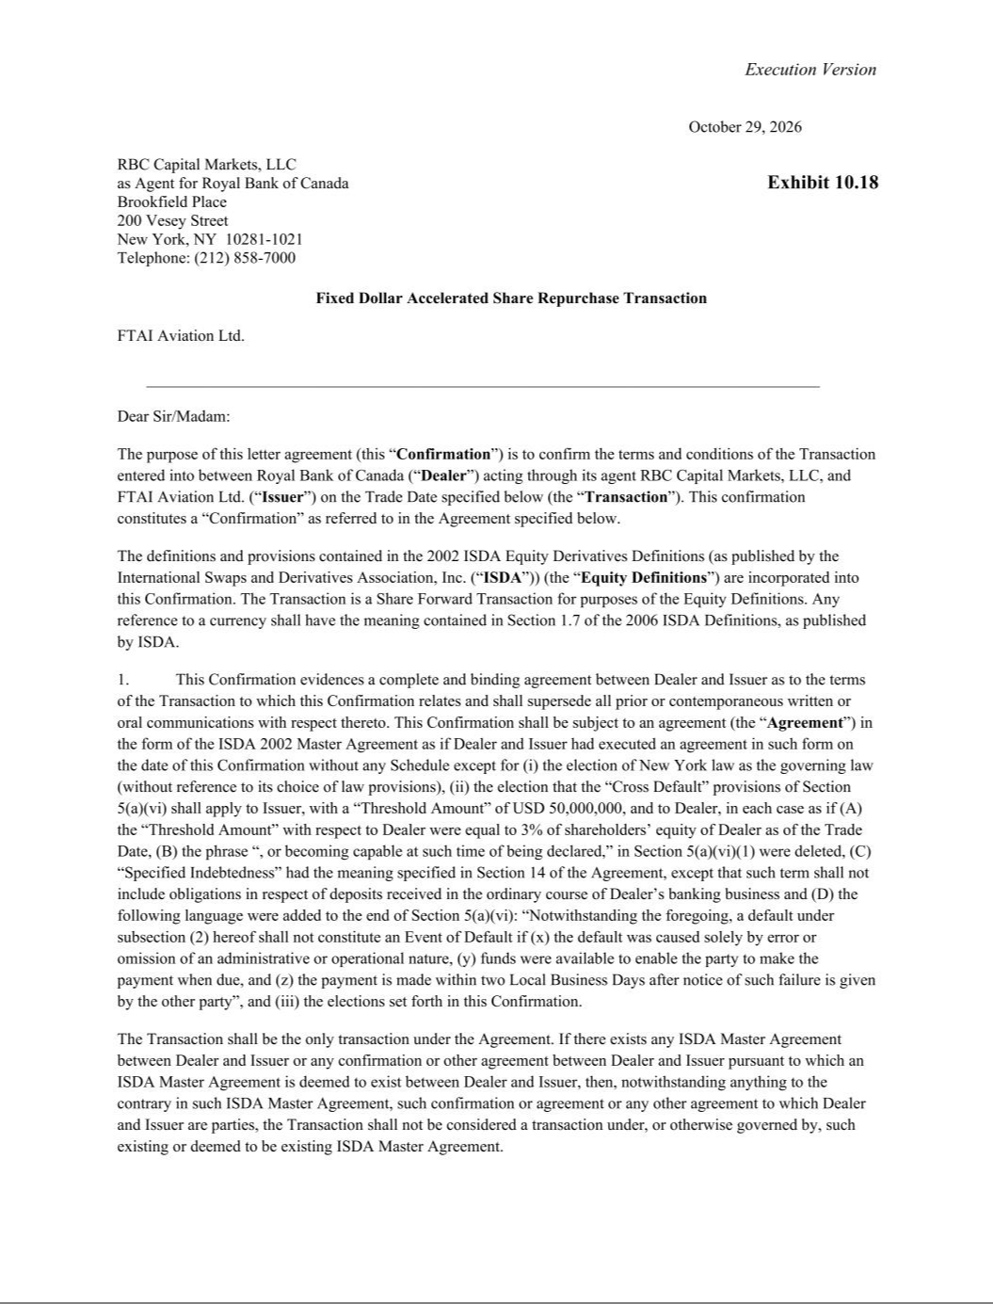

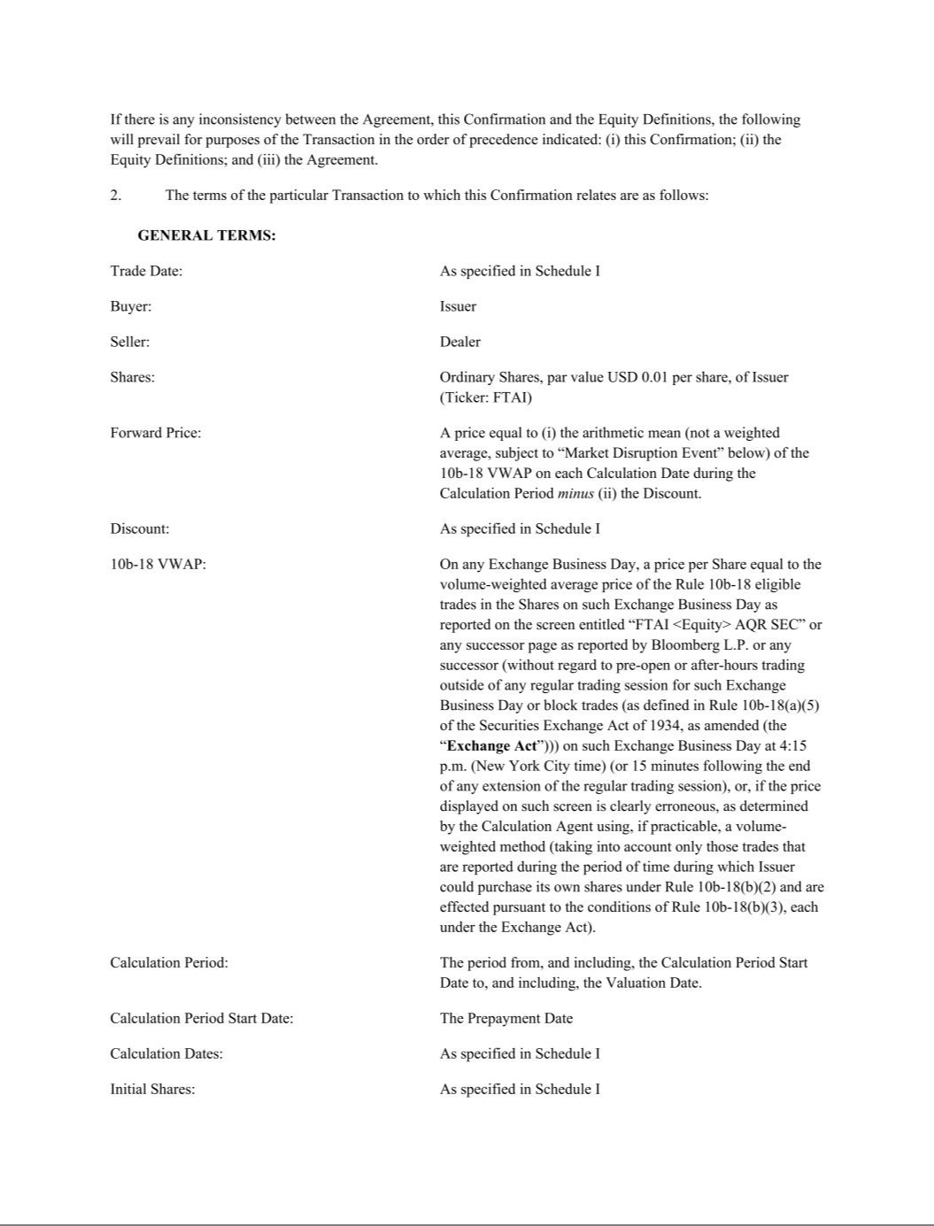

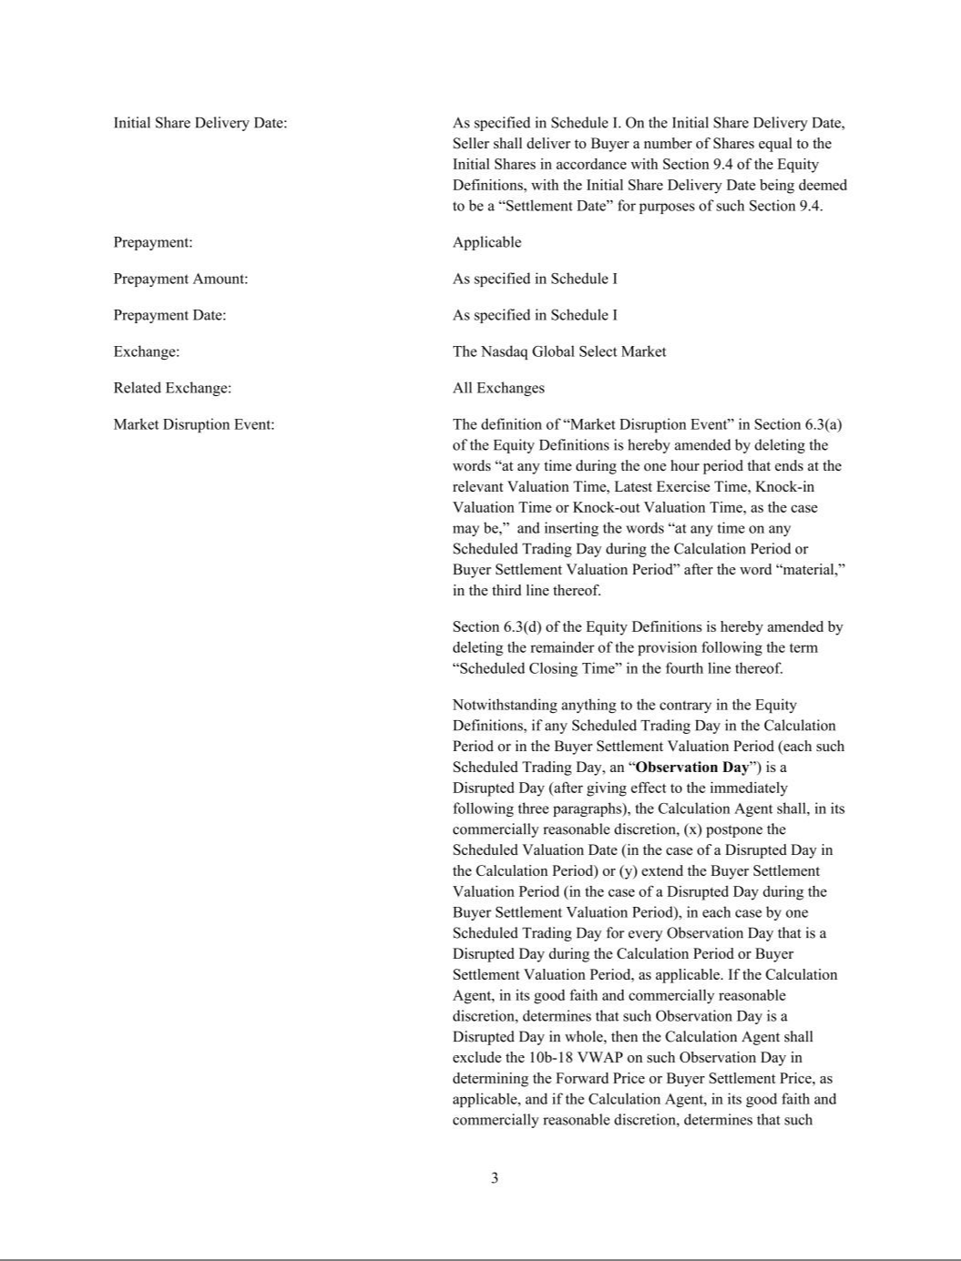

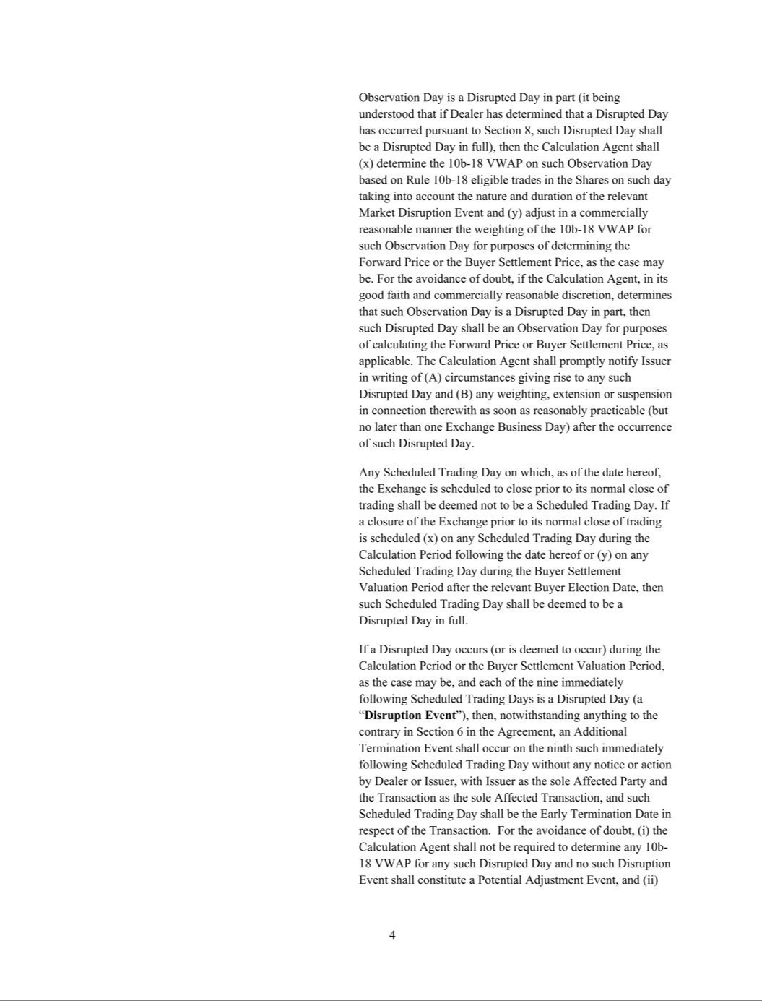

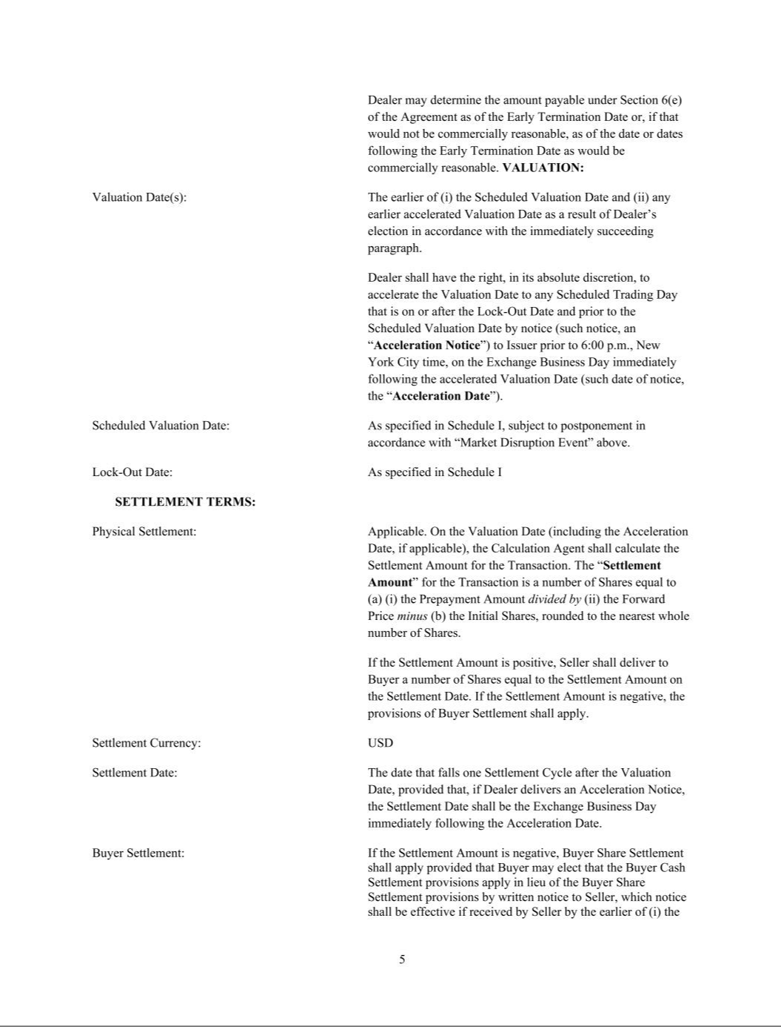

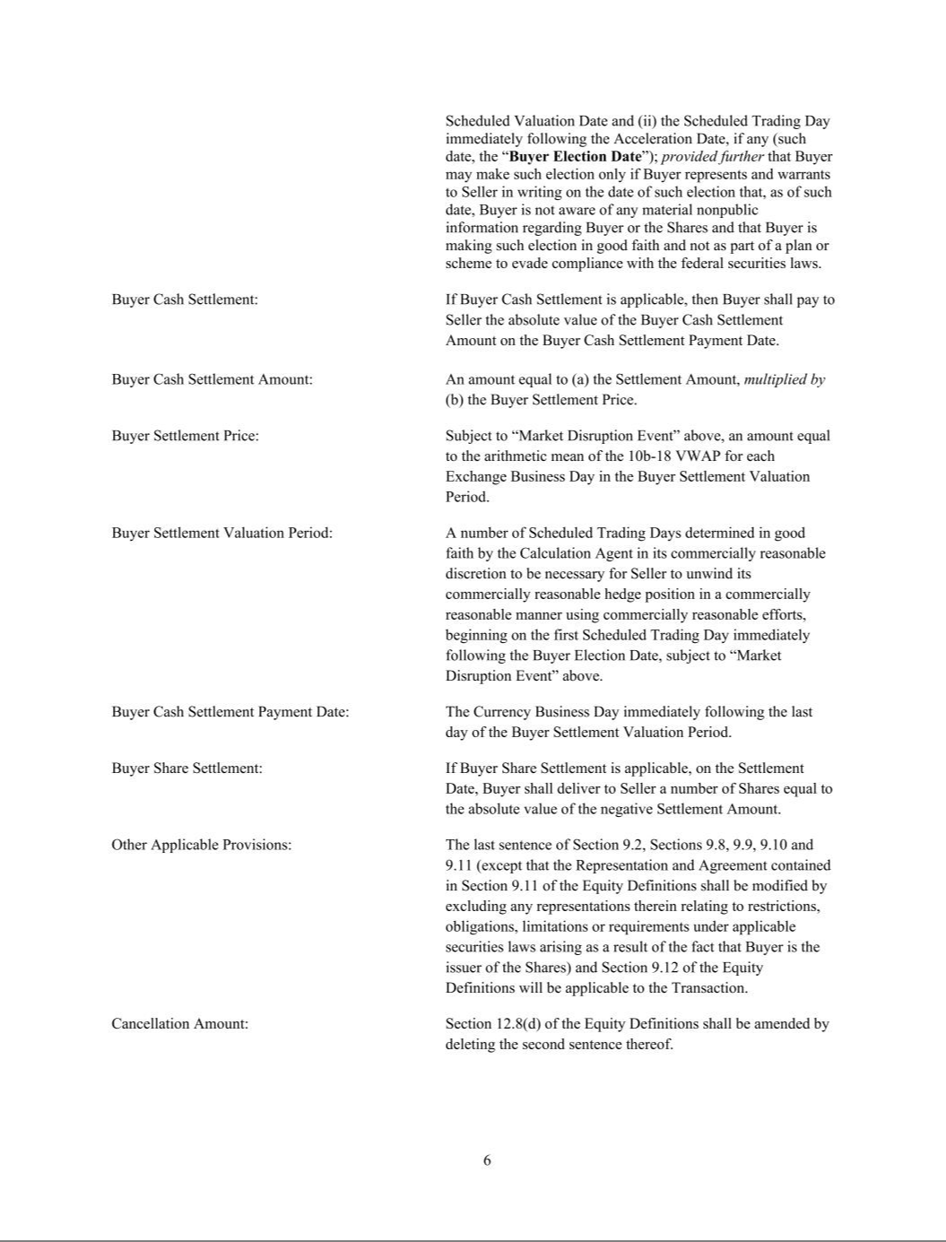

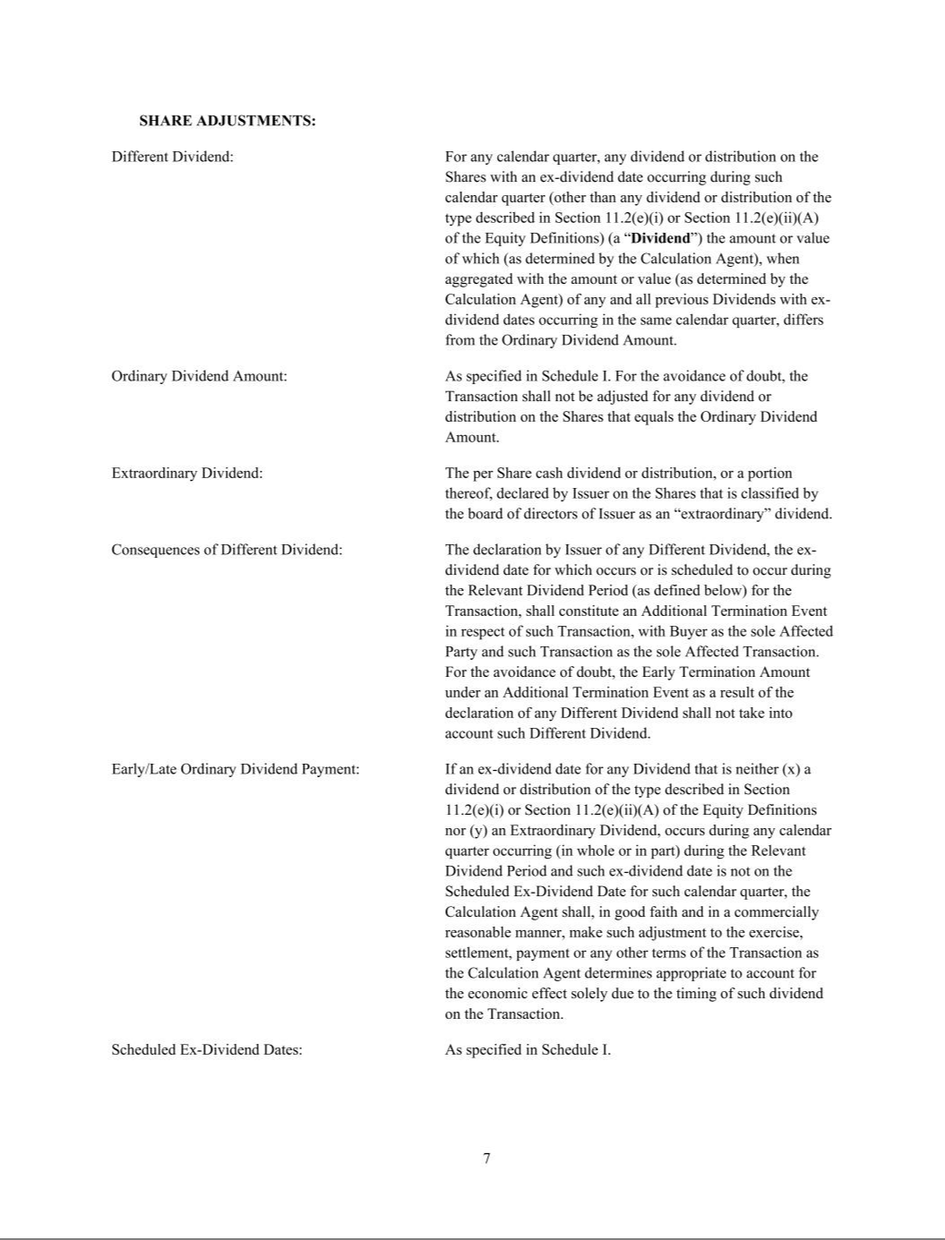

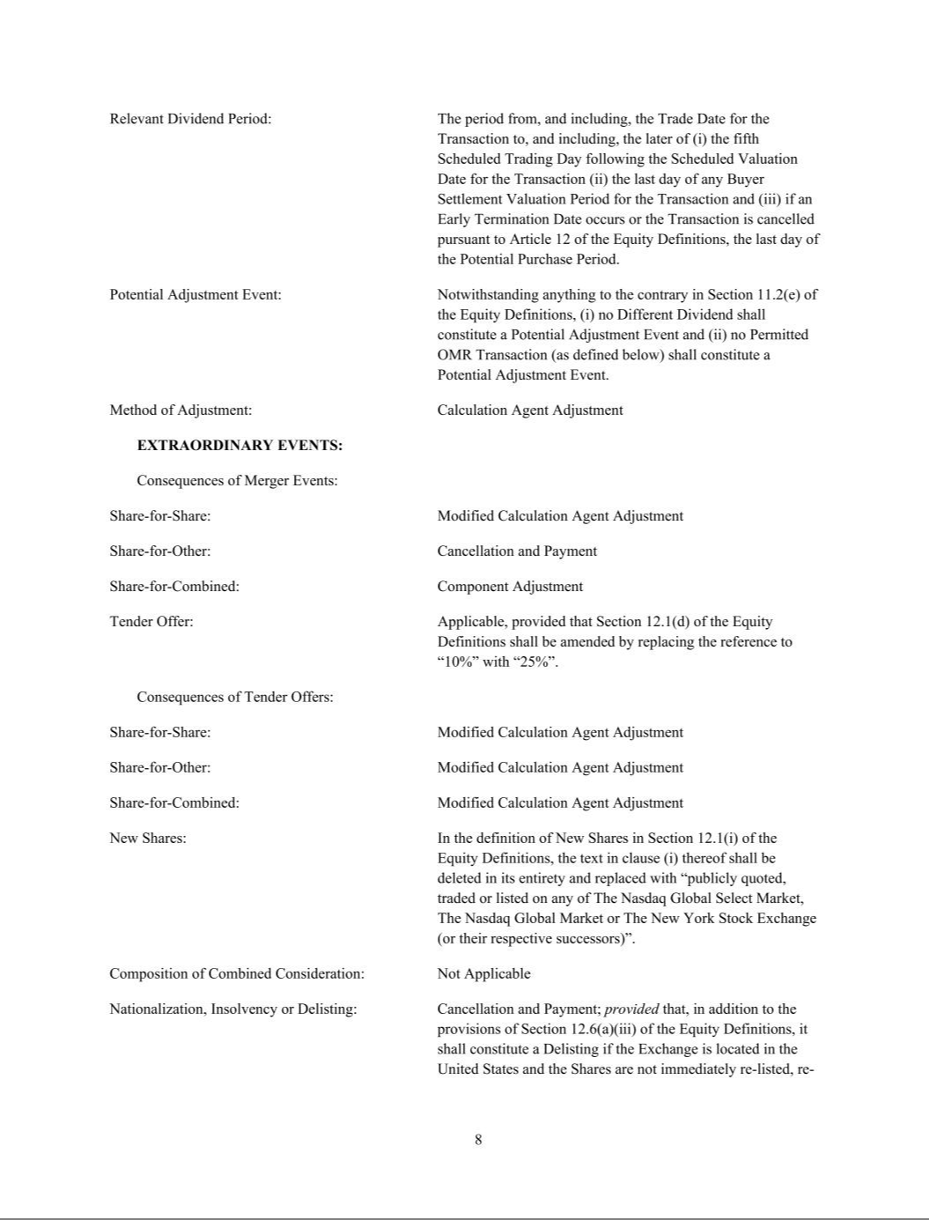

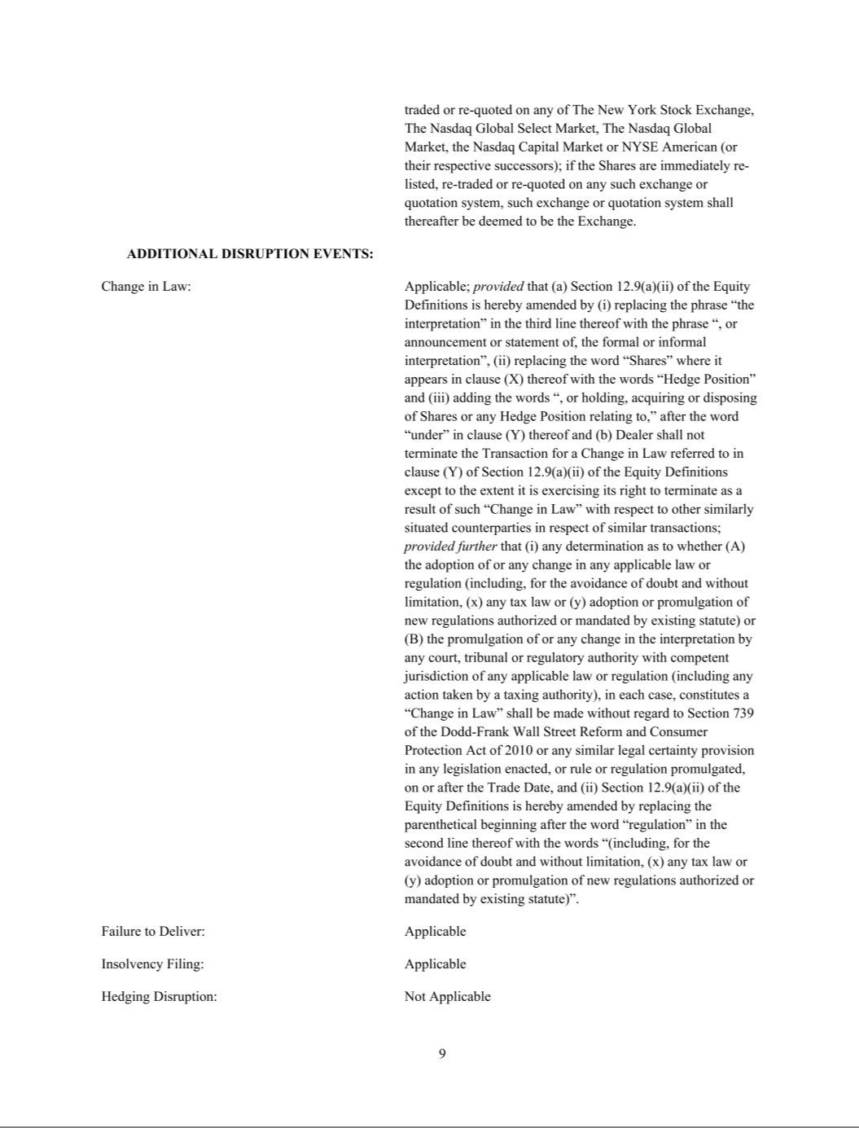

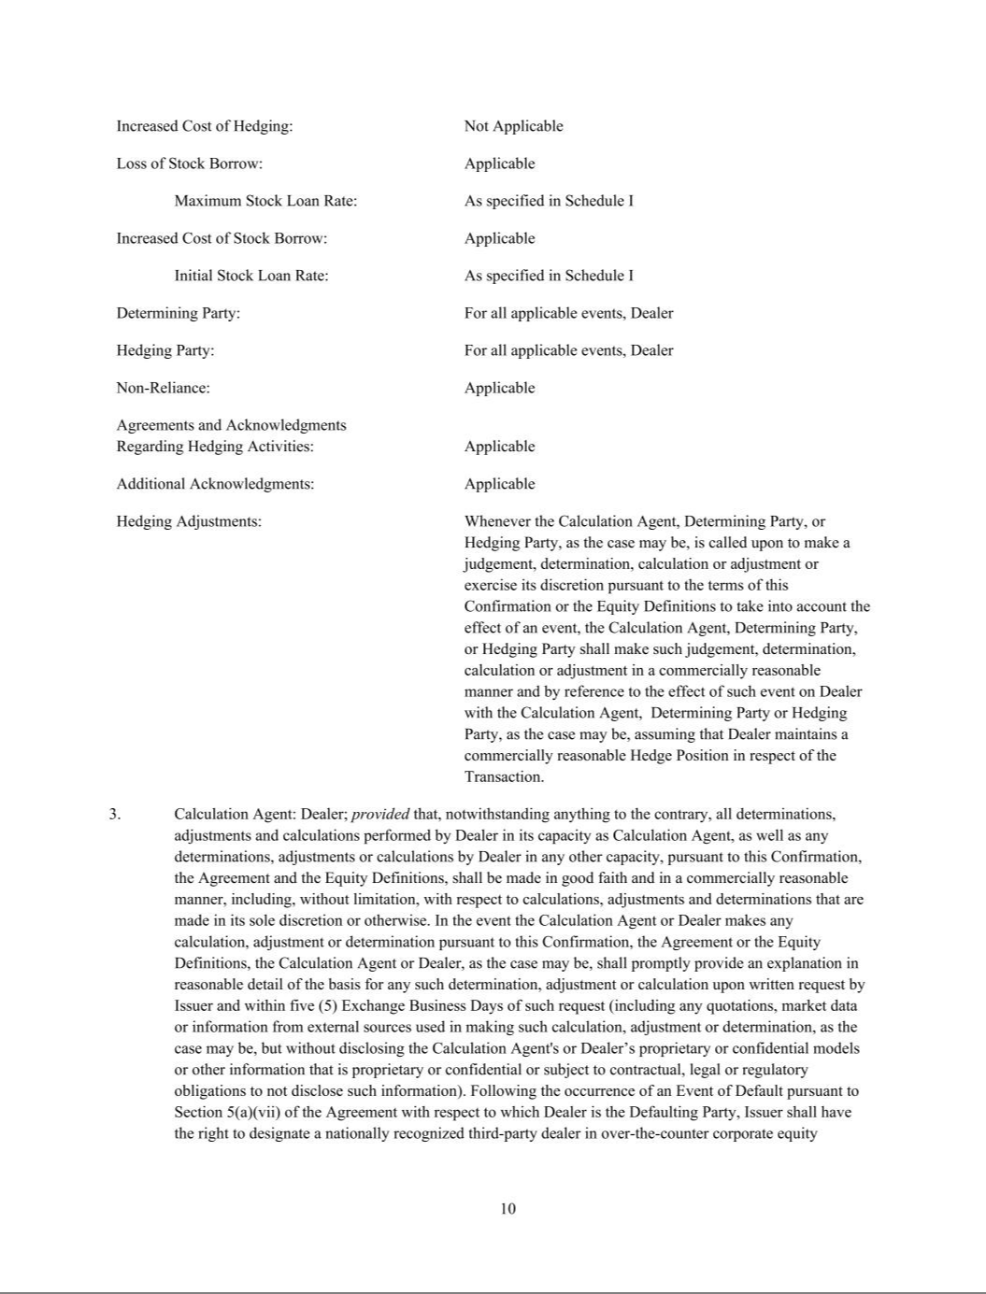

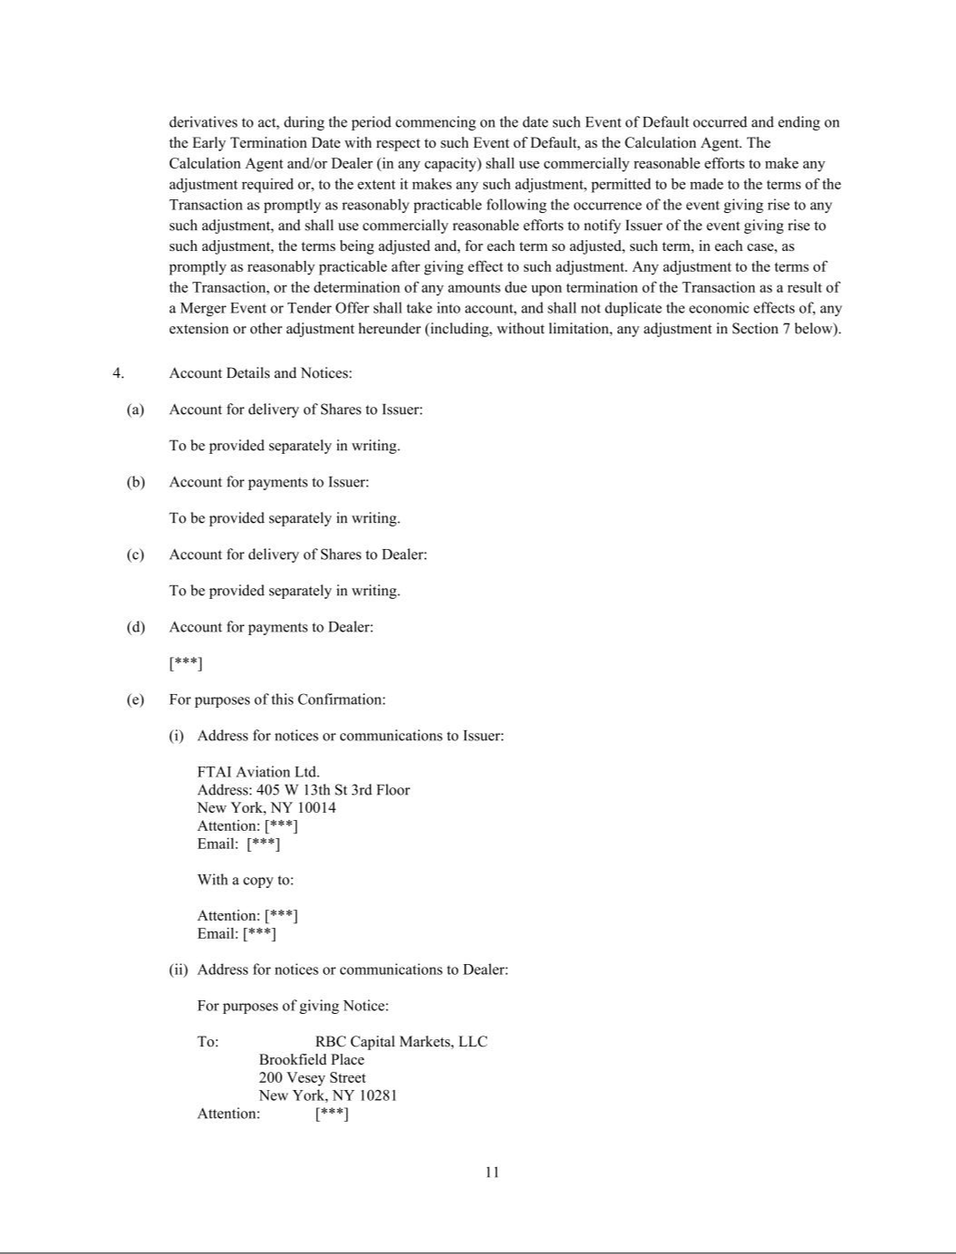

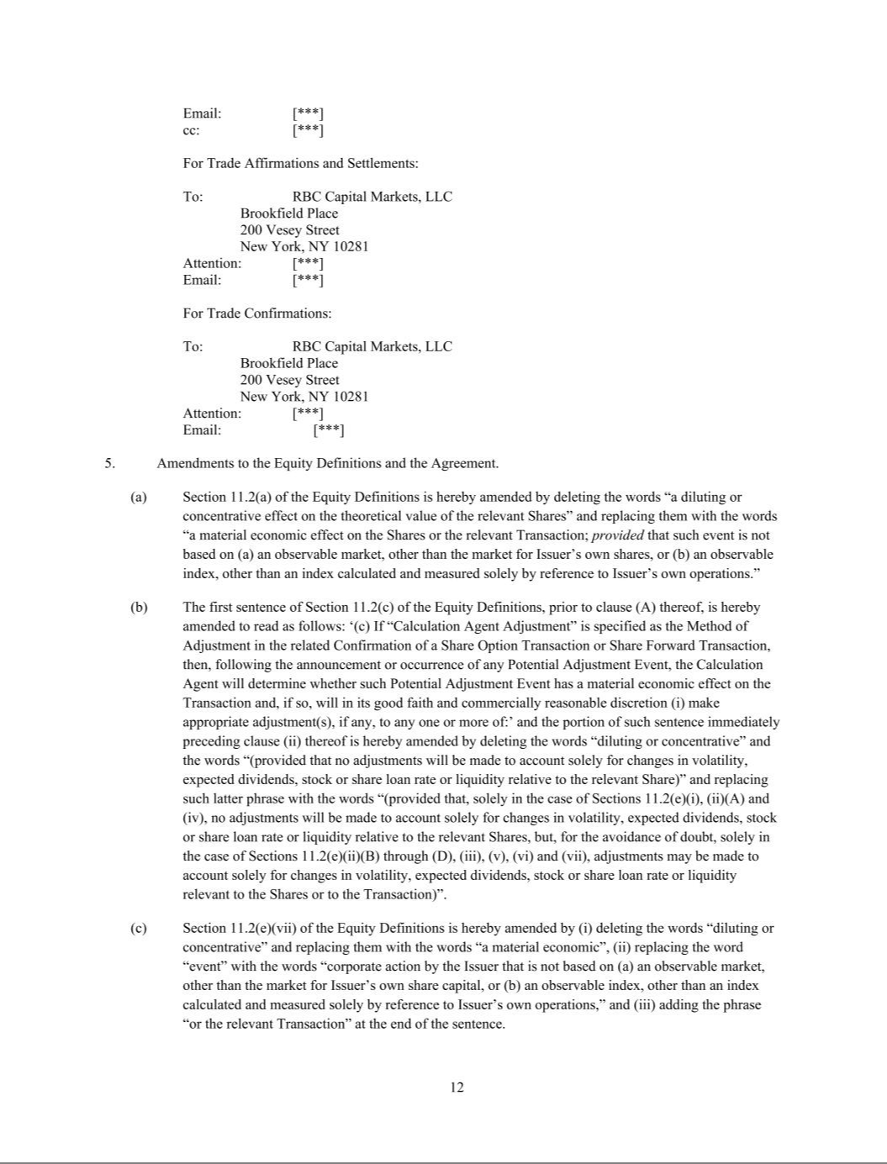

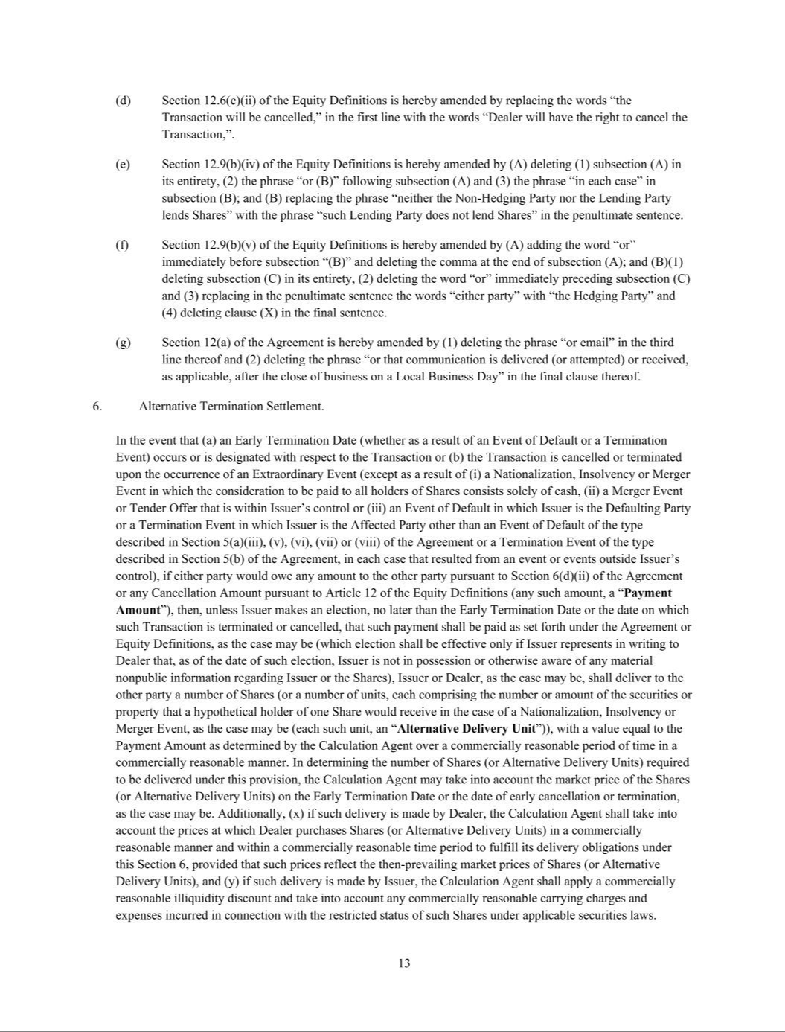

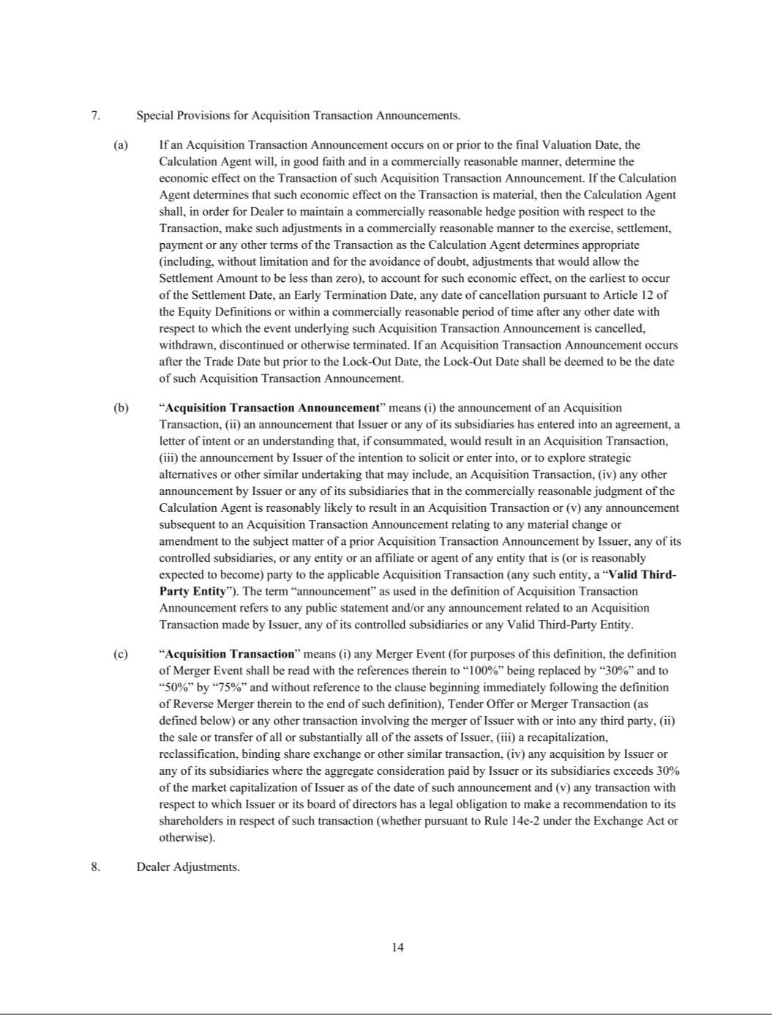

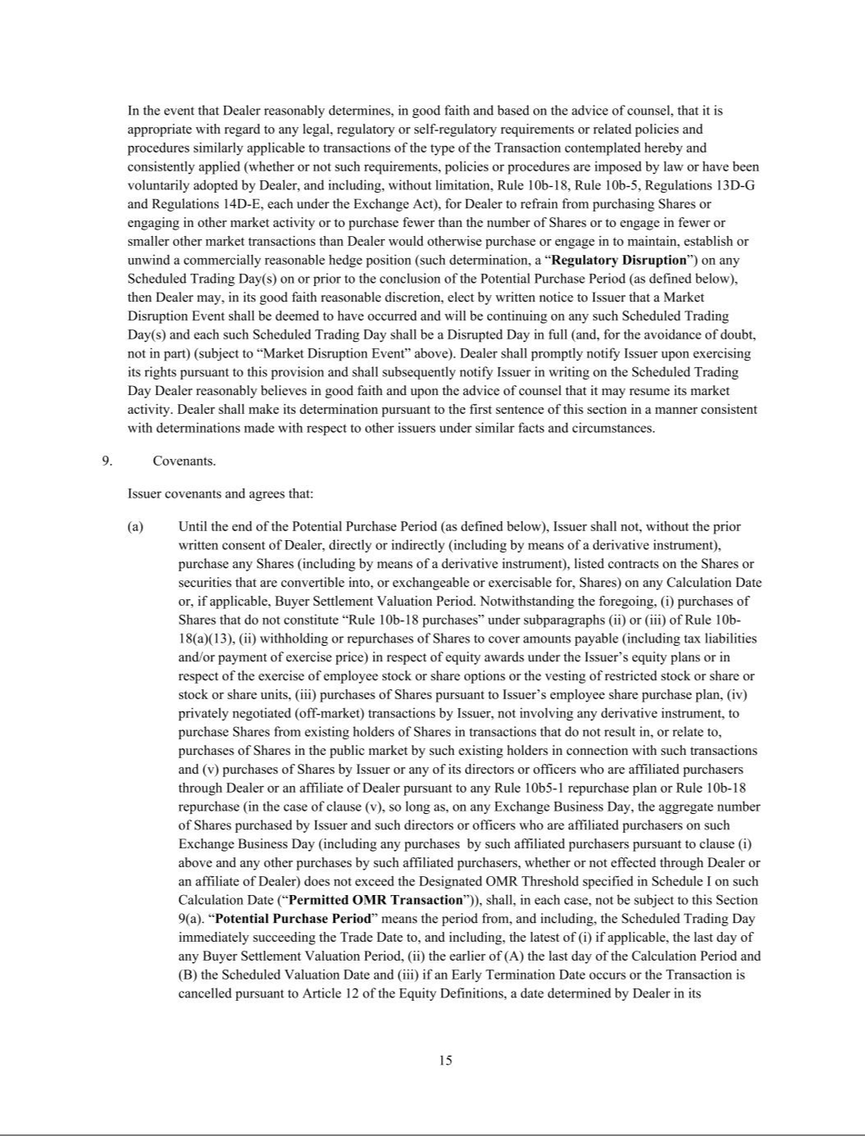

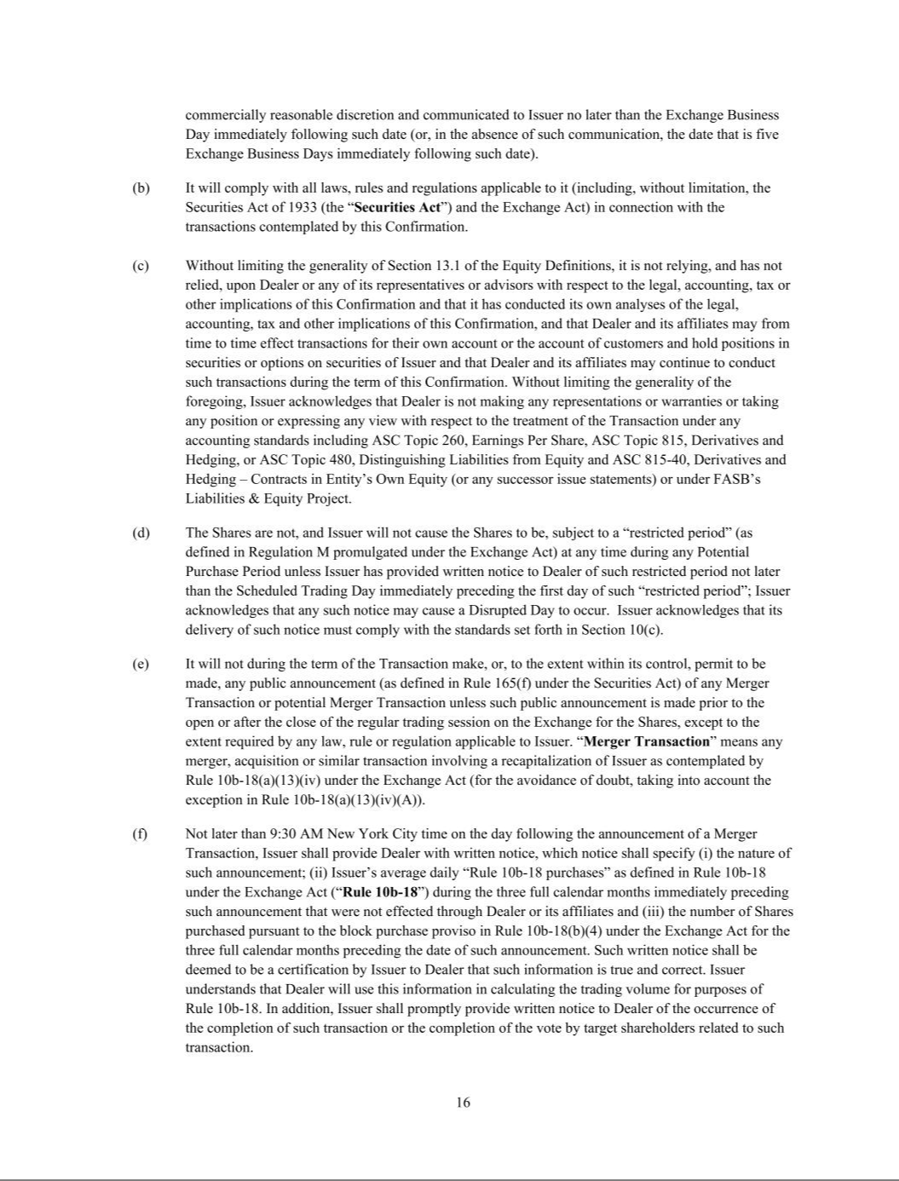

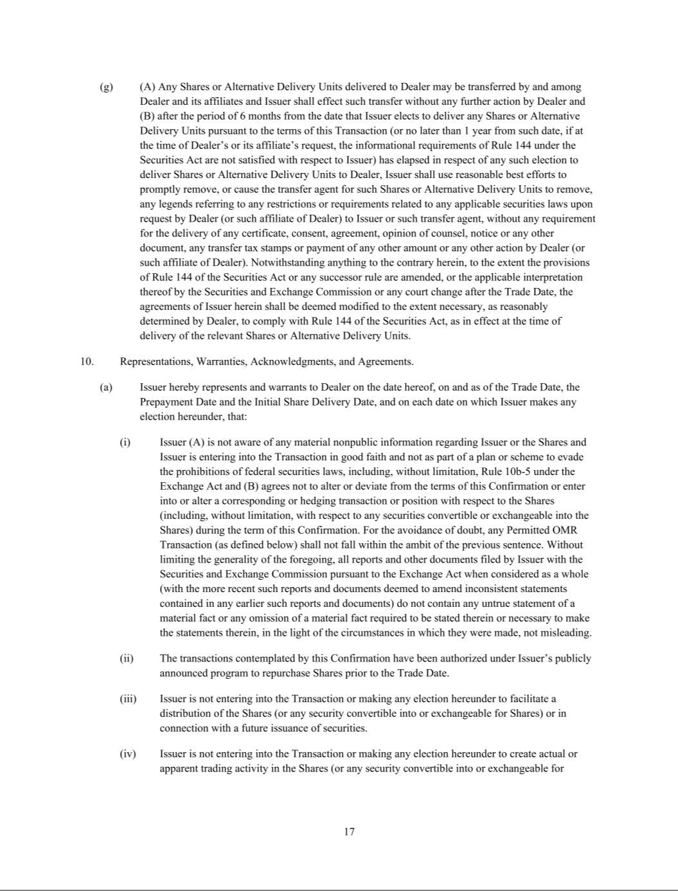

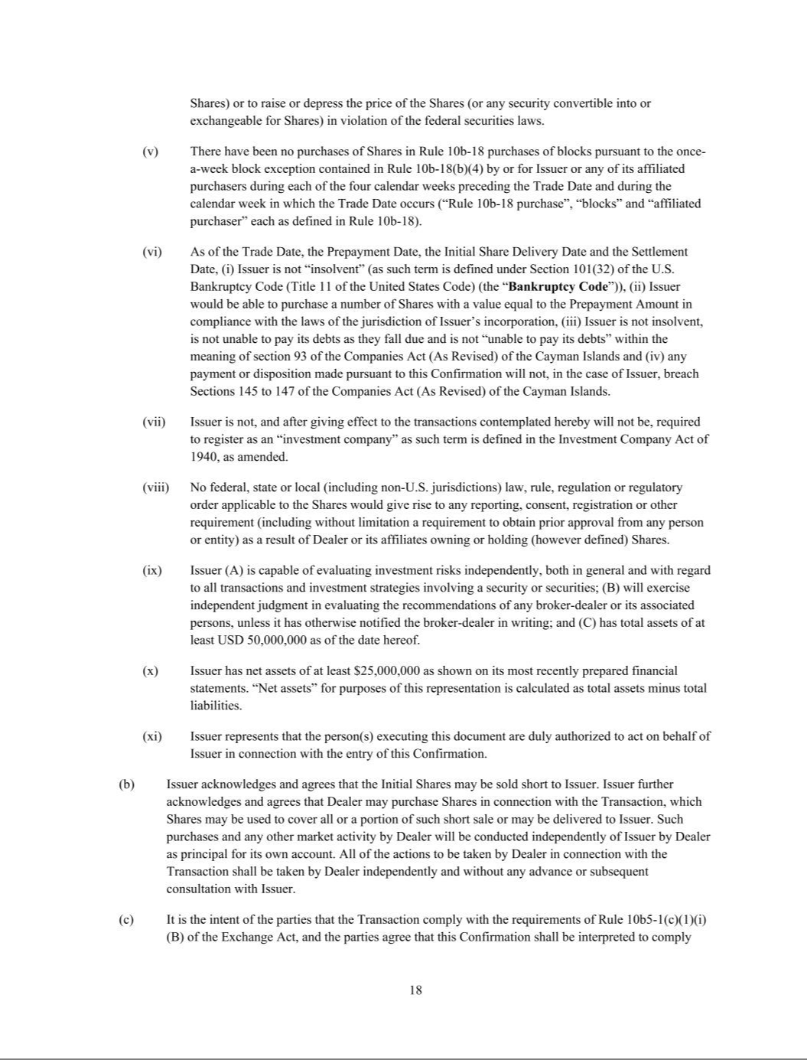

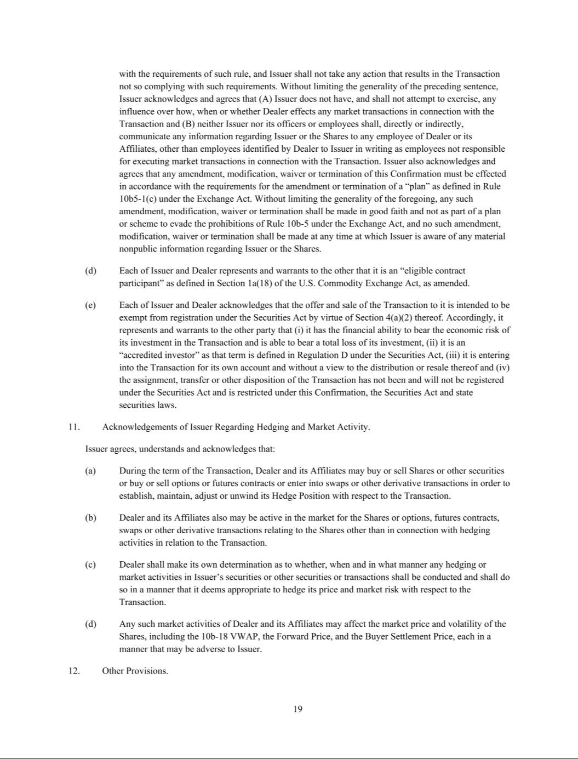

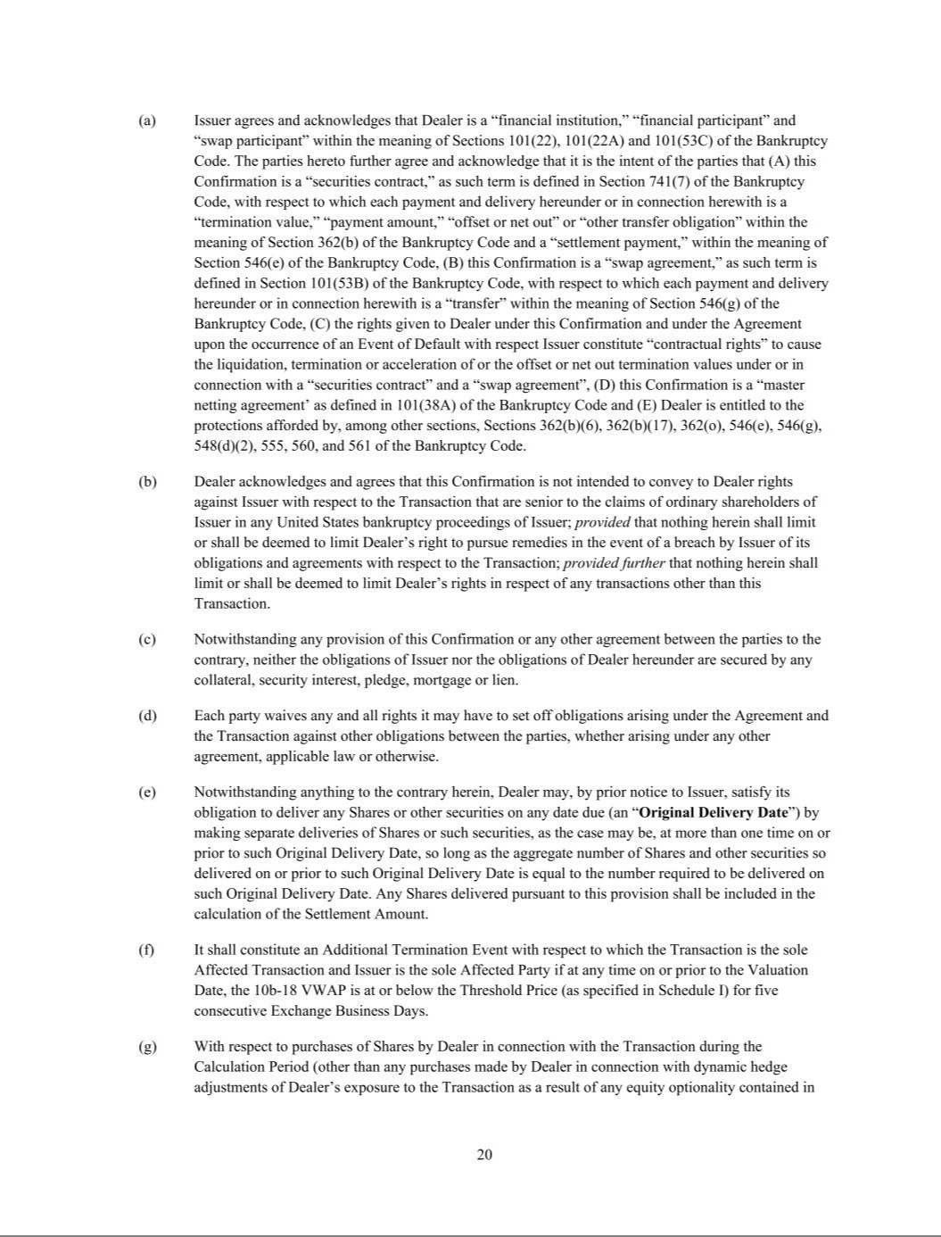

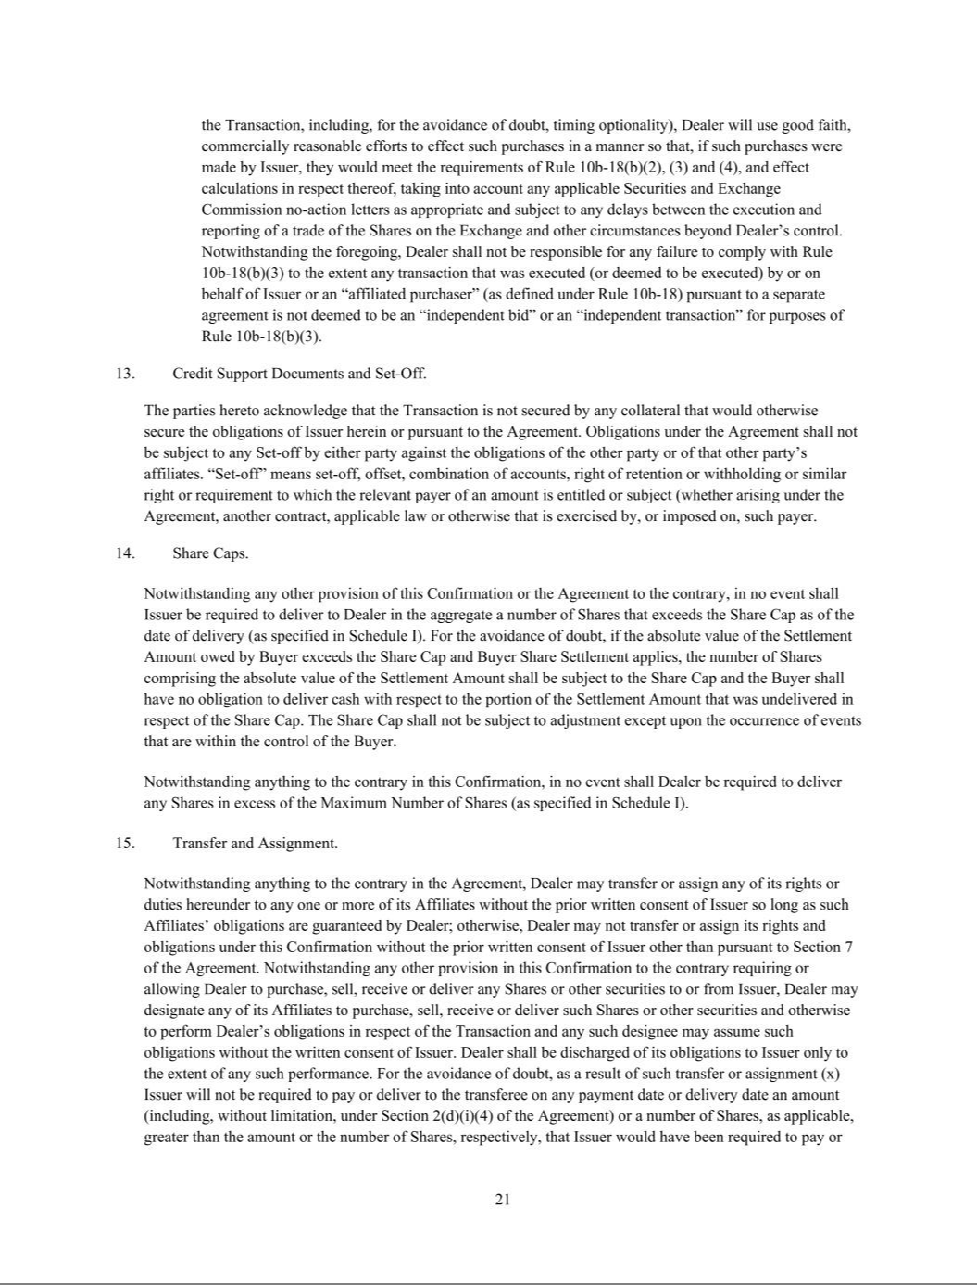

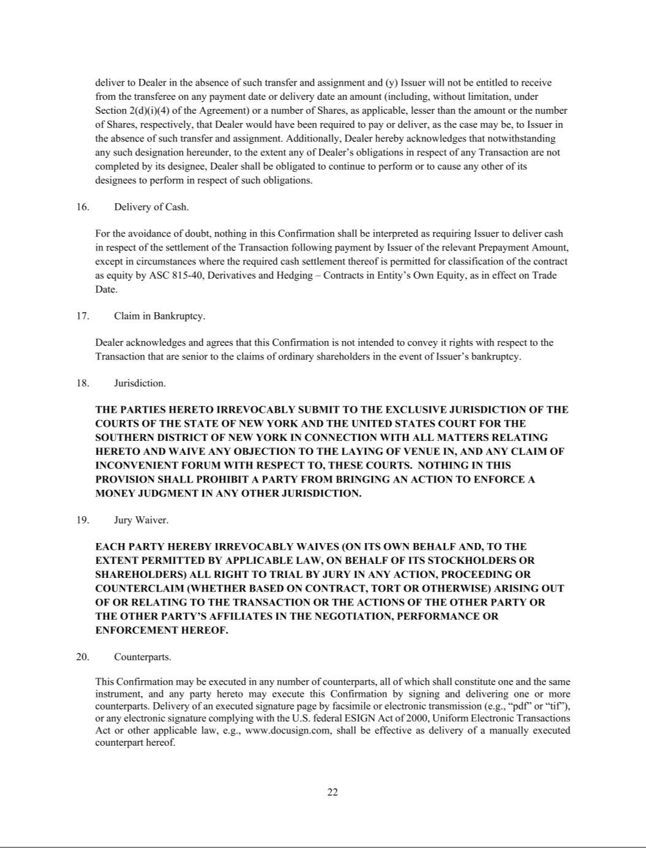

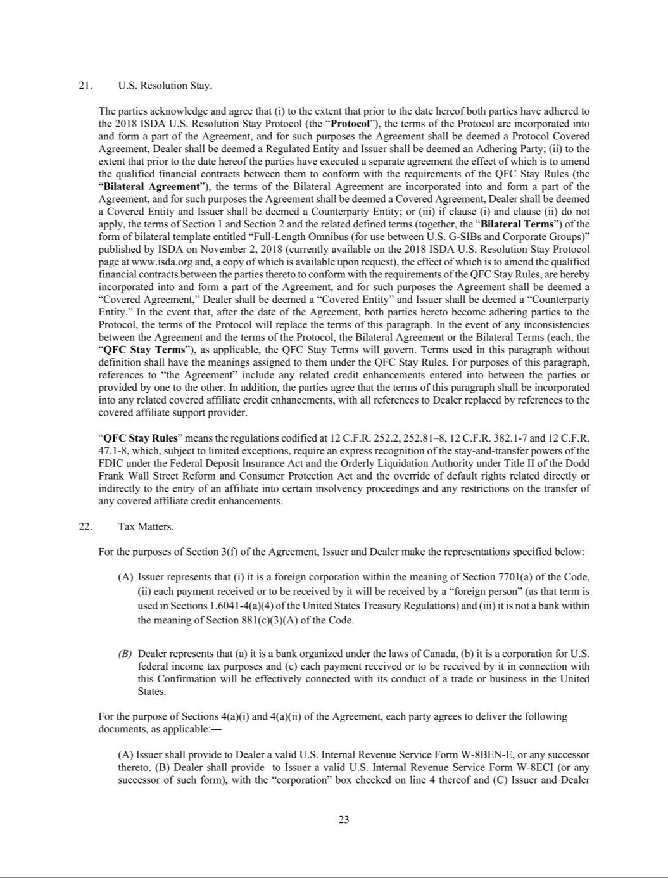

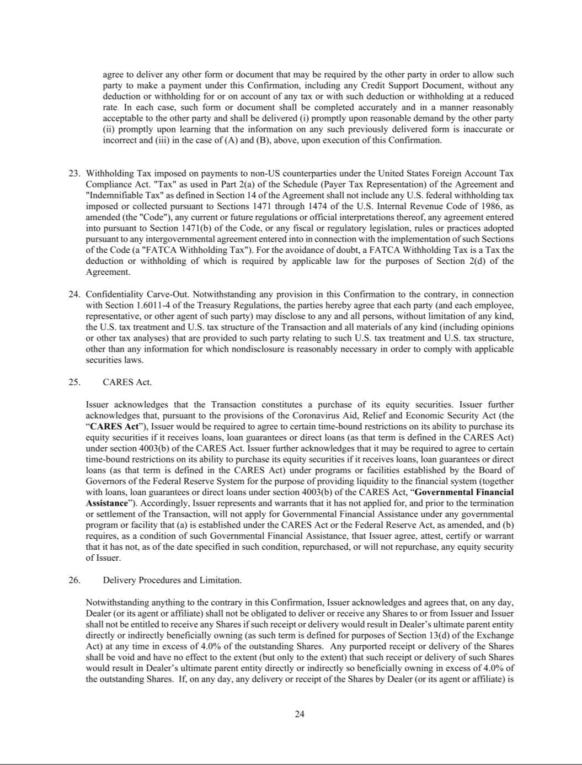

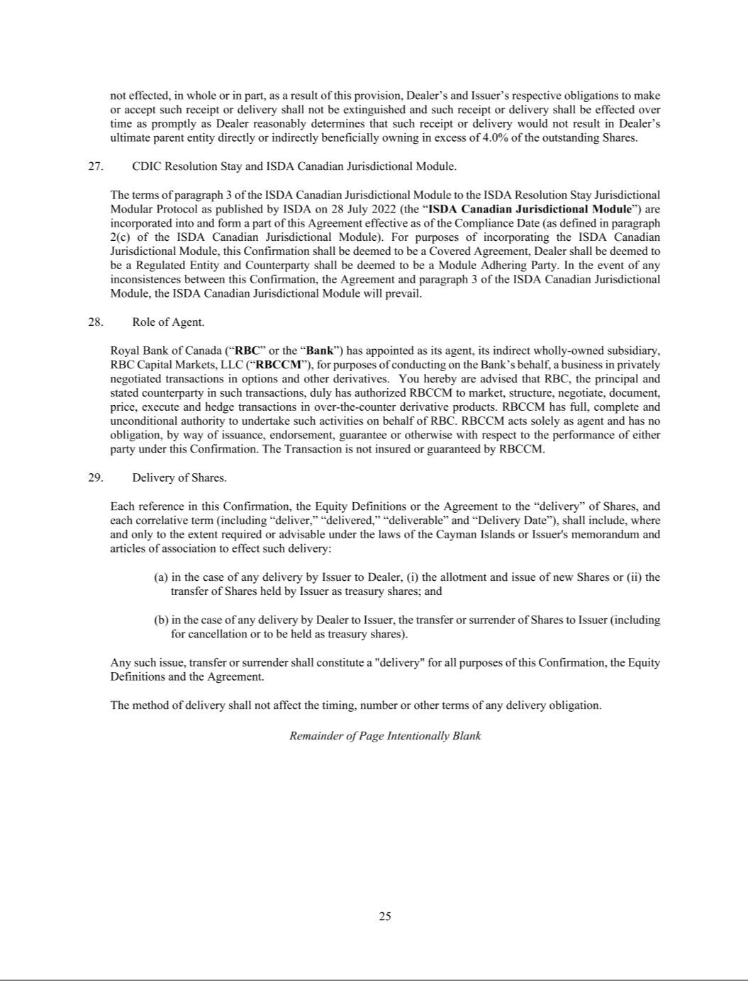





EXHIBIT 31.1

SECTION 302 CERTIFICATION OF CHIEF EXECUTIVE OFFICER

I, Joseph P. Adams. Jr., certify that:

- I have reviewed this Quarterly Report on Form 10-Q of FTAI Aviation Ltd. (the “registrant”);

- Based on my knowledge, this report does not contain any untrue statement of a material fact or omit to state a material fact necessary to make the statements made, in light of the circumstances under which such statements were made, not misleading with respect to the period covered by this report;

- Based on my knowledge, the financial statements, and other financial information included in this report, fairly present in all material respects the financial condition, results of operations and cash flows of the registrant as of, and for, the periods presented in this report;

- The registrant’s other certifying officer(s) and I are responsible for establishing and maintaining disclosure controls and procedures (as defined in Exchange Act Rules 13a-15(e) and 15d-15(e)) and internal control over financial reporting (as defined in Exchange Act Rules 13a-15(f) and 15d-15(f)) for the registrant and have:

  - Designed such disclosure controls and procedures, or caused such disclosure controls and procedures to be designed under our supervision, to ensure that material information relating to the registrant, including its consolidated subsidiaries, is made known to us by others within those entities, particularly during the period in which this report is being prepared;

  - Designed such internal control over financial reporting, or caused such internal control over financial reporting to be designed under our supervision, to provide reasonable assurance regarding the reliability of financial reporting and the preparation of financial statements for external purposes in accordance with generally accepted accounting principles;

  - Evaluated the effectiveness of the registrant’s disclosure controls and procedures and presented in this report our conclusions about the effectiveness of the disclosure controls and procedures, as of the end of the period covered by this report based on such evaluation; and

  - Disclosed in this report any change in the registrant’s internal control over financial reporting that occurred during the registrant’s most recent fiscal quarter (the registrant’s fourth fiscal quarter in the case of an annual report) that has materially affected, or is reasonably likely to materially affect, the registrant’s internal control over financial reporting; and

- The registrant’s other certifying officer(s) and I have disclosed, based on our most recent evaluation of internal control over financial reporting, to the registrant’s auditors and the audit committee of the registrant’s board of directors (or persons performing the equivalent functions):

  - All significant deficiencies and material weaknesses in the design or operation of internal control over financial reporting which are reasonably likely to adversely affect the registrant’s ability to record, process, summarize and report financial information; and

  - Any fraud, whether or not material, that involves management or other employees who have a significant role in the registrant’s internal control over financial reporting.

November 2, 2026 |  | /s/ Joseph P. Adams, Jr.
(Date) |  | Joseph P. Adams, Jr.
 |  | Chief Executive Officer

EXHIBIT 31.2

SECTION 302 CERTIFICATION OF CHIEF FINANCIAL OFFICER

I, Nicholas McAleese, certify that:

- I have reviewed this Quarterly Report on Form 10-Q of FTAI Aviation Ltd. (the “registrant”);

- Based on my knowledge, this report does not contain any untrue statement of a material fact or omit to state a material fact necessary to make the statements made, in light of the circumstances under which such statements were made, not misleading with respect to the period covered by this report;

- Based on my knowledge, the financial statements, and other financial information included in this report, fairly present in all material respects the financial condition, results of operations and cash flows of the registrant as of, and for, the periods presented in this report;

- The registrant’s other certifying officer(s) and I are responsible for establishing and maintaining disclosure controls and procedures (as defined in Exchange Act Rules 13a-15(e) and 15d-15(e)) and internal control over financial reporting (as defined in Exchange Act Rules 13a-15(f) and 15d-15(f)) for the registrant and have:

    - Designed such disclosure controls and procedures, or caused such disclosure controls and procedures to be designed under our supervision, to ensure that material information relating to the registrant, including its consolidated subsidiaries, is made known to us by others within those entities, particularly during the period in which this report is being prepared;

    - Designed such internal control over financial reporting, or caused such internal control over financial reporting to be designed under our supervision, to provide reasonable assurance regarding the reliability of financial reporting and the preparation of financial statements for external purposes in accordance with generally accepted accounting principles;

    - Evaluated the effectiveness of the registrant’s disclosure controls and procedures and presented in this report our conclusions about the effectiveness of the disclosure controls and procedures, as of the end of the period covered by this report based on such evaluation; and

    - Disclosed in this report any change in the registrant’s internal control over financial reporting that occurred during the registrant’s most recent fiscal quarter (the registrant’s fourth fiscal quarter in the case of an annual report) that has materially affected, or is reasonably likely to materially affect, the registrant’s internal control over financial reporting; and

  - The registrant’s other certifying officer(s) and I have disclosed, based on our most recent evaluation of internal control over financial reporting, to the registrant’s auditors and the audit committee of the registrant’s board of directors (or persons performing the equivalent functions):

    - All significant deficiencies and material weaknesses in the design or operation of internal control over financial reporting which are reasonably likely to adversely affect the registrant’s ability to record, process, summarize and report financial information; and

    - Any fraud, whether or not material, that involves management or other employees who have a significant role in the registrant’s internal control over financial reporting.

November 2, 2026 |  | /s/ Nicholas McAleese
(Date) |  | Nicholas McAleese
 |  | Chief Financial Officer

EXHIBIT 32.1

CERTIFICATION OF CHIEF EXECUTIVE OFFICER PURSUANT TO

18 U.S.C. SECTION 1350,

AS ADOPTED PURSUANT TO
SECTION 906 OF THE SARBANES-OXLEY ACT OF 2002

In connection with the Quarterly Report on Form 10-Q of FTAI Aviation Ltd. (the “Company”) for the quarterly period ended September 30, 2026 as filed with the Securities and Exchange Commission on the date hereof (the “Report”), Joseph P. Adams, Jr., as Chief Executive Officer of the Company, hereby certifies, pursuant to 18 U.S.C. Section 1350, as adopted pursuant to Section 906 of the Sarbanes-Oxley Act of 2002, that, to the best of his knowledge:

- The Report fully complies with the requirements of Section 13(a) or 15(d) of the Securities Exchange Act of 1934; and

- The information contained in the Report fairly presents, in all material respects, the financial condition and results of operations of the Company.

/s/ Joseph P. Adams, Jr.

Joseph P. Adams, Jr.

Chief Executive Officer

November 2, 2026

EXHIBIT 32.2

CERTIFICATION OF CHIEF FINANCIAL OFFICER PURSUANT TO

18 U.S.C. SECTION 1350,

AS ADOPTED PURSUANT TO
SECTION 906 OF THE SARBANES-OXLEY ACT OF 2002

In connection with the Quarterly Report on Form 10-Q of FTAI Aviation Ltd. (the “Company”) for the quarterly period ended September 30, 2026 as filed with the Securities and Exchange Commission on the date hereof (the “Report”), Nicholas McAleese, as Chief Financial Officer of the Company, hereby certifies, pursuant to 18 U.S.C. Section 1350, as adopted pursuant to Section 906 of the Sarbanes-Oxley Act of 2002, that, to the best of his knowledge:

- The Report fully complies with the requirements of Section 13(a) or 15(d) of the Securities Exchange Act of 1934; and

- The information contained in the Report fairly presents, in all material respects, the financial condition and results of operations of the Company.

/s/ Nicholas McAleese

Nicholas McAleese

Chief Financial Officer

November 2, 2026

